A Petition for the Creation of Garforth Parish
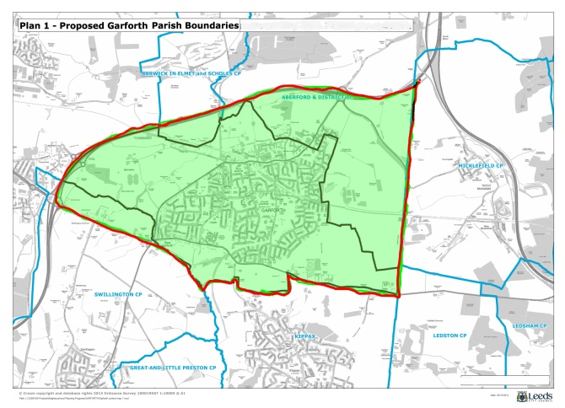 |  | This is a petition addressed to Leeds City Council under section 80 of The Local Government and Public Involvement in Health Act 2007 (hereinafter referred to as ‘The Act’).  We the undersigned, each being a local government elector for the area defined below call upon Leeds City Council to conduct a Community Governance Review in relation to the area defined below in accordance with Section 81 of the Act.  Pursuant of Section 80(4) of the Act we recommend the council designates the neighbourhood of Garforth, part of the ward of Garforth and Swillington and comprising of the Garforth Neighbourhood Plan area, Aberford Parish lands south of the M1, Barwick and Scholes Parish lands south of the M1, Austhorpe Parish lands east of the M1 and Swillington Parish lands north of the A63, an area of land bounded by the M1, the A63 and the old Ridge Road a parished area and that a parish council is established for this defined area (see map enclosed).  We further recommend that this parish be called Garforth.
Name | Address |  | Signature

