Garforth Housing Character Assessment
Introduction
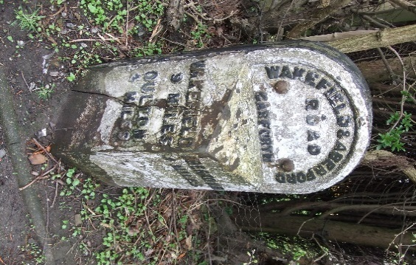
This assessment attempts to record and express the character of Garforth as evidenced by the buildings, streets and pathways, topography and visual appearance of each area of the township.
In the 18th. century, Garforth was in the form of three distinct parts, namely the hamlets of West Garforth and Moor Garforth and the parish of Church Garforth, separated by numerous arable and grazing fields,. East Garforth, as such, did not exist except as fields. It is only in the last 70 or so years that these separate parts have been joined together by housing estates and infill. The oldest structures that still exist today in their original state would appear to be the milestone on Wakefield & Aberford Road and that at the Selby Road (A63)/Ninelands Lane junction. These date from the opening of the Turnpike Road, no earlier than 1735 and may be replacements for earlier stones or, in fact, the original stones fitted with cast-iron facing.
Wakefield Road Milestone
The oldest remaining building in Garforth could well be the Gaping Goose Inn which pre-dates the turnpike road but has been considerably altered. Many towns and villages have a church which goes back to Norman times but Garforth's earlier church was demolished and replaced in 1844.
Open Fields around Garforth

Developers have had little regard for Garforth's past. Scattered throughout Garforth, and indicative of its existence as separate settlements, are Victorian terraces and houses. There is also evidence of the village's expansion which took place because of the development of mining on an industrial scale from 1830 onwards. Although some mining had been carried out previously, Garforth was primarily agricultural and gained a reputation for soft fruit production, notably for strawberries and rhubarb. Mining ceased in 1930 and, now that the last pithead building has been demolished on Ninelands Lane this year, no industrial building linked with Garforth's mining past remains.
No significant growth took place until 1950 when access to the M1, M62 and A1 made Garforth attractive to commuters and businesses, particularly in the distribution sector. A series of housing estates sprang up, beginning in 1930, increasing substantially in the 1950's into the 60s,70s,80s and continuing to the present day. Each estate has its own characteristics, depending on the economic situation, the current mood and style at the time of development. In addition to the housing estates, the population explosion has been catered for by in-filling with single or small groups of modern houses between the older buildings, sometimes with remarkable ingenuity.

Historical Over-view
Between 410 A.D. and 627 A.D. Garforth was a settlement of 4020 acres in the Kingdom of Elmet just off The Magnesium Limestone Ridge - “The Cliff”. In 1086 A.D., according to the Domesday Book, there was a church and a priest and the village was worth 30/-.During the Middle Ages, Garforth was a still a group of small settlements, cultivated by the customary strip method, evidence of which can still be seen in Glebelands. The population during the 14th. Century was recorded as 49. Although at that time, coal was being won from ‘bell’ pits, mining was of little significance. Until the 19^{h}.Century agriculture was the main employment and several farms were dotted in and around Garforth. As with other areas of England, the rural landscape was about to change radically, primarily due to the Industrial Revolution. Mining was an important factor in the first significant population growth in Garforth. In 1830 the population was 782. In 1840 it was 1195, an increase of over 50% in ten years. The rows of terraced housing which were built towards the end of the nineteenth century are evidence of the need to house the workers involved in this expansion. Examples can be seen in Lyndon Avenue, Barleyhill Road, Kensington Terrace, Strawberry Avenue, Beech Grove Terrace, Poplar Avenue, Lidgett Lane, Ash Terrace and Newhold. Farm labourers were attracted to work in the mines following the decline in agriculture during the 1870’s and 1880’s. There is an account of a Mark Morritt travelling with his young family from Temple Hirst near Selby to Garforth for employment. He became a “Coal Hewer” and lived in Strawberry Avenue. When the collieries closed in the first part of the twentieth century, people were forced to look for other kinds of work in and around Leeds, where employment was available in heavy engineering, printing and tailoring.
Terraced Housing, Wakefield Road, circa 1892

The Gaping Goose Inn
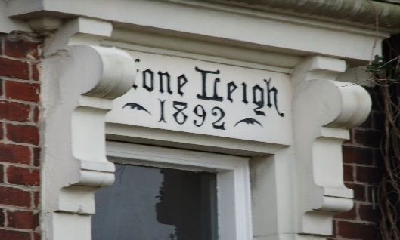
Garforth was starting to become a commuter settlement. In the 1930’s, it experienced a housing shortage and the solution was the first social council housing estate. Built as the Garforth Oak Estate, these properties provided modern facilities, such as indoor toilets and bathrooms, front and back gardens at a reasonable rent. It must be remembered that, at that time, most people did not own their own home and to pay rent, either to a private landlord or to the local authority, was the norm.
After the Second World War, there was a massive housing shortage nationwide. Garforth began building houses in large numbers during the 1950’s. This continued during the 1960’s and 1970’s and into the 80s and 90s. Infill by small scale residential development during this period became common-place. Garforth was, at one point, the fastest growing settlement in the country and was documented in the press across Western Europe.
Door lintel detail
Photo of Oak Estate required Variious image of Oak estate to be used in Area 6 doc Image 2 - 1

PHOTO OF Strawberry Ave Viewed looking from Barleyhill Rd south – both side of road Image 1- 1

Allendale Crescent - 1950
Garforth Bridge Roundabout

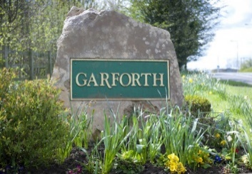
Over the years, Garforth had several Lords of the Manor but the most important were the Gascoignes and their influence affected every aspect of its development – Industry, Housing, Education, Welfare and even Religion. On the Tithe Maps of 1836-51, Richard Gascoigne owned over 75% of the land in the village, mostly arable or under grass. Garforth had a Parish council until 1908, when it became Garforth Urban District Council. In 1939, this expanded to take in Kippax and Allerton Bywater. This arrangement continued until 1974 when Garforth was assimilated into Leeds under the Leeds Metropolitan Council. It is now a “Hierarchical Settlement” with neither Parish Council nor Town Council and as such is denied a direct voice on many aspects of Local Government, particularly regarding financial allocations in connection with developments. Because of boundary changes, anomalies have arisen in that some residential properties and businesses within the historic Garforth boundaries, in East Garforth, Barrowby Lane, Brierlands and Cedar Ridge are required to pay a Precept (an additional tax) which is passed to the out-lying parishes i.e. Berwick-in-Elmet, Austhorpe and Aberford. Another anomaly is that some ‘Garforth’ settlement stones are positioned within other parish boundaries.
East Garforth Boundary
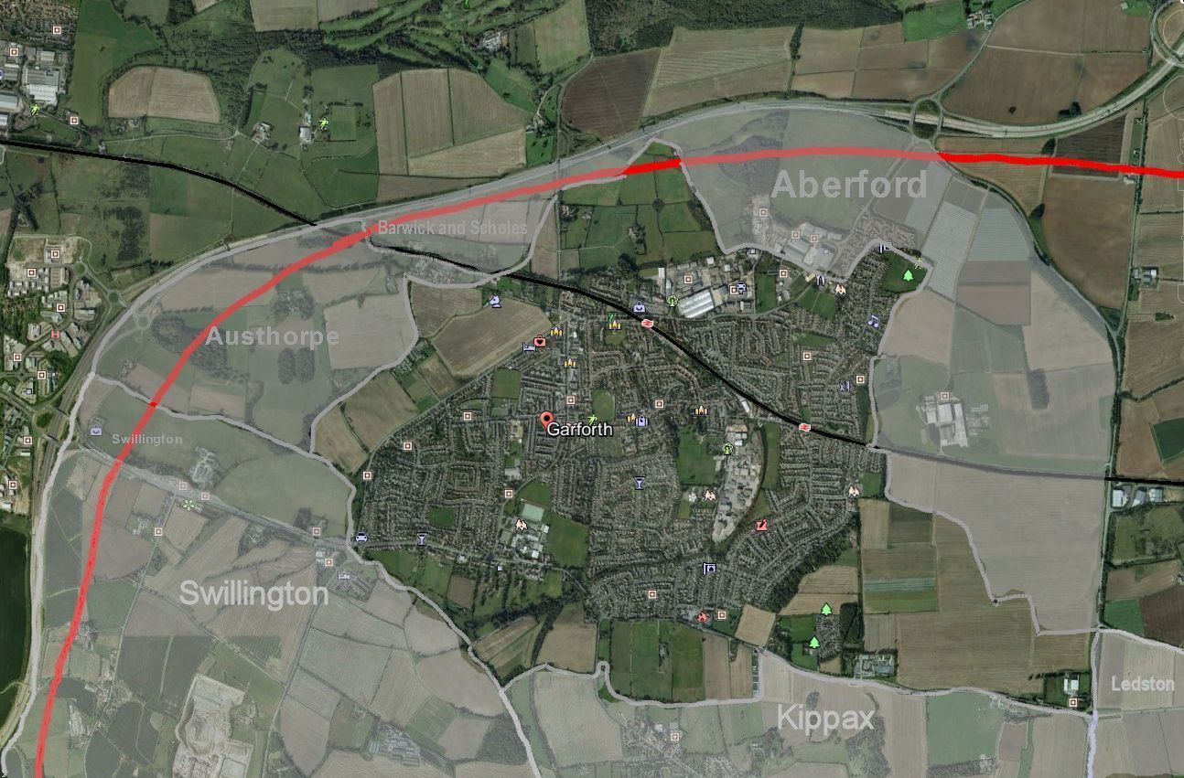
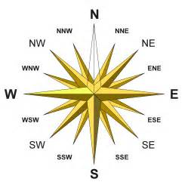
Map of Garforth and the surrounding Parishes
Red Line is proposed HS2 Route Grey Line is the M1
Garforth is located in the Outer South-east Area of the Leeds Metropolitan City Council in the Ward of Garforth and Swillington, West Yorkshire. The population of the Garforth & Swillington Ward is 20533; that of Garforth alone being 17033. The Garforth settlement is roughly triangular and has an area of 4020 acres. It is enclosed by the A63 Leeds to Selby turnpike road, A642 Wakefield to Aberford turnpike road and the A656 Ridge Road, a historic Roman road. Garforth connects to the M1, to the north and south at Junctions 46 and 47. It connects to the A1(M) north via the A642 and M1 and to the A1(M) south via the A63.
Railway & Public Transport: Garforth has two railway stations, named respectively ‘Garforth’ and ‘East Garforth’. The line runs West to East from Leeds and is known as the “Leeds Selby Line” which separates at Church Fenton allowing travel northeast to York after the Cawood junction in North Yorkshire. Garfoth Station has limited car parking for passengers’ /commuters’ use. East Garforth Station, although compliant with the Disability Discrimination Act for accessibility, has no parking facility. The cast iron footbridge at Garforth Station is Grade 1 Listed.
The proposed High-speed H2 North-east/ South rail link is to be routed around Garforth from the South and is to travel North-east to York.

Garforth, 1924 – Courtesy Leeds City Libraries.
Main Street running diagonally from top left to bottom right.

Bus Services: There are bus services that connect Garforth to other communities:
163 Leeds to Castleford, via Ninelands Lane and Main St.
166 Leeds to Castleford, via Fairburn Drive and Main St.
19A Tinsill /Cookridge to East Garforth Metro Station and New Sturton Lane.
402 & 403 Leeds to Selby via East Garforth & Micklefield.
404 Micklefield to Crossgates via Garforth
173 & 174 Wakefield to Wetherby via Garforth
175 Wakefield to Castleford via Garforth

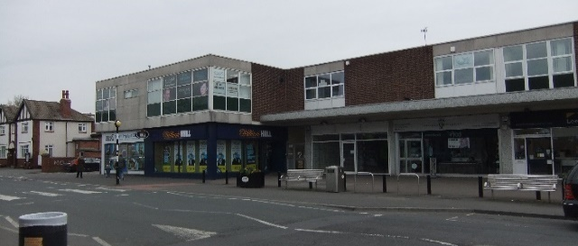
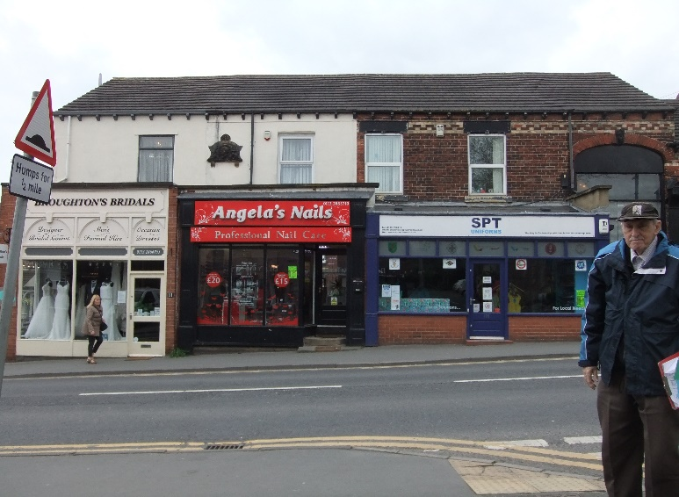
SHOPPING: Main Street is a vibrant shopping area, although the variety of shops and retail outlets has been severely reduced over the years. There are three public car parks and on-street parking is permitted but parking is clearly a problem and traffic congestion is common-place. Garforth has one large supermarket with petrol station and large car park. This site is near Garforth Station, off the Aberford road A642 and remote from the Main Street shopping area. A NEW retail development with another supermarket, smaller auxiliary retail trading units and a new “pub/restaurant” to be built in the same area received planning consent in 2016.
Main Street
Main Street Shopping Parade
Open Spaces
Although Garforth has fields within its boundaries to the north-west, south and south-east, it is no longer a rural settlement but a dormitory town.
Existing open space, grassed areas can be found at
a) Barleyhill Road Recreations ground with bowling green ,2 tennis courts, children’s play area and equipment
b) Glebelands (previously owned by the Church), with a concrete skateboard play area, a rugby pitch and a small play area with basic equipment
c) East Garforth adjacent to Ash Lane & Newhold with 2 football pitches and open grass areas
d) Ninelands Lane Open grass land with trees behind the Fire Station
e) Firthfields, East Garforth Grass area with community centre
f) Westbourne Avenue and Goosefield, West Garforth An area of open grassland surrounded by hawthorn hedges and used mainly for dog walking and as a play area. It is understood to be protected from development by a covenant. A public footpath crosses the area from Selby Road to Ringway.
Westbourne Avenue and Goosefield
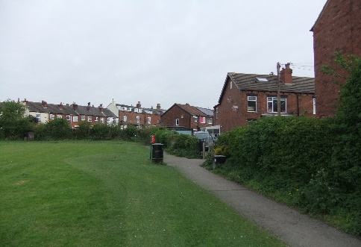
g) Hawks Nest Wood A large un-managed area of grass and woodland with numerous foot-paths, some not easily accessible
Photo Community open space & centre Firthfields east Garforth Image 7 - 1

Barleyhill Road Recreation Park

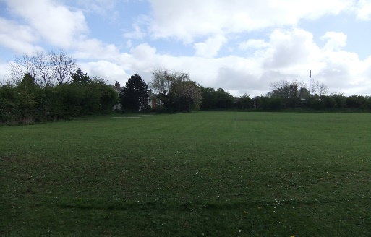
PHOTO OF Geleblands Image 9 - 1

Off Ash Lane and Newhold
Amenities
Garforth is rich in community groups, social, leisure and voluntary organisations or clubs. Buildings and facilities used by such groups include:
Garforth Miners’ Welfare Hall, built in 1924
Garforth Country Social & Bowling Club.
PHOTO St Marys church Image 10 - 1
Garforth Barleyhill Road Working Men’s Social Club
Garforth Library and One-Stop Centre
St. Mary’s Church and Parish Centre St Benedict’s Church and Hall
Methodist Chapel and Hall Dayspring Evangelist Chapel and Hall
Garforth Academy College 5 Junior Schools
Garforth Villa Football Teams Garforth Tigers Rugby Teams
2 Cricket Clubs 3 Members’ Social Clubs
6 Recreation Grounds
with 2 Tennis courts, 2 Bowling Greens, skate-board area, Rugby and Football pitches
Also used by the community are:
Health Centre 2 Doctors’ Surgeries
3 Dentists’ Surgeries
Fire Station, not fully manned
8 Public Houses 1 Hotel
Halliday Court Council maisonettes and Residential elderly supported care facility with social room
Westbourne Council Sheltered Bungalows with warden support and social building
East Garforth “Oval residents” community centre
Council Children’s Support and “NET” Elders Support Team Facility, East Garforth
Garforth has numerous Private Nursing Homes & Residential Care Homes for the Elderly
PHOTO item 3 of Public footpath and Cycle route – old rail track to Allerton by water / and road A63 bridge over “ “Leeds Country Way and old extension to fly line Image 12 - 1
Public Footpaths
There are a number of Footpaths in Garforth and these are identified on the Green Corridors Map in the Green Space Section. Their standard of upkeep varies from ‘excellent’ (The Lines Way) through ‘needs TLC’ (Hawks Nest Woods) to ‘needs drastic attention’ (part of East Garforth Footpath)
PHOTO look down from cliff to Charlie Sweeps Corner Image 13- 1
General Topography
Garforth Cliff, 338 ft. above sea-level marks the eastern boundary of Garforth. On it stands the Water Tower, which, now that it is surrounded by tall trees, is not as visible as it was. The view to the south-west is towards Wakefield and the Pennines and on a clear day Emley Moor Television Mast, 18 miles away, can be seen. To the East, the land falls gently towards Peckfield. Town End at 254 ft. and the Church at a similar height are the highest points within the township. The Church, with its 120 ft. spire is visible for miles in every direction. From these three points the land sweeps down west-wards and south-wards to Garforth Bridge roundabout at 163 ft.
The undulating nature of the topography can be seen in the town where many streets have ‘highs’ and ‘lows’ causing problems with surface water. In Wakefield Road the undulations are gentle but in Ninelands Lane they are more abrupt, falling to 209ft. in the ‘dip’ with the Cliff on the East towering 120ft. above, and then rising to join Selby Road.
PHOTO of “The Cliff Water Tower with view looking West or East – if poss panoramic view over towards Kippax. Image 13- 1

Based on Ordnance Grid Ref: SE 330 405 OS Explorer sheet 289Leeds, South East
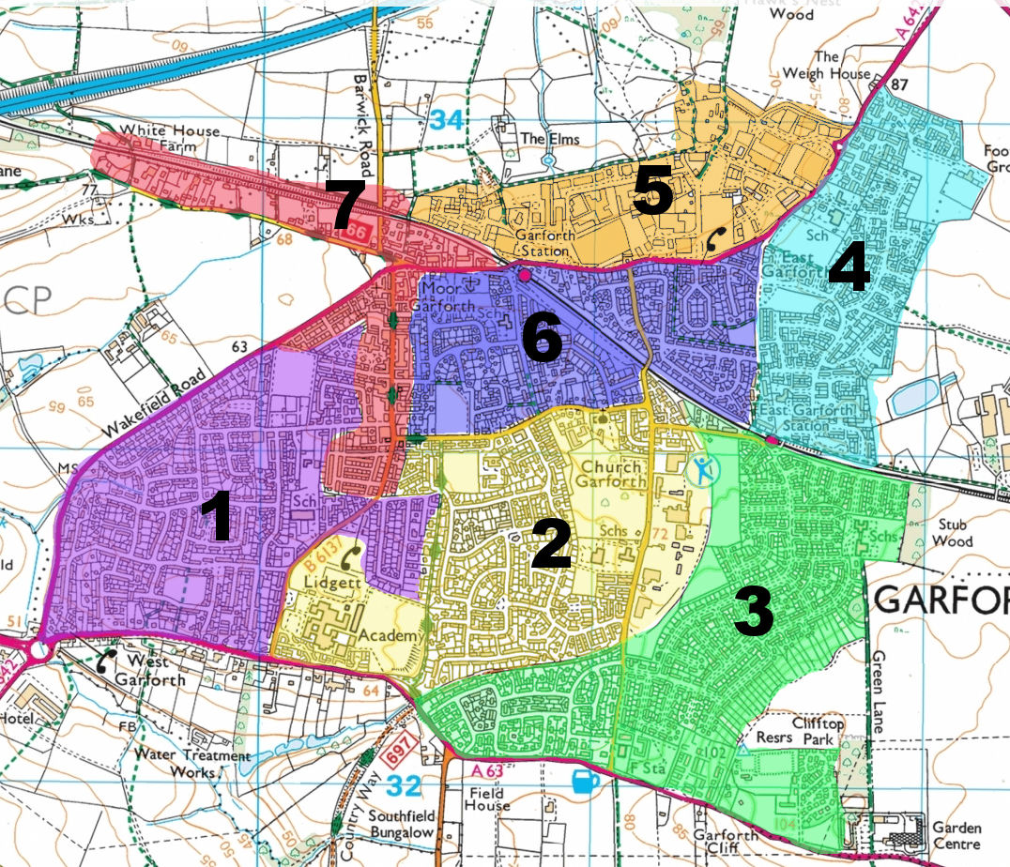
- Area 1 West Garforth
- Area 2 Church Garforth
- Area 3 Long Meadows Estate and Wimpy Estate
- Area 4 East Garforth
- Area 5 Lotherton Industrial Estate
- Area 6 Moor Garforth
- Area 7 Central Garforth- Main Street,Town End and Barrowby Lane

