GNPF Working Group

Green Space Analysis Report
May 2017

Contents

LCC Recognised Green Spaces in Garforth

Garforth Greenspace Analysis

Green Corridors

Garforth School Fields

Areas of Green Space not mentioned on the LCC website

Garforth Allotments

Garforth in Bloom Small Flower beds

The positive effects of sports and leisure activities on health and wellbeing, ESPECIALLY in children and old people.

Survey of Land Areas Around Garforth

Estimate of the agricultural Land Surrounding Garforth. July 2015 - Chris Lomas

Appendices

Greenspace comments

Housing Sites Comments

Industry Sites Comments

Are there enough green spaces in and around Garforth that you can access? If No, where would you like to see more greenspace?

Do some of the existing green spaces need improvement? If yes, please explain

Land Character Assessment

LCC Recognised Green Spaces in Garforth

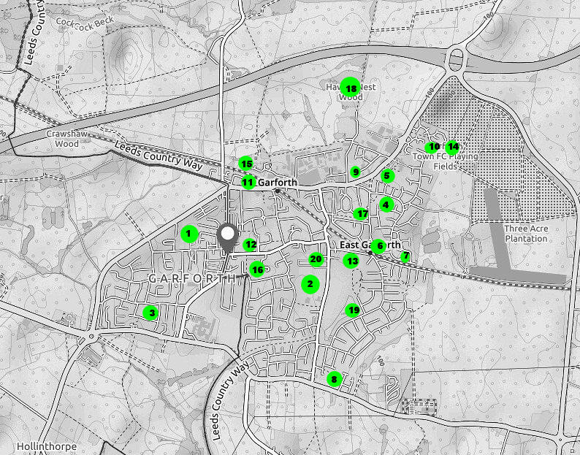
LCC ref | Site no and name | Site Location | Characteristics of site | Rating
23 | - Barleyhill Park | Between Barleyhill Rd and Wakefield Rd | 2 football fields, plus children’s play equipment, tennis, bowls, flood relief, amenity greenspace. Many houses in close proximity. All facilities well used | 4.0
51 | - Glebelands Recreation Ground | Ninelands Lane | Children’s play equipment, skate rink, games fields , amenity green space . Many houses in close proximity. All facilities well used | 6.3
1232 | - Goose Fields | Westbourne Avenue |  | 5.6
1015 | - Firthfields POS | Firthfields | Childrens play equipment
1487 | - East Garforth Field | Aberford Road |  | 4.7
1017 | - Inverness Road | Inverness Road |  | 5.1
1018 | - New Sturton Bus turnaround
1231 | - Long Meadows | Shaw Close |  | 5.6
1013 | - Ash Lane Pitch | Ash Lane and Aberford Road |  | 2.7
1125 | - Brierlands Lane pitches | Brierlands Lane | Cannot be accessed from East Garforth estate | 5.3
1854 | - Garforth/Swillington Bowling Green | Beaconsfield Court | Private green attached to the Country Club
1226 | - Garforth Cricket Club ground | Pinfold Lane |  | 6.4
1228 | - Green Lane Cricket Club | Green Lane |  | 6.0
1126 | - Wheatley Park Football Ground | Brierlands Lane | Main Garforth football field and appears well used with good facilities. Cannot be accessed from East Garforth estate | 8.5
1012 | - Bank Row Allotments | Off Dale Croft |  | 2.4
1227 | - Church Lane Allotments | Off Church Lane |  | 6.1
1015 | - Firthfield Allotments | Firthfields |  | 3.5
1014 | - Hawkes Nest Wood | Fly Line on Ash Lane continuation | Probable HS2 route through here | 3.7
1229 | - Kennet Lane Meadow | Fairburn Drive | Much wildlife and looks really interesting | 3.7
1041 or 48 | - St Mary’s Church and Garforth cemetery | Church Lane and Ninelands Lane | Space for new graves may be running out | 3.9

Garforth Greenspace Analysis

This analysis is based on the detail found in the LCC greenspace document for the Outer South East (Garforth and Swillington and Kippax and Methley wards). We have used their figures to determine the current greenspace in Garforth, by removing those areas of greenspace that do not fall between the M1, A63 and Ridge road in order to calculate actual greenspace in our area. We then used their standard greenspace values per 1000 people and an estimated population of 15,000 for Garforth to calculate what we should have. We were then able to calculate the shortfall.

Overall summary

The table below summarises the analysis of quantity of provision by greenspace type.
Type | Standard per 1000 | Actual | Population x standard | Shortfall
Parks and gardens | 1.00 ha | 8.471 | 15.000 | 6.529
Amenity Greenspace | 0.45 ha | 2.535 | 6.750 | 4.215
Allotments | 0.24 ha | 2.391 | 3.600 | 1.209
Natural Greenspace | 2.00 ha | 3.185 | 30.000 | 26.815
Totals |  | 16.582 | 55.350 | 38.768

Detail

The population is calculated from the ONS Population Census 2011.
Community | Population
Garforth (G&S ward – S parish-G&L P parish) | 15,000

Child population are taken from the ONS Population Census 2011 and the 2007 mid year estimates. The 2011 census figures are grouped in 5 year categories so there are accurate figures for 0 - 4, 5 – 9 and 10 – 14 year olds. The next category is 15 – 19 year olds so the 2007 mid year estimates have been used to estimate the number of 15 and 16 year olds. These estimates are broken down to individual years so the number of 11 and 12 year olds in 2007 (15 and 16 year olds in 2011) has been added to the 2011 population figures to give an estimate of children and young people by ward. This is set out below:
Community | Population aged 0 -16 years
Garforth (G&S ward – S parish-G&L P parish) | 2,805

Core Strategy policy G3 identifies the following standards for quantity of greenspace:

Greenspace type | Quantity per 1000 population
Parks and Gardens | 1 hectare
Outdoor sports provision | 1.2 hectares (excluding education provision)
Amenity greenspace | 0.45 hectares
Children and young people’s equipped play facilities | 2 facilities per 1,000 children (excluding education provision)
Allotments | 0.24 hectares
Natural Greenspace | 0.7 hectares (main urban area and major settlements, 2 ha other areas)

Quantities by types
The quantities of greenspace types compared to the Core Strategy standards are as follows.
Parks and Gardens Garforth
SITE_ID | Site No. |  | SITE_NAME | AREA_HA
51 | 2 |  | Glebelands Recreation Ground | 4.245
23 | 1 |  | Barley Hill Park | 3.161
1232 | 3 |  | Goose Fields | 1.065
 |  | Total |  | 8.471
Quantity (per thousand people) 8.471÷ 15 = .565 hectares

Conclusion - Compared against the standard of 1.0 hectares per 1000 population, Garforth falls below the recommended Core Strategy standard and so is has a deficiency in terms of the quantity of parks and gardens
Outdoor Sports Provision
Methodology
Outdoor sports facilities in educational use have been excluded as it cannot be assumed that these are available for the public to use. Golf courses and other privately owned assets have also been excluded.
There are instances where outdoor sports provision occurs within other primary typologies. We have identified these and used the Sport England Comparison Standards to extract out the size of facilities as follows:

• Playing pitch (adult) = 1.2ha

• Junior pitch = 0.5ha

• Bowling green = 0.14ha

• Tennis court = 0.0742

• Cricket pitch = 1.37ha

• Synthetic turf pitch = 0.7ha

Outdoor Sports Provision Garforth
SITE_ID | Site No | SITE_NAME
1124 | 14 | Wheatley Park Football Ground
1125 | 10 | Brierlands Lane Pitches
51 | 2 | Glebelands Recreation Ground
23 | 1 | Barley Hill Park
1015 | 4 | Firthfields POS
1854 | 11 | Garforth and Swillington Bowling Club
1013 | 9 | Ash Lane Pitch
1228 | 13 | Green Lane Cricket Club
1232 | 3 | Goose Fields

The quantity of outdoor sports provision on the above sites is as follows:

Type | No. | Area (ha)
Adult Pitches | 7 | 8.4
Junior Pitches | 8 | 4.0
Cricket Pitches | 1 | 1.37
Tennis Courts | 2 | 0.1484
Bowling Green | 3 | 0.42
Synthetic Pitches | 0 | 0
Total |  |  | 14.34
Quantity (per thousand people) 14.34÷ 15 = .956 hectares

Conclusion - Compared against the standard of 1.2 hectares per 1000 population, Garforth falls below the recommended Core Strategy standard and so is has a deficiency in terms of the quantity of outdoor sports provision.

Amenity Greenspace Garforth
SITE_ID | Site No | SITE_NAME |  | AREA_HA
1017 | 6 | Inverness Road POS |  | 0.347
1018 | 7 | New Sturton Bus Turnaround POS |  | 0.249
1231 | 8 | Long Meadows |  | 1.204
1487 | 5 | East Garforth Field |  | 0.737
 |  |  | Total | 2.535
Quantity (per thousand people) 2.535 ÷ 15 = 0.169 hectares

Conclusions - Compared against the standard of 0.45 hectares per 1000 population, Garforth falls below the recommended Core Strategy standard and so has deficiency in provision in terms of the quantity of amenity greenspace.
Childrens & Young Peoples Equipped Play Facilities Garforth

SITE_ID | Site No | SITE_NAME
51 | 2 | Glebelands Recreation Ground
23 | 1 | Barley Hill Park
1015 | 4 | Firthfields POS
Type of Facility |  |  | Number
MUGA |  |  | 0
Child Play Area |  |  | 3
Skate Park |  |  | 1
Teen Shelter |  |  | 0
TOTAL |  |  | 4

Quantity (per thousand children) 4 ÷ 2.8 = 1.43
Based on the recommended Core Strategy standard there is an under provision in Garforth.
Allotments:

Allotments Garforth

SITE_ID | Site No | SITE_NAME |  | AREA_HA
1016 | 17 | Firthfields Allotments |  | 0.557
1012 | 15 | Bank Row Allotments |  | 0.401
1227 | 16 | Church Lane Allotments |  | 1.433
 |  |  | Total | 2.391
Quantity (per thousand people) 2.391 ÷ 15 = 0..159 hectares

Compared against the standard of 0.24 hectares per 1000 population, Garforth falls short of the recommended standard and so has under provision in terms of the quantity of allotments.

Natural Greenspace Garforth
SITE_ID | Site No | SITE_NAME |  | AREA_HA
1014 | 18 | Hawkes Nest Wood Garforth HS2 |  | 5.634
1229 | 19 | Kennet Lane Meadows |  | 3.185
 |  |  | Total | 3.185

Have excluded Hawks Nest Wood as it is on the route of HS2 and will therefore be bulldozed flat at some point in the next 15 years

Quantity (per thousand people) 3.185 ÷ 15 = 0.21 hectares

Conclusions - Compared against the standard of 2 hectares per 1000 population, Garforth significantly falls short of the recommended standard and so has under provision in terms of the quantity of natural greenspace.

ACCESSIBILITY OF GREENSPACE

Core Strategy Policy G3 identifies the following standards for accessibility of greenspace. Each type of greenspace should be within the distance specified.
Greenspace type | Accessibility distance
Parks and Gardens | 720m
Outdoor sports provision | Tennis courts – 720m  Bowling greens and grass playing pitches – 3.2km  Athletics tracks and synthetic pitches – 6.4km
Amenity greenspace | 480m
Children and young people’s equipped play facilities | 720m
Allotments | 960m
Natural Greenspace | 720m

Green Corridors

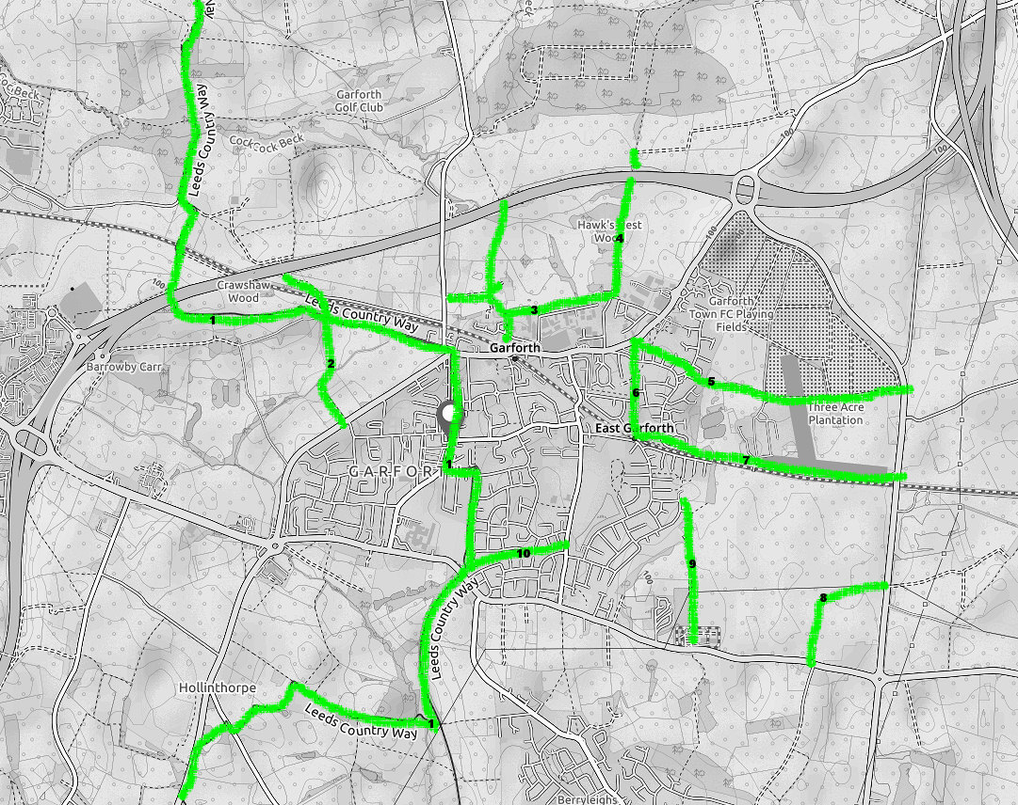
- Leeds Country Way which comes into Garforth along Barrowby Lane and down Main Street, left into Church Lane turning right past the allotments heading south to join the Lines Way and pass under the A63
- Path from the M1 motorway past White House farm and crossing the level crossing and Barrowby Lane/ Leeds Country way heading south behind Clear View Farm to the A642/ Wakefield Road
- Path leading east from Barwick Road north of the railway line, close to The Elms, then parallel to Lotharton Way and behind the industrial estate. PLUS two spurs heading north from this corridor to converge at a tunnel under the M1. PLUS various other paths heading south, one to emerge behind Tesco and another to pass in front of Sisters Villas to cross the railway line to then to the A642
- Path from the bottom of Ash Lane turning north along the old railway line, the Fly Line, up to Hawkes Nest Wood to pass under the M1 motorway
- Path from the A642 Aberford Road near East Garforth Primary School due east across Makin's land to the A654 Ridge Rd. This corridor forks to provide two paths to the Ridge Road passing each side to Three Acre plantation
- From East Garforth Station north through to the A642
- Path from East Garforth Station passing east to the Ridge road travelling parallel and close to the railway line during the whole length along the southern boundary of 1232A
- From A63 Peckfield Bar north east across 1232b to meet the A656 Ridge Road
- Green Lane from Severn Drive (near the primary school) down to Winfields Outdoors centre across the A63 and on to Kippax
- Path from Ninelands Lane south along the Lines Way to join the Leeds Country Way close to the A63

Garforth School Fields

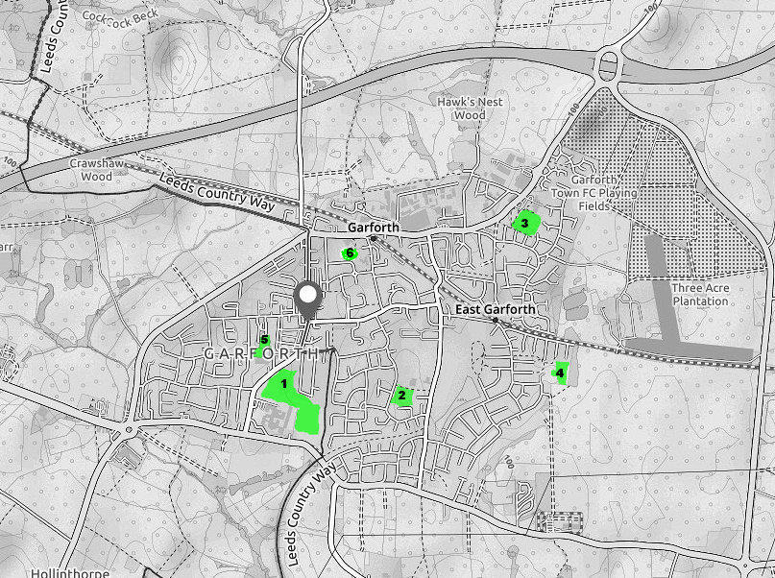
LCC Ref | Site name | Site Location | Green Space in Ha
1569 | 1 Garforth Academy | Lidgett Lane | 8.65
1570 | 2 Ninelands Infant and Junior School | Ninelands Lane | 1.56
1572 | 3 East Garforth Primary Academy | Aberford Road | 1.94
1571 | 4 Green Lane Primary Academy | Ribblesdale Avenue | 1.41
1568 | 5 Strawberry Fields | Lidgett Lane | 1.21
1579 | 6 St Benedict Roman Catholic Primary |  | 0.72

Areas of Green Space not mentioned on the LCC website

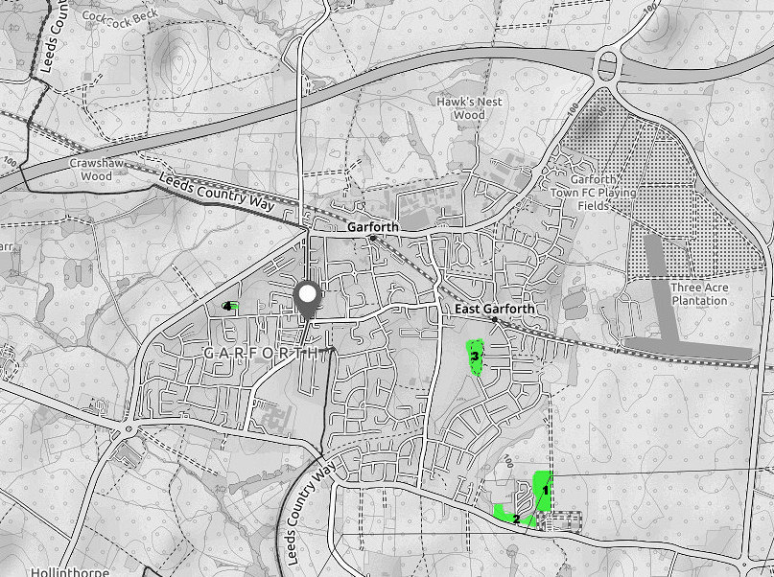
Site | Place in Garforth | Comment | Approx .  Area in  Ha
- Area of ex quarry workings now covered in scrub woodland | By Winfield’s Outdoors clothing shop bounded by Green Lane and Cliff Park homes. | Ideal for a creative outdoor pursuits area qv Emma Grumwell proposal. | ca. 2 .0
- Two plots of pasture land close to Cliff Park | Fronting on to the A63 either side of Newfield Cres | Fair farm land and good as a smallholding but small to be commercial. | 3.0
- Area between Green Lane Cricket field and Kennet Lane meadow |  |  | Ca 0.5
- Small plot on Queensway off Barley Hill Road | Small plot on Queensway off Barley Hill Road | Not very significant but good for the houses fronting on to it | 0.2

Garforth Allotments
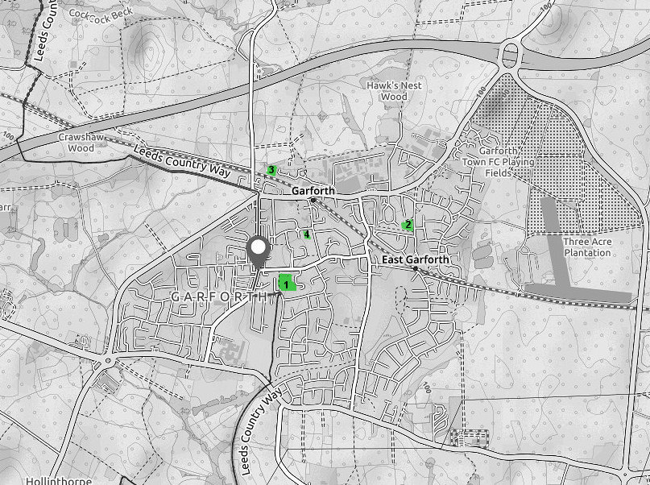

Introduction
Garforth has four Allotment sites divided into differing numbers of plots. The sites, areas and numbers of plots are as follows:
Allotment Sites
- Church Lane - Situated between Church Lane and Grange Avenue the overall area is 1.433 ha (LCC figure) with 1.32 ha. divided into 82 plots shown in the Table:

- Firthfields/East Garforth - Situated to the between Firthfields and Meadow Road the overall area is 0.557 ha. (LCC figure) with 0.485 ha. divided as shown in the Table.

- Bank Row - Situated adjacent to and north of the Leeds – York railway line close to Higham Way. The area measured by LCC is 0.401 ha divided into 13 plots as shown below

- Oak Estate - Situated behind the houses on Station Fields and accessed down Oak Drive. Leeds City Council does not mention this allotment in its greenspace inventory so the figure of 0.1 ha is accepted as accurate.

The total area devoted to allotments is therefore 2.49 ha. This amount is discussed further below.

Table 1: Sizes of Garden Plots in each of the Four Allotments
Plot Sizes in Sq Metres | Bank Row Allotment | Church Lane Allotments | Firthfields  Allotments | Oak Estate Allotments | TOTAL
84 |  | 2 |  |  | 2
100 |  | 4 |  |  | 4
125 |  | 47 | 13 |  | 60
151 | 1 | 3 |  |  | 4
167 | 1 | 6 |  | 6 | 13
188 | 8 |  |  |  | 8
209 |  |  | 1 |  | 1
250 |  | 21 | 12 |  | 33
376 | 3 |  |  |  | 3
TOTALS | 13 | 83 | 26 | 6 | 128

Observations from the Allotment Co-ordinators
1 The plots are reported to be overwhelmingly well managed and used. They are rented from Leeds City Council at rents generally considered fair by the holders. From October2016 the annual rental price of a 250 m² plot is £65 and the rent of different sized plots is adjusted pro rata. Thus the rental price together with fairly gentle pressure from the Association provides incentives for the individual plots to be well used. The Chair of Allotments Association keeps an oversight of all the sites. All allotment holders are members of the Garforth Allotments and Home Gardens Association
2 There is currently a stable situation where the supply of plots is roughly in balance with the demand. All the plots are currently occupied but with no immediate vacancies and a waiting list of only two or three which they hope to accommodate within the next few months. However in recent years there has been an occasional shortages of plots for the numbers of people applying for them. The Association is currently planning a publicity campaign to show their wares to the public but are nervous of stimulating a demand for plots which they are not in a position to provide. Maybe there are prospective plot holders in Garforth who don’t know about how the system works or that applying for one is comparatively easy.
3 All the plots are allocated to people actually living in Garforth or had a very close connection with the town at the time of allocation. At the time of allocation plot holders agree to maintain their plots and to plant at least 60% of their area to food crops for home and family consumption. The rest of the plot can then be used to house a shed and/or greenhouse, water butts and compost bins. It also allows for pathways and the growing of non-edible crops such as flowers.

4 The question of proximity of particular allotments to the holders’ houses is not considered relevant. Applications for plots are considered centrally by the Chair of the Allotment Association and applicants are generally happy to accept a vacancy on any of the four sites.

5 Piped water is available from the beginning of April until the end of September at Church Lane, Firthfields and Bank Row but not at Oak Estate. A small charge is added to the yearly rent for water as well a small additional charge to join the Garforth Allotments and Home Gardens Association and a charge to cover public liability insurance.

6 The distribution hut is run by the Garforth Allotments and Home Gardens Association and is open 10.30 to 12 noon on Saturdays. It sells a wide range of gardening products for use on the allotment or in the garden. These include compost, weed killer, seeds and many other products. By joining the Association for the year (membership is currently £4), this also gives people 10% discount to use at various nurseries and garden centres including Lumby, Woodend in Great Preston, Rothwell and Oulton.

7 The Association is conscious of the LCC’s promise to provide 0.24 ha per 1000 population which with an estimated current population of 15,000 should provide 3.6 ha of allotment land. The current allocation of 2.49 ha indicates a shortfall of 1.1 ha. The possible (likely?) population increase would need a corresponding increase in 0.24 ha of land allocated to allotments for every extra 1,000 increase in population size.

Chris Lomas
8th March 2017

We are grateful to Mrs Ruth Dorgan and Mr Walt Treloar the Chair and Administrator respectively of Garforth Allotment Association for providing information concerning Garforth Allotments. Mr Peter Harrison the Site Manager of Church Lane Allotments also kindly provided information and showed me round those allotments.

Garforth in Bloom Small Flower beds

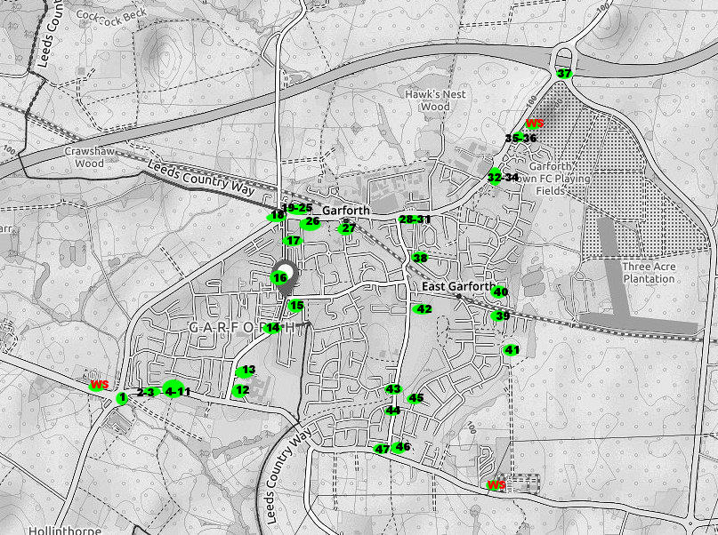

Number | Garforth in Bloom site number | Position
1 | 33 | Beside Miller & Carter pub
2 | 10 | Along Selby Road
3 | 11 | Along Selby Road
4 | 1 | Outside the Gaping Goose
5 | 2 | Outside the Gaping Goose
6 | 3 | Outside the Gaping Goose
7 | 4 | Outside the Gaping Goose
8 | 5 | Outside the Gaping Goose
9 | 6 | Outside the Gaping Goose
10 | 7 | Outside the Gaping Goose
11 | 8 | Outside the Gaping Goose
12 | 32 | On Lidgett Lane near Scholars Gate entrance
13 | 9 | Further along Lidgett Lane
14 | 31 | Lidgett Lane opposite Lowther Drive
15 | 30 | Main Street nr the library
16 | 64 | Large bed on Marshall St
17 | 36 | Main St Chapel Close entrance
18 | 40 | Bed at Town End
19 | 66 | Bed at Town End
20 | 67 | Bed at Town End
21 | 68 | Bed at Town End
22 | 70 | Bed at Town End
23 | 37 | Bed at Town End
24 | 38 | Bed at Town End
25 | 39 | Bed at Town End
26 | 27 | Jubilee Gardens Outside the Lord Gascoine pub
27 | 29 | Station Fields outside the railway station
28 | ? | Aberford Rd past Bar Lane turning
29 | 20 | Aberford Rd past Bar Lane turning
30 | 19 | Aberford Rd past Bar Lane turning
31 | ? | Aberford Rd past Bar Lane turning
32 | 22 | Bed at Brierlands
33 | 23 | Bed at Brierlands
34 | 24 | Bed at Brierlands
35 | 25 | Bed at Cedar Ridge
36 | 26 | Bed at Cedar Ridge
37 | ? | On the roundabout for Junction 47 of the M1
38 | 14 | Montague Crescent
39 | 98 | Woodlands Drive
40 | 28 | Ludlow Avenue
41 | 35 | Green Lane Academy
42 | 17 | Beside the Squash Club on Ninelands Lane
43 | 15 | NinelandsLane/Derwent Avenue
44 | 16 | Ninelands La. beginning of The Lines Way* i.e.the old railway line
45 | 34 | Fairburn Drive
46 | 13 | Garforth Firestation
47 | 12 | Near Crusader pub

The positive effects of sports and leisure activities on health and wellbeing, ESPECIALLY in children and old people.

Section 1

1.0 Introduction
This report attempts to identify the positive effects of sports and leisure activities on health and wellbeing. It is assumed that it mainly relates to areas of greenspace but it also includes general sport and leisure activities in non-greenspace areas.
The town of Garforth contains greenspace within the village perimeter which serves mainly community needs. It is also surrounded by greenspace which is also termed greenbelt. The greenbelt area has a primary (and very productive) rôle in food production and the provision of habitat for wildlife and also provides many benefits for nearby urban dwellers.
As well as a brief introduction this section identifies a number of websites which provide empirical evidence concerning the positive effects of sports and leisure on health and wellbeing. It also attempts a brief précis of the relevant points made in each of those websites.
Section 2 lists the specific types of greenbelt in Garforth (as defined by the Leeds City Council) and then summarises in bullet points the positive effects of sports and leisure activities particularly among children and old people.

The message that regular exercise, sports and leisure activities especially outdoors in the fresh air are good for one’s health and wellbeing particularly in greenspace areas is asserted by many sources. These sources include both national and local governments, the press, and general medical opinion and is therefore written in a large number of documents. Such documents range from mere commentary from various experts to specific peer reviewed scientific evidence. This document attempts to locate authoritative data relating to West Yorkshire particularly and also including written material relating to the whole of the UK as well as the world at large.
Because Garforth is a part of Leeds the first reference cited is Leeds University’s “Brief Guide to the benefits of Urban Green Spaces” produced in cooperation with LEAF (The Leeds Ecosystem, Environment Atmosphere and Forest Centre) and others. The hyperlink (or cut and paste in google) to this paper is:
http://leaf.leeds.ac.uk/wpcontent/uploads/2015/10/LEAF_benefits_of_urban_green_space_2015_upd.pdf
The report quotes 88 other references – many of them primary and drawing on its own research to list and explain greenspace benefits in the six broad areas which are:
- health and wellbeing;
- temperature and climate change;
- air quality;
- flooding and water quality;
- wildlife and habitats
- economic impacts.

The main specific benefits include:
- Improved physical fitness
- Reduced depression
- Improved air quality
- Limit the impact of heat waves by reducing air temperature
- Urban vegetation stores carbon
- Helps mitigate climate change
- Reduces the likelihood of flooding by storing excess rainwater

The other major local reference concerning Garforth is the Leeds City Council website:
http://www.leeds.gov.uk/docs/Small%20PGS%20strategy%5B2%5D.pdf
and is entitled “A Parks and Green Space Strategy for Leeds”. The Council recognises the wide range of benefits plus the wide public attraction for greenspace and exercise generally so their promotion has much political support. Their link draws on work by CABE (The Commission for Architecture and built Environment) which lists empirical evidence that green spaces can offer lasting economic, social, cultural and environmental benefits. Also how quality parks can influence behaviour. This document also recognises the importance of and benefits of greenbelt land.

The LCC website above promotes green space and undertakes to enhance and expand particular items where there is a demonstrated public demand. From the report this demand is clear though actual scientific evidence of the benefits is not often cited. (See pages 36 and 37 for a few exceptions) and this reference also provides plentiful assertion of the health and welfare benefits of greenspace.

There is evidence that the beneficial effects of greenspace varies positively according to the distance between to one’s house and greenspace. This is documented in a number of academic papers the following being reasonably persuasive.
https://academic.oup.com/jpubhealth/article/33/2/212/1585136/The-health-benefits-of-urban-green-spaces-a-review

http://www.sciencedirect.com/science/article/pii/S0169204607000503
https://www.google.co.uk/#q=relationship+between+health+benefits+and+green+space+proximity+in+urban+areas&*&spf=1
Apart from Yorkshire references there are many written by national and international institutions a few of which have been chosen below for particular emphasis. Firstly from the World Health Organisation.
http://www.salzburgglobal.org/fileadmin/user_upload/Documents/2010-2019/2017/Session_574/Urban-green-spaces-and-health-review-evidence.pdf
The above World Health Organisation Document “Urban green spaces and health. A Review of evidence” summarises the available evidence of the beneficial effects of urban greenspace to affect a range of medical conditions. This 92 page document has a comprehensive take on the scientific proof of the benefits of urban greenspace.
Links between green space and health have been recognized throughout history, and
were one of the driving forces behind the urban parks movement of the 19th century in Europe and North America (Schuyler, 1988).

Morris et al., (2006) note that new research techniques provide opportunities to study the mechanisms behind associations between green space and health with increasing sophistication and helps to satisfy contemporary scientific standards of evidence demanded to inform policy and practice.

This refined understanding of the health promotion potential of urban green spaces can contribute to addressing major public health issues related to non-communicable diseases. Across Europe and beyond, preventable non-communicable diseases, such as mental illness, obesity, cardiovascular diseases, type 2 diabetes and cancer, remain major factors not only affecting health and well‐being, but also driving up the cost of health care and reducing the productivity of the workforce. Many such illnesses are linked to chronic stress and lifestyle factors, such as insufficient physical activity (Shortt et al., 2014). Urban green spaces, as part of a wider environmental context, potentially preventing health problems which is clearly a more efficient approach than simply dealing the consequences of ill health when that occurs.

Epidemiological studies have used a multitude of approaches to measure the effects of urban green space availability and accessibility on the health outcomes of study participants. Given the potential of urban green spaces to act as settings for health promotion it is therefore necessary to summarize the existing evidence identifying, where possible, the underlying mechanisms contributing to both the negative and positive health outcomes of urban green space

Section 2.1 provides scientific definitions of Urban greenspace including a pan European definition

Section 2.4 gives examples of potential pathogenic effect of green spaces on health. The evidence of adverse effects of urban green space or neighbourhood greenery on health is scarce in comparison to the evidence of beneficial effects. An overview of some of these detrimental effects and their mechanisms is provided by Lõhmus & Balbus, (2 015). These include several items such as encouraging allergies and concentrating pollution.
WE MAYBE NEED TO LEAVE THIS OUT SINCE WE ARE ONLY LOOKING FOR BENEFITS
The British National Health Service (NHS) is concerned with preventing as well as curing illnesses. As budgets become ever more constrained the benefits of disease prevention over cure will require ever more emphasis The NHS website:
www.nhs.uk/Livewell/fitness/Pages/Whybeactive.aspx points to exercise particularly reducing the risk of major illnesses such as heart disease, stroke, type 2 diabetes and cancer by up to 50%. It can reportedly lower the risks of early death by up to 30%. This website cites the benefits of exercise specifically to four particular demographic groups
- early childhood (under five years old)
- young people (five to 18 years old)
- adults (19 to 64 years old)
- older adults (65 and over)

of which group 2 and 4 (both hyperlinked) are the most appropriate for this document and are discussed specifically (sections 2.0 and 3.0) later.

The organisation Science Direct copies the abstract of an article in The Journal of Experimental Psychology (June 2010)
http://www.sciencedirect.com/science/article/pii/S0272494409000838
The article is entitled “The vitalizing effects of being outdoors and in nature” by Richard Ryan et al. :

Richard M. Ryan^{a, ,} ,
- Netta Weinstein^{e},
- Jessey Bernstein^{b},
- Kirk Warren Brown^{c},
- Louis Mistrettaª,
- Marylène Gagné^{d}

It summarises five studies utilising various scientific methods to assess the subjective effects of being outdoors on subjective vitality. Their results indicate (it seems to me) that being outdoors in a natural environment improves physical and social interaction among groups of people. The internet link is not specific as to the ages of the subjects studied but intuitively it is young people who would benefit most and so are described specifically below.

2.0 Children and Young People (5 to 18 years old)
As stated above the UK NHS provides specific consideration of the scientific evidence of the benefits of green space for young people the NHS link
http://www.nhs.uk/Livewell/fitness/Pages/physical-activity-guidelines-for-young-people.aspx
provides guidance on how young people can stay healthy or improve health.as a result of physical activity. The website emphasises the benefits of physical activity in general. However many of the sporting activities (e.g. football, rugby, cricket, distance running, cyclo cross etc.) generally require green areas in order to carry them out. The website does not provide scientific evidence for its assertions but comes from a well-respected organisation thus providing credibility.

The Royal Society for the Protection of Birds (RSPB) enters the discussion with its report “Every Child Outdoors” which lauds the benefits of being outdoors. The hyperlink:

https://www.rspb.org.uk/Images/everychildoutdoors_tcm9-259689.pdf
draws on 22 references (of varying scientific rigour admittedly) which show how over the last decade, a large amount of research has been carried out into the diverse benefits for children of contact with nature and outdoor experiences. These benefits include positive impacts on the following:
- education,
- physical health,
- emotional wellbeing
- personal and social skills, including their development as responsible citizens.
Some of the key RSPB conclusions regarding greenspace benefits for children include::

EDUCATION – “First-hand experiences from being outdoors can make an important contribution to pupils’ future economic wellbeing and preparing them for the next stage
of their lives.” (Ofsted, 2008):

HEALTH AND WELLBEING – “Children increase their physical activity levels when outdoors and are attracted to nature… All children with ADHD [Attention Deficit
Hyperactivity Disorder] may benefit from more time in contact with nature. (Bird, 2007)

ADHD is a significant public health problem affecting from 5 to 10 % of children in the UK. Outdoor activities in nature appear to improve symptoms of attention deficit hyper activity disorder (ADHD) in children by 30% compared with urban outdoor activities and three fold compared with the indoor environment
The estimated total cost of mental health problems of children and young people in England apparently runs into millions of pounds annually. There has been a steady increase in medication in childhood mental illness with more than 40,000 children apparently now taking anti-depressants on a regular basis. The implication in the report is that exercise and participation in sporting activities would drastically reduce the numbers of young people suffering mental illnesses such as depression.

PERSONAL AND SOCIAL SKILLS – “Experience of the outdoors and wild adventure space has the potential to confer a wide range of benefits on young people. Development of a positive self-image, confidence in one’s abilities and experience of dealing with uncertainty can be important in helping young people face the wider world and develop enhanced social skills.” (Ward Thompson et al, 2006)

The findings are presented according to the separate areas of benefit shown above, but there is a great deal of overlap between these areas and the benefits reinforce and catalyse each other. This not only highlights the extent of the positive impacts on children and young people that contact with exercise and nature can have, but also the broader effects these impacts have on schools, communities and society as a whole.

Dr Ahmed Djoghlaf, Executive Secretary of the United Nations Convention on Biological Diversity notes that children’s knowledge of biodiversity is in decline at a time when we need future generations to be more engaged and aware in order to halt its loss. There is a very real need to educate our children as the future guardians of our planet, to provide them with the knowledge they need today to preserve the natural world for tomorrow.

According to Professor David W. Orr, Environmental Studies and Politics at Oberlin College, Ohio considers “Children’s view of nature to be increasingly distant, abstract, and utilitarian. However affluent, their lives are impoverished by diminishing contact with nature. Their imaginations, simulated by television and computers, are being impoverished ecologically, socially, and spiritually.”

Research by the Forest School linked at
http://www.forestschooltraining.co.uk/forest-school/the-benefits/
Supports practioners’ views that children and young people are stimulated by the outdoors and typically experience over time increase in their self-belief, confidence and learning capacity, enthusiasm problem solving skills and emotional wellbeing.

The organisation Environmental Health Perspectives at
https://ehp.niehs.nih.gov/1308038/ writing December 2014 evaluated the risks and benefits of greenspaces for children and working mainly with children aged 9 to 12 years. They concluded that residential proximity (defined as living within 300 metres of a forest or park) resulted in a lower prevalence of obesity or overweightness.

Other benefits of participating in sports for children and young people include:
- Improvement in general health keeping away colds and seasonal illnesses.
- Better levels of immediate fitness as well as long term benefits in warding off obesity and diabetes in later life.
- Competitive sports can help children to relate well to their peers fostering friendships and relationships
- Community benefits in saving on medical bills for long term/chronic illnesses
- International success in sporting participation comes from children having sporting opportunities at an early age

In an article by Rubab G. Arim, Leanne C. Findlay, and Dafna E. Kohen there is evidence from Canada that children with Neurodevelopmental Disorders can be helped by Participation in Physical Activity

Apart from the health aspects outdoor sports help team building skills can be built up as well as learning to win and lose graciously (Think that is a Lomas thought and I didn’t find a reference for it.

3.0 Benefits for old people in Exercise and Green Space leisure activities
The NHS hyperlink above and repeated here
- older adults (65 and over)
provides a guideline for older adults aged 65 and over. Using a 2nd hyperlink on the NHS website the Department of Health infographic (PDF, 500kb). Working on total population studies this website gives a quantitative summary of specific reductions of geriatric illnesses benefits of physical activity for middle aged and older adults as follows:
40% reduction in Type II diabetes
35% reduction in cardio vascular disease
30% reduction in falls, depression and dementia
25% reduction in joint and back pain
20% reduction in cancer (colon and breast)

The website http://www.tandfonline.com/doi/abs/10.1300/J081v19n03_09 has an article by
Takemi Sugiyama and Catharine Ward Thompson titled Environmental Support for Outdoor Activities and Older People’s Quality of Life

This article demonstrates that the outdoor environment provides older people with opportunities to be active, have contact with nature and meet friends and neighbours. Research has shown that such outdoor activities have substantial benefits for older people’s well-being. However, going outdoors is often difficult for them due to increasing frailty and environmental barriers. This study argues that a neighbourhood environment facilitating older people’s outdoor activities has a positive effect on their well-being. Small-scale studies were conducted to explore the concept

The WHO report referred to in general terms above and hyperlinked again here
http://www.salzburgglobal.org/fileadmin/user_upload/Documents/2010-2019/2017/Session_574/Urban-green-spaces-and-health-review-evidence.pdf

also emphasises the positive relationships between the amount of greenspace and self‐reported health in senior adults and this was demonstrated in the Netherlands (de Vries et al., 2003).
Toussaint et al. (2015) explored the role of green spaces in sleep deficiency and found a stronger protective effect for people aged 65 and older, compared to younger adults

Sedentary behaviour is an important health hazard in older adults, who are often the most sedentary segment of society. A recent systematic review found that when measured objectively 67% of adults aged 60 years and over spent more than 8.5 hours of their waking day sedentary (Harvey et al., 2013). Evidence of beneficial effects of green spaces on physical activity in individuals aged 60 years or older is summarized by Broekhuizen et al. (2013). Older adults living in inner‐city neighbourhoods also benefit from the presence and use of green spaces, which appears to promote social ties and a sense of community (Kweon et al., 1998). Social contact is known to be important for health and well‐ being, especially for older people, where social isolation has been significantly associated with increased mortality (Steptoe et al., 2013).

Can dog ownership prove good for the health of older people? The need to exercise dogs can get such people walking themselves and can also help them form social relationships by making friends with other dog owners. Again this is not only good for their health but can save public funds on medical intervention. (Lomas again didn’t see a reference!)

The benefits of outdoor exercise are confirmed again by the Science Daily website already mentioned in general terms above

https://www.sciencedaily.com/releases/2011/02/110204130607.htm

The senior author of the study, Professor Michael Depledge, Chair of Environment and Human Health at the University of Exeter Medical School. Shows how older people can be re-connected with nature via specific exercise programmes (Green Gym and Blue Gym)

The website https://ijbnpa.biomedcentral.com/articles/10.1186/1479-5868-9-89 discusses how older people’s health can sometimes be impaired by a low level of Vitamin D. J Kerr –(‎2012) – shows how going outdoors can have long term health benefits for those older adults who have Vitamin D deficiency.

The website: http://overlook-mass.org/7-benefits-of-being-outdoors-for-seniors/
defines seven benefits of being outdoors for seniors. Although not specifically referenced to academic research and forming part of an assisted living sales pitch in the USA the seven benefits are worth relating to complete this study:
i lifts your spirits
ii improves your sleep
iii strengthens your immune function
iv keeps your vitamin D level healthy
v gives your energy a jolt
vi boosts overall health and helps recovery from surgery
vii enhances relationships

Perhaps finally it is worth mentioning a more objective and respected organisation the Harvard University medical school:
www.health.harvard.edu/press_releases/spending-time-outdoors-is-good-for-you

This website cites five benefits of older adults getting outside
i Your vitamin D levels rise. Sunlight hitting the skin begins a process that leads to the creation and activation of vitamin D. Studies suggest that this vitamin helps fight certain conditions, from osteoporosis and cancer to depression and heart attacks. Limited sun exposure (don't overdo it), supplemented with vitamin D pills if necessary, is a good regimen.
ii You’ll get more exercise. Physical activity helps people to relax and cheer up.
iii You’ll be happier especially if the outdoors is green. Light elevates people’s moods
iv Your concentration will improve q.v the ADHD discussion above
v You may heal faster cites University of Pittsburgh research working on patients who had recently undergone spinal surgery.

Section Two

Examples of Green Space - Publically and Privately Owned
- Parks and gardens
- Outdoor sports provision
- Amenity greenspace excludes cemeteries
- Cemeteries
- Children’s and Young Peoples equipped play facilities
- Allotments
- Natural Greenspace
- Green Corridors
- The green belt surrounding much of Garforth is largely on productive fertile land
http://www.leeds.gov.uk/docs/Small%20PGS%20strategy%5B2%5D.pdf

Ascribed benefits

1 National Food Security and Public Benefits
- Garforth’s greenbelt land serves for good quality agricultural production playing major role in national food security Grades 2 and 3a
- Properly configured greenspace can help alleviate or prevent flood damage through ponding and/or drainage
- Green belt land (in some places around Garforth) provides valuable wildlife habitat and species conservation
- Greenspace can provide heat sinks which will help to alleviate high temperatures in dominant concrete surroundings.

2 General Public Health Benefits
- Generally improved health
- Improved feelings of well being
- Improved physical fitness
- Reduced depression and anxiety
- Improved mental health conditions generally
- Shown to produce levels and patterns of chemicals in the brain which are associated with low stress and positive impacts on blood pressure
- Improved performance when undertaking attention demanding tasks
- In the UK only about a third of the population achieves the recommended level of exercise and the health impact of this is estimated by the website above to have a direct economic cost in excess of 1 billion pounds per year.
- Poor air quality is a serious threat to human health causing problems for the respiratory system and cardio vascular diseases. The presence of urban vegetation results in the overall reduction of health damaging pollution.
- The Leeds Forest Strategy provides a framework for future woodland and tree planting which will help to counter pollution by removing harmful particles and carbon dioxide from the air by ‘carbon fixing’ whereby trees lock up carbon as they grow, and store it in maturity or within timber products and finally release it when the wood rots or is burnt.
- Can provide spaces for large public events and activities e.g. Temple Newsem’s Opera and Party in the Park events
- Provides opportunities for people to participate in sports and communal activities
- Introduces opportunities for training in outdoor jobs and employment

Specific benefits for young people
- Outside play often in greenspace areas can help moderate the current obesity problem many young people have
- Outdoor play helps in improving concentration and behaviour
- There is evidence that out children with ADHD benefit from time spent in contact with nature.
- Plus many of the items a to m above.

Specific benefits for older people
- Green spaces provide pleasant areas to relax and socialise promoting greater levels of social activity and stronger neighbourhood relationships. This is particularly important in maintaining a high quality of life for elderly people.
- Keeping active (particularly including active outdoors) helps maintain health and independence in older adults
- Helps problems of sleep deficiency
- Reduces the risk of illness, progression and death from:
      - coronary heart disease,
      - diabetes,
      - depression and loneliness
      - high blood pressure,
      - obesity and
      - certain cancers

Adverse effects from greenspace
- can cause or trigger allergies such as hay fever and asthma
- can concentrate pollution
- exposure to disease vectors and zoonotic infections (diseases transmitted directly from animals to humans e.g Lyme’s disease)
- excessive exposure to UK light
- vulnerability to crime eg vandalism and drug dealing.

Survey of Land Areas Around Garforth
We created a map of parcels of land surrounding Garforth and asked what each area of land should be used for – Housing, greenspace or Industry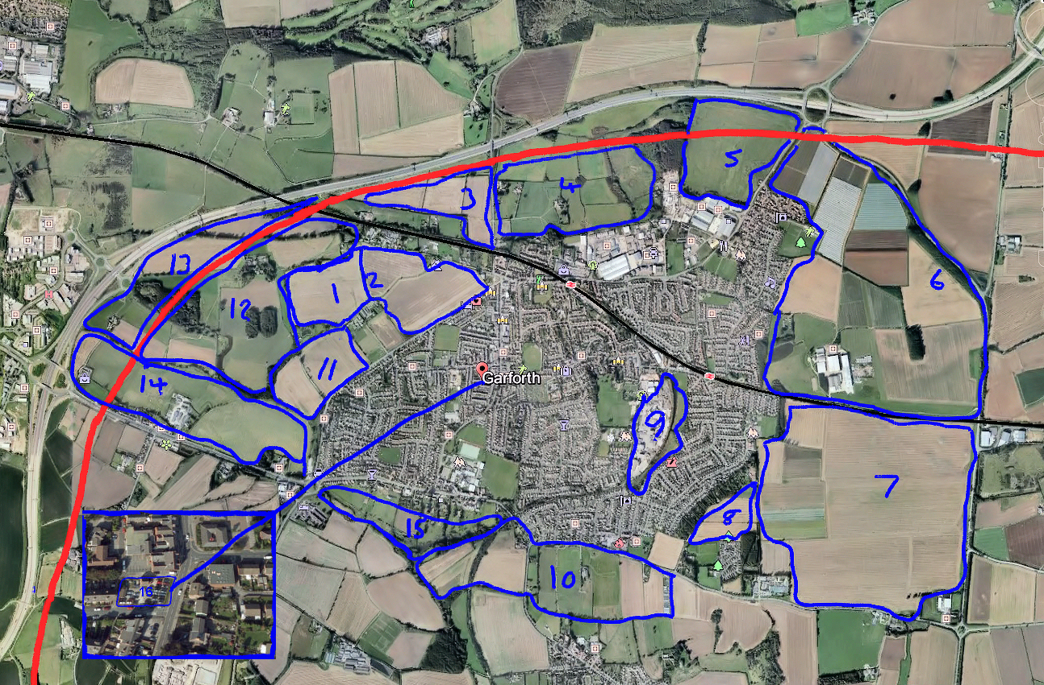
Findings
50%+ Support – The colour coding identifies what usage more than 50% of survey participants thought the land should be used for. Green = greenspace, brown = industry, shading = no overall preference, top 2 colours shown
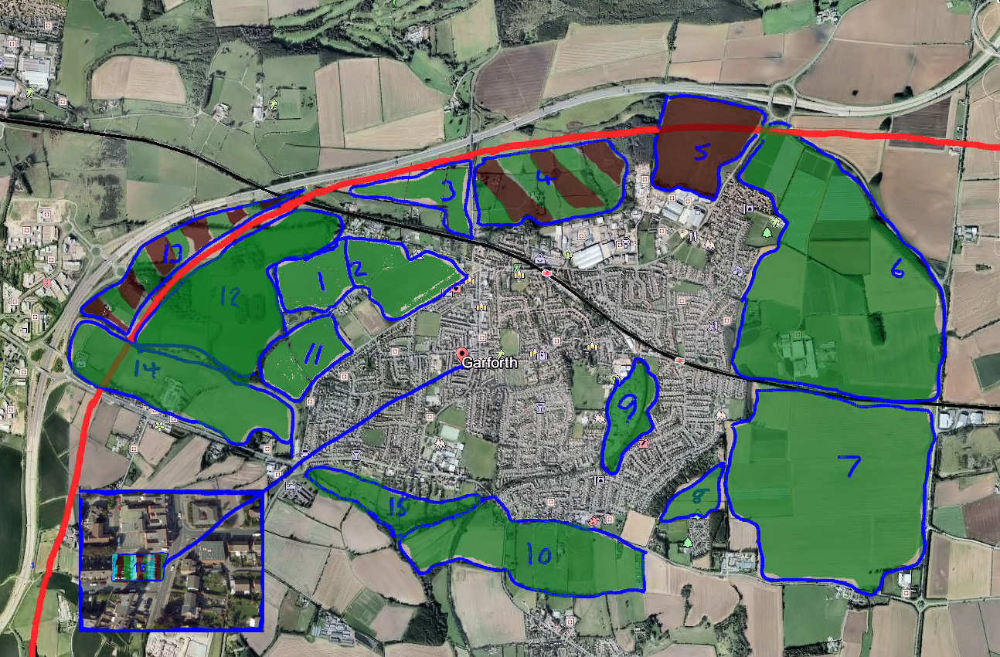

Top 5 Housing Sites – no site achieved 50% support
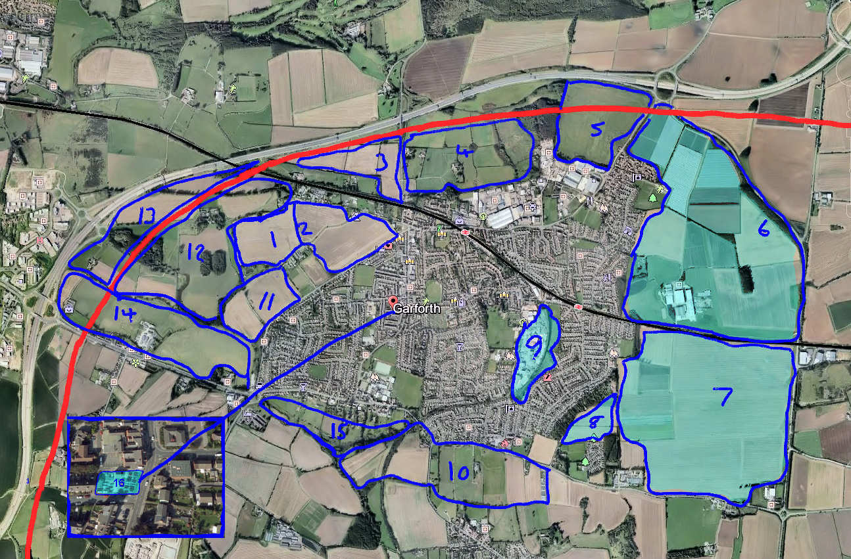

Top 5 Recreation Sites
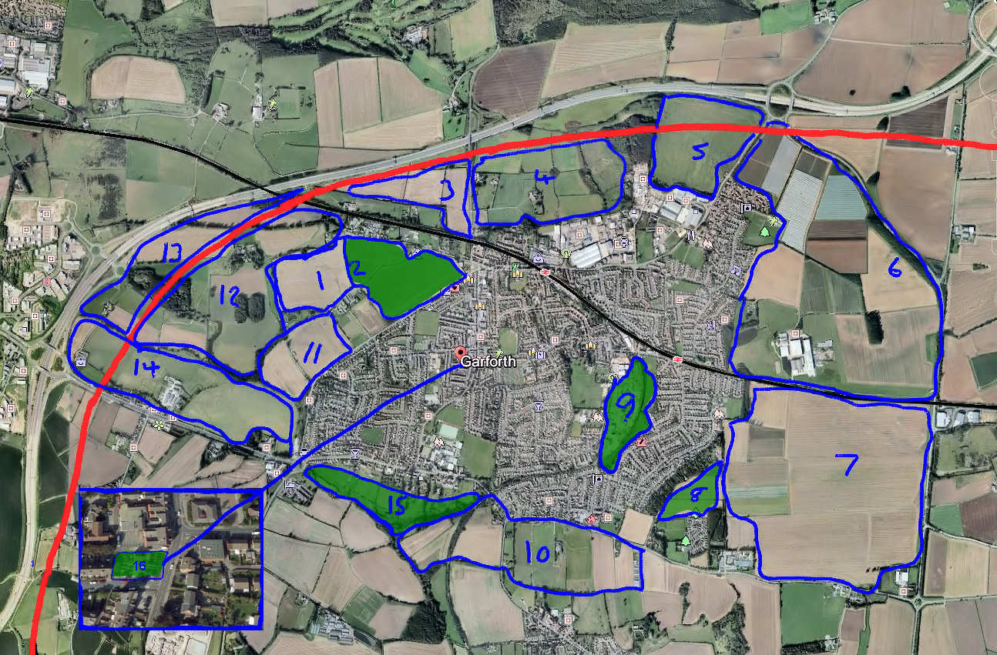

Top 5 Industry Sites
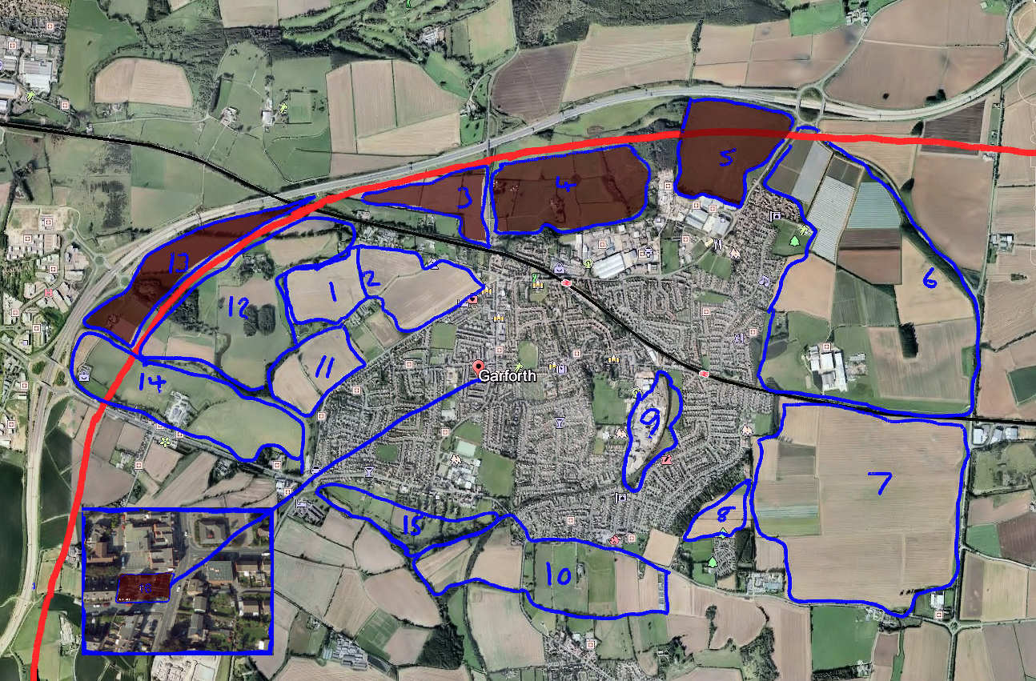

Estimate of the agricultural Land Surrounding Garforth. July 2015 - Chris Lomas

The Garforth Neighbourhood Plan will hopefully be produced and presented in the second half of 2016 or early 2017. There is pressure to include a considerable number of houses within the Garforth area together with the associated and necessary infrastructure for transport, education, health, leisure etc.
In addition the work done by the Leisure Sub-group of the Garforth Forum demonstrates a requirement to enhance the existing facilities for leisure and recreation not to mention other infrastructure requirements just to improve the living standards of the existing Garforth population.
It is clear that fulfilling the above requirements will require land and much of that will come from areas previously designated as greenbelt. Land which not only contributes to making Garforth a more pleasant place to live in but also has significant agricultural production potential.
Natural England (NE) is the official UK Government body tasked with the flowing mission statement:
“We are the Government’s adviser for the natural environment in England, helping to protect England’s nature and landscapes for people to enjoy and for the services they provide”
NE publishes maps of England indicating the agricultural potential of land with 5 categories. Grades 1 is class as excellent, Grade 2 is very good and grade 3 is good to moderate. Grade 3 is usually subdivided into Grades 3a and 3b with 3a still being considered as good quality, crop producing, arable land. The Map showing the quality of farmland around Garforth is at:
http://publications.naturalengland.org.uk/publication/130043?category=5954148537204736
Areas 6 and 7 on the16 area map above is classified as Group 2 “Very good for agricultural production”. The rest of the land surrounding Garforth is classed as Group 3 and given its proximity to the Group 2 land it is likely to be group 3i although NE is not specific about this.
The reasons for protecting farmland from development are often rehearsed. A basic food security capability is crucial to the UK not just in times of national emergency when food can be difficult to import but also in the future given to increasing difficulty of food production in warmer parts of the world if/when climate change and global warming really starts to bite.
In July 2015 I walked round the outside of Garforth and looked at the pieces of land surrounding Garforth and pinpointed on the Chris Coyle map. I tried to take a view of each piece particularly from an agricultural viewpoint. My views were as follows:
Walk round the areas demarcated by the 16 area map for Site allocation July 2015
Area Number 1: Farmland behind buildings on Wakefield Road
Visited 21st July. Good quality farmland. Nice crop of wheat. Bit slopey but not limiting
20 - 30 acres? Agricultural Land Class 2.

Area Number 2: Farmland west of Wakefield Rd. A642 up to Town end
Visited 21st July. Almost the same cropping as area 1 though bigger. Good quality farmland growing wheat. Land Class 2 and 3i

Area Number 3: Farmland west of Barwick Road
Visited 23rd July. Quite a big piece of land subdivide into 3 fields. Travelling east: the wheat field must stretch behind the houses parallel with Nanny Goat Lane and reaching Barwick Road. Only really visible from the last few yards on Nanny Goat Lane and down Barwick Rd.
Crop of wheat but not so good as the crop down Wakefield Road and is likely to be adjacent to the HS2 railway line in due course. Agricultural Land class is probably still 3i.

Area Number 4 : Fields east of Barwick Road and north of Lotherton Way
23rd July. Large field. Many bits to the area
- i tiny little field of wheat (2-3 acres) near the road and quite a scraggy crop (not special).
- ii few acre presumably belonging to Laneside cottage. Not used for much it seems
- iii Larger section to the east green and sort of managed. Contains the Elms large house
- iv several fields which have been cut for hay (baler in the field). Well managed though I have never seen it grazed.
- v East again a real rubbish field at the end going to waste. Scrub trees moving in plus long, overgrown and unmanaged grass. The Natural England Map indicates Grade 3 but the farming is not impressive

Area Number 5: North Hold, land west of A642 close to Junction 47
Visited 23rd July. Notice: Private Property. Please Keep Out, Dangerous. Former mine workings.
Liz Crossland’s field contains the Weigh House. According to the Natural England map this is definitely Agricultural Land Class3i or even 2 but not borne out on the ground. Large field (20 to 30 acres maybe) and all one type. Poor field - looks more like moorland than other Garforth land. May be polluted with old mine/ industrial workings etc Few animals graze there occasionally but not that agriculturally productive.

Area Number 6: Makins’s Farm 1232A Farmland west of the Ridge road, between railway and A63
Visited 27th July. The area between the Ridge Road and the Garforth to York railway line. Unequivocally Agric Land Class2.
Between the railway and no 6 bit of parkland and then more barley looking to be a good crop. No 6 is all poly tunnels and looks a brilliant crop of strawberries for the tunnel beside the footpath. Many polytunnels maybe a 100 (?) and up to 50 yards ears long.
Football field with broken down goalposts next along the field and on the other side of the road were lots of caravans where the strawberry pickers live and have a recreation facilities.

Area Number 7: Peckfield, farmland west of the Ridge Road and north of the railway. Makin Land 1232B
27th July Big field of barley looked like a short straw variety bit weedy but OK. Gently undulating and rather pretty. Definitely Agric Land Classification 2.

Area Number 8: Farmland to the rear of Cliff Top Park and the water tower
2 or 3 fields and not clear which ones are included. From the north end:
- i Horse paddock. Looks OK though probably not included in the Coyle map
- ii About 5 acres perhaps under wheat and again really nice
- iii As (ii) 4 acres or so. Smaller growing barley again nicely looked after.
Natural England’s map shows this as urban land which is not currently the case on the ground.

Area Number 9: Stocks Bros site and land on Kennet Lane
- i Stocks Blocks part facing Ninelands Laneblock making factory lots of hard standings and buildings
- ii Kennet Lane part up Kennet Lane and off Fairburn Drive. 5 ish acres of land unused and overgrown. Presumably ex mine workings. Good for houses or industry presumably needs cleaning up.
Good for Urban or greenspace use but no agricultural potential.

Area Number 10: Fields south of A83 either side of road to Kippax
- i Most easterly part and probably not included bjt nicely managed with a good crop of wheat. Goes quite a long way towards Kippax.
- ii Next on the western side: same size as No i ploughed but unused and weedy. Farm buildings on the western edge
- iii Next field – more unused pasture and weedy last field to the east of Kippax road.
- Iv Field to the west of Kippax road seems to be growing a good crop of potatoes and possibly part of Breck’s farm. Quite a steep gradient down to the disused railway line.
All Agricultural land class as urban or 3i

Area Number 11: Fields west of Wakefield Road A642 astride A642 track to Pike’s Water lillies
Visited 22nd July
- i North of the track – good land gently undulating . Crop of wheat doing well.
- ii. South of the track bit more hilly but again good land currently growing a very nice crop of barley.
Agric Land class 3 i.

Area Number 12: Farmland east of proposed HS2 route, north of A63
21st July. Real mixture of land use and owners
- i Horse paddock not much over an acre
- ii North of the bridleway little bit of Shippon house meadow/pasture.
- iii South of the bridleway track to the road to Barrowby: Good quality wheat like 1 and 2 above
- iv Land below (south of Barrowby Hall: Good quality land with 2 little woods and a pond. Not easily accessed without trespass and annoying the man who lives at Barrowby Hall.
Agric Land class 3 i.

Area Number 13: Land bordered by the M1 and proposed HS2 route near Thorpe Park
21st July.
- i Bit of Shippon House Farm used for a crop of hay and then grazing pasture usually for sheep. Not cereal probably because that is not part of that farm’s system but presumably good quality land.
- ii 5 or 6 acre ?? field down to a good crop of oil seed rape
- iii Then a little wooded rough area
- iv Mainly pasture land which seems to go with Bradbury grange farm which seems to be a bit rough
Agric Land class 3 i.

Area Number 14: Fields adjacent to north side of A63 from M1 to Old George roundabout
Visit 28 July. Mainly wheat and well grown. Met Mr Wilson the owns the land and came out to see what I was at and the land and seemed keen for it to stay as farmland.
Reckoned the land was ALC grade 3a that it has a lot of clay in it and needs good farming practice.
At the very top (western) end is a meadow which has recently produced a good crop of hay.
Agric Land class 3 i.

Area Number 15: Land south of A63 from Old George roundabout to Academy
Visit 27 July Is this pass land?
Quite a narrow sliver and steep gradient. Behind houses some of which are expensive ones.
Rough grazing pasture one field with 4 cows in it and another with a few sheep. Both cows and sheep looking OK from a distance.
Not sure of its land classification.

Area Number 16: Small area of land at bottom of Main Street opposite the library
Not visited – seems OK for housing or industry. Clearly of no commercial agricultural potential.

Appendices

We asked people to give their reasons for choosing an area of land for greenspace, housing or industry/commerce. These are listed below , sorted by land area number

Greenspace comments
1 "The land is flat, suitable for sports
It is a large area making up for the shortfall in greenspace
sites are close to centre of Garforth, accessible to all
This area of Garforth has always been open. It is our equivalent of the Stray in Harrogate"
1 Hard to define depending on what"recreation" Bigger projects. Cinema , outdoor sports etc on larger sites with smaller sites for parks within the community.
1 Land that is already enjoyed by joggers, dog walkers and people out for a stroll. Would make an excellent park. Already can get waterlogged so perhaps a lake!
1 The sites next to the HS2 would make ideal parkland. The old Stocks blocks site could be turn into playing fields and/or leisure facilities.
1 A building of any size would need to be out of built up areas
1 These sites have the developmental potential for recreational use and already have accessibility or could have it made.
1 "Areas on perimeter of Garforth are needed to ensure there is a break between Crossgates / Colton / Micklefield / Kippax etc. to ensure it remains a town in its own right and not just a sprawling suburb of Leeds.
Any new build area needs recreational facilities for the new residents. Small areas in existing developments need to be maintained for recreation. Would also keep the north / northwest areas isolated from the HS2 line"
1 Lend themselves to "open air" recreation.
2 "Area 2 would be very easy for all Garforth residents to access and people from outside visiting a sports centre, swimming pool or park could well visit Main Street
"
2 "The land is flat, suitable for sports
It is a large area making up for the shortfall in greenspace
sites are close to centre of Garforth, accessible to all
This area of Garforth has always been open. It is our equivalent of the Stray in Harrogate"
2 Centrally located, easily accessible
2 Hard to define depending on what"recreation" Bigger projects. Cinema , outdoor sports etc on larger sites with smaller sites for parks within the community.
2 Because they are in different areas of garforth so they appear more spread out.
2 Land that is already enjoyed by joggers, dog walkers and people out for a stroll. Would make an excellent park. Already can get waterlogged so perhaps a lake!
2 The sites next to the HS2 would make ideal parkland. The old Stocks blocks site could be turn into playing fields and/or leisure facilities.
2 A building of any size would need to be out of built up areas
2 Area 2 - big enough area to facilitate further needed services for current residents and additional housing to be built, with space for parking, already accessible by current road.
2 They are both easily accessible and attractive pieces of land which would lend themselves to woodland/parkland.
2 Close to Main Street and centre of Garforth
2 Garforth needs more recreation land to provide outdoor facilities and separation from over developed housing.
2 These sites have the developmental potential for recreational use and already have accessibility or could have it made.
2 If more houses are to be built then more parks/ playgrounds and leisure centres need to be built
2 Close to built up residential areas
2 2 & 6 because of the need to spread out this type of facility.
2 Convenience for Garforth residents
2 "Areas on perimeter of Garforth are needed to ensure there is a break between Crossgates / Colton / Micklefield / Kippax etc. to ensure it remains a town in its own right and not just a sprawling suburb of Leeds.
Any new build area needs recreational facilities for the new residents. Small areas in existing developments need to be maintained for recreation. Would also keep the north / northwest areas isolated from the HS2 line"
2 Keep recreation close to the center of Garforth to accommodate young people
2 Lend themselves to "open air" recreation.
2 easily accessible for public
2 Locations with good access and use in keeping with surroundings.
3 Hard to define depending on what"recreation" Bigger projects. Cinema , outdoor sports etc on larger sites with smaller sites for parks within the community.
3 As you can hide it and incorporate it into the greenbelt without effecting it too much.
3 If Garforth is to expand wevneed to balance the increased numbers with more green space.
4 As you can hide it and incorporate it into the greenbelt without effecting it too much.
4 We need more for the family's
4 Near to current housing and leisure centre in one case and area without recreation in the other
4 4 is a mixed environment ready for development for local walking, nature reserve etc.
4 A building of any size would need to be out of built up areas
4 "Area 4 has existing footpath links to open countryside and would be an appropriate site to extend these facilities nearer to the town.
Area 9 is adjacent to existing recreation facilities - leisure centre, kids facilities and Ninelands park area."
4 Within walking distance for most residential areas in garforth, but far enough from main Street to stop teenagers lingering around main St.
4 Central or accessible
4 If Garforth is to expand wevneed to balance the increased numbers with more green space.
5 Central locations in existing Garforth and potential near preferred housing development areas
5 As you can hide it and incorporate it into the greenbelt without effecting it too much.
5 We need more for the family's
5 A building of any size would need to be out of built up areas
5 There isn't enough green space around east garforth the estate built by Wimpey's hardly has any green areas.
5 Central or accessible
5 I have assumed that greenbelt also includes farmland (see below). However greenbelt and recreation are not mutually exclusive and walking is a very popular recreation in Garforth. Whilst much of the farmland is reasonably endowed with public footpaths more would always be welcome. Landowners could be encouraged to allow more public access and walkers need more education not to damage fences or crops or allow dogs to worry animals or leave mess..
6 As you can hide it and incorporate it into the greenbelt without effecting it too much.
6 We need more for the family's
6 For the size of Garforth we have no big park area with bicycle, jogging or walking trails. No woods, no outdoor area for small concerts or events. Leeds 10 has Middleton Park, Halton and Colton have Temple Newsam. Armley has Gotts Park.Even Rothwell has a park. It would be great to develop Areas 6,7, 8 into a new urban park for Garforth with gardens as well - even a Cafe and coffee house. An area where toddlers, families, teenagers and older people could socialise
6 It's suitable for the town to have this here.
6 If more houses are to be built then more parks/ playgrounds and leisure centres need to be built
6 "The 2 large tracts of land ( 6 & 7 above ) should be integrated houses, shops & recreation - not separate deserts of shops, houses or recreation.
"
6 2 & 6 because of the need to spread out this type of facility.
6 "Areas on perimeter of Garforth are needed to ensure there is a break between Crossgates / Colton / Micklefield / Kippax etc. to ensure it remains a town in its own right and not just a sprawling suburb of Leeds.
Any new build area needs recreational facilities for the new residents. Small areas in existing developments need to be maintained for recreation. Would also keep the north / northwest areas isolated from the HS2 line"
7 Because they are in different areas of garforth so they appear more spread out.
7 There isn't enough green space around east garforth the estate built by Wimpey's hardly has any green areas.
7 Central or accessible
7 To allow for development where there is nothing, wouldwouldn't have a massive impact on volume of traffic
7 "The 2 large tracts of land ( 6 & 7 above ) should be integrated houses, shops & recreation - not separate deserts of shops, houses or recreation.

"
7 "Areas on perimeter of Garforth are needed to ensure there is a break between Crossgates / Colton / Micklefield / Kippax etc. to ensure it remains a town in its own right and not just a sprawling suburb of Leeds.
Any new build area needs recreational facilities for the new residents. Small areas in existing developments need to be maintained for recreation. Would also keep the north / northwest areas isolated from the HS2 line"
8 Not particularly suitable for housing or industry
8 Not particularly suitable for housing or industry
8 Central locations in existing Garforth and potential near preferred housing development areas
8 Hard to define depending on what"recreation" Bigger projects. Cinema , outdoor sports etc on larger sites with smaller sites for parks within the community.
8 Central in the overall plan, but the area between 11 & 12 should also be recreation, to give this side of the development some recreation space. With the boundaries either side of HS2 increased to Rec / greenbelt, as no one will want to live next to HS2.
8 There isn't enough green space around east garforth the estate built by Wimpey's hardly has any green areas.
8 Garforth needs more recreation land to provide outdoor facilities and separation from over developed housing.
8 garforth has expanded so much in the last few years. We do not want to loose any more green fields surrounding Garforth. There needs to be more places to walk without having to get a car or bus to get to it. Most other places have large parkd or at least fields withtracks Garforth doesnt have any
8 Central or accessible
8 To allow for development where there is nothing, wouldwouldn't have a massive impact on volume of traffic
8 "Areas on perimeter of Garforth are needed to ensure there is a break between Crossgates / Colton / Micklefield / Kippax etc. to ensure it remains a town in its own right and not just a sprawling suburb of Leeds.
Any new build area needs recreational facilities for the new residents. Small areas in existing developments need to be maintained for recreation. Would also keep the north / northwest areas isolated from the HS2 line"
8 Make more of the resources available
8 Site 8 would be good for recreation to serve the new houses on Harvest View and any new developments at Makins or on the Cliff top. It would be a shame if any children living up there felt as though they were a long way from a park area.
8 If Garforth is to expand wevneed to balance the increased numbers with more green space.
8 easily accessible for public
9 Not particularly suitable for housing or industry
9 Not particularly suitable for housing or industry
9 This site needs to be parking. So does the verge opposite the housing on church lane. This road is a traffic nightmare.
9 Central locations in existing Garforth and potential near preferred housing development areas
9 Small recreational areas needed. Stocks blocks especially suited for public park. Garforth has no park and I feel this land would be especially suitable.
9 Centrally located, easily accessible
9 Hard to define depending on what"recreation" Bigger projects. Cinema , outdoor sports etc on larger sites with smaller sites for parks within the community.
9 Because they are in different areas of garforth so they appear more spread out.
9 Too much housing in-filling already and not enough green space within Garforth
9 Central in the overall plan, but the area between 11 & 12 should also be recreation, to give this side of the development some recreation space. With the boundaries either side of HS2 increased to Rec / greenbelt, as no one will want to live next to HS2.
9 Near to current housing and leisure centre in one case and area without recreation in the other
9 The sites next to the HS2 would make ideal parkland. The old Stocks blocks site could be turn into playing fields and/or leisure facilities.
9 9 is centrally based for East and West Garforth and good size for sports etc.
9 Area 9 is adjacent to existing recreation facilities - leisure centre, kids facilities and Ninelands park area.
9 "Stocks Bros site is close to the existing Leisure Centre and offers scope for a multi activity games area which would be free to use and not good-weather dependent.
"
9 There isn't enough green space around east garforth the estate built by Wimpey's hardly has any green areas.
9 "Area 9 - by planning carefully this could be an extension of the current facilities already accessed via Ninelands Lane, providing additional parking as well as additional services, thereby making Ninelands Lane Yellow lined completely allowing free flow of traffic on what is one of our main roads through the town already.
"
9 For the size of Garforth we have no big park area with bicycle, jogging or walking trails. No woods, no outdoor area for small concerts or events. Leeds 10 has Middleton Park, Halton and Colton have Temple Newsam. Armley has Gotts Park.Even Rothwell has a park. It would be great to develop Areas 6,7, 8 into a new urban park for Garforth with gardens as well - even a Cafe and coffee house. An area where toddlers, families, teenagers and older people could socialise
9 Garforth needs more recreation land to provide outdoor facilities and separation from over developed housing.
9 These sites have the developmental potential for recreational use and already have accessibility or could have it made.
9 If more houses are to be built then more parks/ playgrounds and leisure centres need to be built
9 Central or accessible
9 To allow for development where there is nothing, wouldwouldn't have a massive impact on volume of traffic
9 9 & 16 are only ticked to comply with your 'requirements'
9 "9 & 16 because it was the most appropriate of the 3 choices.

"
9 Convenience for Garforth residents
9 "Areas on perimeter of Garforth are needed to ensure there is a break between Crossgates / Colton / Micklefield / Kippax etc. to ensure it remains a town in its own right and not just a sprawling suburb of Leeds.
Any new build area needs recreational facilities for the new residents. Small areas in existing developments need to be maintained for recreation. Would also keep the north / northwest areas isolated from the HS2 line"
9 Keep recreation close to the center of Garforth to accommodate young people
9 Because 2 are in a built up area so easy for children to access and 1 in on main road so family's from surrounding areas can access easily
9 Because the areas chosen are close to community /housing areas.
9 GREEN BELT WASNT AN OPTIO
9 Make more of the resources available
9 Lend themselves to "open air" recreation.
9 "It would make sense for the Stocks site to be recreation since it's near Ninelands, the squash club and the skate part and is central to both Church and East Garforth.

"
9 Area 9 - I do not think the area could sustain any more housing (i.e. traffic, flooding etc) or industry (road inappropriate for HGV's to travel down, already issues with stock blocks lorries coming over single track bridge etc)
9 If Garforth is to expand wevneed to balance the increased numbers with more green space.
9 easily accessible for public
9 Locations with good access and use in keeping with surroundings.
10 Not particularly suitable for housing or industry
10 Not particularly suitable for housing or industry
10
10 Hard to define depending on what"recreation" Bigger projects. Cinema , outdoor sports etc on larger sites with smaller sites for parks within the community.
10 Easily accessible to most of the town and will keep the look of the town from the main road as something pretty and attractive.
10 "Open aspect
Easy access by creating road link from roundabout at Miller and Carter would not inconvenience nearby residents
"
10 I have assumed that greenbelt also includes farmland (see below). However greenbelt and recreation are not mutually exclusive and walking is a very popular recreation in Garforth. Whilst much of the farmland is reasonably endowed with public footpaths more would always be welcome. Landowners could be encouraged to allow more public access and walkers need more education not to damage fences or crops or allow dogs to worry animals or leave mess..
11 "The land is flat, suitable for sports
It is a large area making up for the shortfall in greenspace
sites are close to centre of Garforth, accessible to all
This area of Garforth has always been open. It is our equivalent of the Stray in Harrogate"
11 Hard to define depending on what"recreation" Bigger projects. Cinema , outdoor sports etc on larger sites with smaller sites for parks within the community.
11 Should not overly increase A63 traffic .
11 Land that is already enjoyed by joggers, dog walkers and people out for a stroll. Would make an excellent park. Already can get waterlogged so perhaps a lake!
11 They are both easily accessible and attractive pieces of land which would lend themselves to woodland/parkland.
11 Close to Main Street and centre of Garforth
11 Garforth needs more recreation land to provide outdoor facilities and separation from over developed housing.
11 Lend themselves to "open air" recreation.
11 Locations with good access and use in keeping with surroundings.
12 Area 12 is close to Thorpe Park and the Motorway giving easy access. Also close to bus routes.
12 Area 12 is close to Thorpe Park and the Motorway giving easy access. Also close to bus routes.
12 As you can hide it and incorporate it into the greenbelt without effecting it too much.
12 Should not overly increase A63 traffic .
12 Central or accessible
13 The sites next to the HS2 would make ideal parkland. The old Stocks blocks site could be turn into playing fields and/or leisure facilities.
14 As you can hide it and incorporate it into the greenbelt without effecting it too much.
14 It's suitable for the town to have this here.
14 Garforth needs more recreation land to provide outdoor facilities and separation from over developed housing.
14 Locations with good access and use in keeping with surroundings.
15 "Area 15 is adjacent to the Holiday Inn and could attract visitors to the hotel.
"
15 Not particularly suitable for housing or industry
15 Not particularly suitable for housing or industry
15 Small recreational areas needed. Stocks blocks especially suited for public park. Garforth has no park and I feel this land would be especially suitable.
15
15 As you can hide it and incorporate it into the greenbelt without effecting it too much.
15 "Area15 Maintains present open look of land and is near to Academy for benefit of school
Should not overly increase A63 traffic ."
15 Easily accessible to most of the town and will keep the look of the town from the main road as something pretty and attractive.
15 "Open aspect
Easy access by creating road link from roundabout at Miller and Carter would not inconvenience nearby residents
"
15 There isn't enough green space around east garforth the estate built by Wimpey's hardly has any green areas.
15 For the size of Garforth we have no big park area with bicycle, jogging or walking trails. No woods, no outdoor area for small concerts or events. Leeds 10 has Middleton Park, Halton and Colton have Temple Newsam. Armley has Gotts Park.Even Rothwell has a park. It would be great to develop Areas 6,7, 8 into a new urban park for Garforth with gardens as well - even a Cafe and coffee house. An area where toddlers, families, teenagers and older people could socialise
15 Area 15 goes towards the Academy so could have the possibility of something for the 11 plus age group
15 Garforth needs more recreation land to provide outdoor facilities and separation from over developed housing.
15 garforth has expanded so much in the last few years. We do not want to loose any more green fields surrounding Garforth. There needs to be more places to walk without having to get a car or bus to get to it. Most other places have large parkd or at least fields withtracks Garforth doesnt have any
15 These sites have the developmental potential for recreational use and already have accessibility or could have it made.
15 If more houses are to be built then more parks/ playgrounds and leisure centres need to be built
15 Within walking distance for most residential areas in garforth, but far enough from main Street to stop teenagers lingering around main St.
15 Because 2 are in a built up area so easy for children to access and 1 in on main road so family's from surrounding areas can access easily
15 Because the areas chosen are close to community /housing areas.
15 I have assumed that greenbelt also includes farmland (see below). However greenbelt and recreation are not mutually exclusive and walking is a very popular recreation in Garforth. Whilst much of the farmland is reasonably endowed with public footpaths more would always be welcome. Landowners could be encouraged to allow more public access and walkers need more education not to damage fences or crops or allow dogs to worry animals or leave mess..
16 Not particularly suitable for housing or industry
16 Not particularly suitable for housing or industry
16 This site needs to be parking. So does the verge opposite the housing on church lane. This road is a traffic nightmare.
16 Central locations in existing Garforth and potential near preferred housing development areas
16 Centrally located, easily accessible
16 Too much housing in-filling already and not enough green space within Garforth
16 We need more for the family's
16 The Main St. site would be ideal for a small play/ seating area with appropriate trees and planting.
16 Area 16 - would give residents in this area as well as shoppers space to rest and recouperate.
16 For the size of Garforth we have no big park area with bicycle, jogging or walking trails. No woods, no outdoor area for small concerts or events. Leeds 10 has Middleton Park, Halton and Colton have Temple Newsam. Armley has Gotts Park.Even Rothwell has a park. It would be great to develop Areas 6,7, 8 into a new urban park for Garforth with gardens as well - even a Cafe and coffee house. An area where toddlers, families, teenagers and older people could socialise
16 garforth has expanded so much in the last few years. We do not want to loose any more green fields surrounding Garforth. There needs to be more places to walk without having to get a car or bus to get to it. Most other places have large parkd or at least fields withtracks Garforth doesnt have any
16 If more houses are to be built then more parks/ playgrounds and leisure centres need to be built
16 Within walking distance for most residential areas in garforth, but far enough from main Street to stop teenagers lingering around main St.
16 Central or accessible
16 Close to built up residential areas
16 9 & 16 are only ticked to comply with your 'requirements'
16 "9 & 16 because it was the most appropriate of the 3 choices.

"
16 Convenience for Garforth residents
16 "Areas on perimeter of Garforth are needed to ensure there is a break between Crossgates / Colton / Micklefield / Kippax etc. to ensure it remains a town in its own right and not just a sprawling suburb of Leeds.
Any new build area needs recreational facilities for the new residents. Small areas in existing developments need to be maintained for recreation. Would also keep the north / northwest areas isolated from the HS2 line"
16 Keep recreation close to the center of Garforth to accommodate young people
16 Because 2 are in a built up area so easy for children to access and 1 in on main road so family's from surrounding areas can access easily
16 Because the areas chosen are close to community /housing areas.
16 GREEN BELT WASNT AN OPTIO
16 Make more of the resources available
16 "Area 16 - close to houses, and end of main street
"

Housing Sites Comments

1 Because this will spread out the new build houses but will keep the actual housing in garforth together rather than be completely cut off.
1 A lot more housing as needed & Garforth needs to expand, so these choices will help link it to Kipax and Thorpe Park & the new A1.
1 These sites have good access to main roads and to the town centre and are large pieces of land which should provide the number of houses required.
1 The housing needs to be built up on the west side of the town, the east of Garforth has been over developed and the road networks can't take anymore cars. If sites 6 and 7 were to be developed these houses would be miles away from shops therefore people would need to drive making the roads even worse. If you built sites to the west of the town a new school could be built as there is a lot of land, shops are nearby and a new road could be built to link up to Thorpe Park and the motorway. Also building to the east would make Garforth incredibly close to Micklefield and the landfill.
1 It seems sensible to build houses within walking distance of railway links rather than having to build bigger car parks and increase road traffic
1 they should not impact too much on houses already in the area
2 "There
are already houses each side of the site - opposite side of Wakefield
Road and Barrowby Lane but does not take Garforth nearer to Swillington
Common.
"
2 "There
are already houses each side of the site - opposite side of Wakefield
Road and Barrowby Lane but does not take Garforth nearer to Swillington
Common. A relatively small number of houses would leave space for sports facilities.

"
2 These sites have less impact on Garforth's identity
2 A lot more housing as needed & Garforth needs to expand, so these choices will help link it to Kipax and Thorpe Park & the new A1.
2 The housing needs to be built up on the west side of the town, the east of Garforth has been over developed and the road networks can't take anymore cars. If sites 6 and 7 were to be developed these houses would be miles away from shops therefore people would need to drive making the roads even worse. If you built sites to the west of the town a new school could be built as there is a lot of land, shops are nearby and a new road could be built to link up to Thorpe Park and the motorway. Also building to the east would make Garforth incredibly close to Micklefield and the landfill.
2 It seems sensible to build houses within walking distance of railway links rather than having to build bigger car parks and increase road traffic
2 Theses sites would have the lowest impact and retain Garforth' separation from Leeds.
3 Thought they would be okay for builds and not impact too much on present population. Need their own amenities, green spaces etc.,
3 "All 3 sites have some form of access already in use, less likely to impact directly on the already over subscribed routes through Garforth, but maintain links to major routes.
"
3 Because they are on the outskirts of garforth with plenty of green fields around the area .
3 Because my chosen areas will not have a detrimental effect on the current infrastructure and developers of these sites will need to build in the relevant drainage and road systems .
3 I think it would be better if Garforth has to expand that it expanded on the cliff top towards Micklefield. Being on the top of the cliff this doesn't really spoil anyone's existing views and avoids 'filling in' the green space in between Garforth and Austhorpe/Colton which keeps Garforth separate from Leeds.
3 Access to the shops, roads and other infrastructure.
4 "area 4 is close to the amenities of Garforth - Main Street, station, pubs, supermarket. An attractive area for people to live in
"
4 Because this will spread out the new build houses but will keep the actual housing in garforth together rather than be completely cut off.
4 Thought they would be okay for builds and not impact too much on present population. Need their own amenities, green spaces etc.,
4 Access to the shops, roads and other infrastructure.
5 Thought they would be okay for builds and not impact too much on present population. Need their own amenities, green spaces etc.,
5 These sites have good access to main roads and to the town centre and are large pieces of land which should provide the number of houses required.
5 Has the least impact on the area for boundaries not merging into Kippax and beyond. The Main Street site is a brownfield space and I have chosen some larger plots on areas 5 and 6 to support the need for more housing and they are nearer to Garforth Town which may support them.
5 They do not join Garforth to Leeds.They preserve green belt.
6 It would create an entirely separate area so no infills in existing Garforth. So new schools, doctors etc would be required
6 Largest sites, located away from motorway noise, prevents Garforth spreading into Kippax or Swillington Common. I am supportive of growth (if neccessary) in this direction.
6 Maintains identity of "Garforth". Contains the sprawl of one amorphous mass. Eg Rothwell Carlton, Woodlesford, Oulton
6 They are already near housing so won't take anymore green belt.
6 A lot more housing as needed & Garforth needs to expand, so these choices will help link it to Kipax and Thorpe Park & the new A1.
6 Thought they would be okay for builds and not impact too much on present population. Need their own amenities, green spaces etc.,
6 These sites have good access to main roads and to the town centre and are large pieces of land which should provide the number of houses required.
6 On the larger sites this would give the opportunity to build schools and possible local facilities.
6 "I feel the infra structure in Garforth - particularly drainage- is already overloaded. In-filling within the borders of the existing settlement could be disastrous.
Both the sites I have chosen could accommodate a large number of houses and would have their own infrastructure - including drainage - and shops and amenities, possibly school/s and doctors surgeries."
6 The housing needs to be built up on the west side of the town, the east of Garforth has been over developed and the road networks can't take anymore cars. If sites 6 and 7 were to be developed these houses would be miles away from shops therefore people would need to drive making the roads even worse. If you built sites to the west of the town a new school could be built as there is a lot of land, shops are nearby and a new road could be built to link up to Thorpe Park and the motorway. Also building to the east would make Garforth incredibly close to Micklefield and the landfill.
6 Has the least impact on the area for boundaries not merging into Kippax and beyond. The Main Street site is a brownfield space and I have chosen some larger plots on areas 5 and 6 to support the need for more housing and they are nearer to Garforth Town which may support them.
6 easy access to motorway, A roads and rail links. large area to accommodate housing whilst protecting rest of the green belt.
6 There are already a huge amount of houses in that area we are looking for the least impact on the overall look surrounding Garforth
6 Generally or specifically fits in with current housing sites
6 They do not join Garforth to Leeds.They preserve green belt.
6 Areas 6 & 7 have good transport links with the possibility of its own station which would not impact on the existing roads and stations. A large development would have to have its own new utilities and other public services again not impacting on the existing town. There would be room for schools / doctors etc. without impacting on existing services.
6 Because they are on the outskirts of garforth with plenty of green fields around the area .
6 Because my chosen areas will not have a detrimental effect on the current infrastructure and developers of these sites will need to build in the relevant drainage and road systems .
6 Keep housing near links for travel
6 I think it would be better if Garforth has to expand that it expanded on the cliff top towards Micklefield. Being on the top of the cliff this doesn't really spoil anyone's existing views and avoids 'filling in' the green space in between Garforth and Austhorpe/Colton which keeps Garforth separate from Leeds.
7
7 It would create an entirely separate area so no infills in existing Garforth. So new schools, doctors etc would be required
7 Largest sites, located away from motorway noise, prevents Garforth spreading into Kippax or Swillington Common. I am supportive of growth (if neccessary) in this direction.
7 Maintains identity of "Garforth". Contains the sprawl of one amorphous mass. Eg Rothwell Carlton, Woodlesford, Oulton
7 They are already near housing so won't take anymore green belt.
7 Least likely to put an additional burden on the already inadequate surface water drainage system.
7 A lot more housing as needed & Garforth needs to expand, so these choices will help link it to Kipax and Thorpe Park & the new A1.
7 Area 7. On the edge of Garforth with green spaces around it for the benefit of residents but still near enough to shops and amenities .
7 These sites have good access to main roads and to the town centre and are large pieces of land which should provide the number of houses required.
7 On the larger sites this would give the opportunity to build schools and possible local facilities.
7 Garforth cannot absorb any more 'in-fill' developments - the infra-structure and community resources will not survive. A new separate discrete community with it's own community resources is the only sensible solution to the quest for increased housing in the Garforth area.
7 "Area 7 is an opportunity to create a community with a unified identity and provide appropriate support facilities (schools, shops,transport links) without overloading existing facilities.
"
7 "I feel the infra structure in Garforth - particularly drainage- is already overloaded. In-filling within the borders of the existing settlement could be disastrous.
Both the sites I have chosen could accommodate a large number of houses and would have their own infrastructure - including drainage - and shops and amenities, possibly school/s and doctors surgeries."
7 easy access to motorway, A roads and rail links. large area to accommodate housing whilst protecting rest of the green belt.
7 Generally or specifically fits in with current housing sites
7 they should not impact too much on houses already in the area
7 On outskirts of garforth near to main rounds. Traffic congestion is bad enough around garforth without adding more houses around central garforth.
7 They do not join Garforth to Leeds.They preserve green belt.
7 Areas most suited to residential development
7 7 & 14 to keep the independence of Garforth ( some of the other choices would spread Garforth out and 'merge' it with adjacent settlements )
7 Areas 6 & 7 have good transport links with the possibility of its own station which would not impact on the existing roads and stations. A large development would have to have its own new utilities and other public services again not impacting on the existing town. There would be room for schools / doctors etc. without impacting on existing services.
7 Make it easier to build new road and easy access to main roads. Take away traffic congestion from the other parts of Garforth
7 Because they are on the outskirts of garforth with plenty of green fields around the area .
7 Because my chosen areas will not have a detrimental effect on the current infrastructure and developers of these sites will need to build in the relevant drainage and road systems .
7 Keep housing near links for travel
7 Appear to be appropriate for estate type developments.
7 I think it would be better if Garforth has to expand that it expanded on the cliff top towards Micklefield. Being on the top of the cliff this doesn't really spoil anyone's existing views and avoids 'filling in' the green space in between Garforth and Austhorpe/Colton which keeps Garforth separate from Leeds.
7 Best compromises.
8 Largest sites, located away from motorway noise, prevents Garforth spreading into Kippax or Swillington Common. I am supportive of growth (if neccessary) in this direction.
8 Maintains identity of "Garforth". Contains the sprawl of one amorphous mass. Eg Rothwell Carlton, Woodlesford, Oulton
8 They are already near housing so won't take anymore green belt.
8 A lot more housing as needed & Garforth needs to expand, so these choices will help link it to Kipax and Thorpe Park & the new A1.
8 Thought they would be okay for builds and not impact too much on present population. Need their own amenities, green spaces etc.,
8 On the larger sites this would give the opportunity to build schools and possible local facilities.
8 Garforth cannot absorb any more 'in-fill' developments - the infra-structure and community resources will not survive. A new separate discrete community with it's own community resources is the only sensible solution to the quest for increased housing in the Garforth area.
8 Extension of existing housing
8 "Area 7 is an opportunity to create a community with a unified identity and provide appropriate support facilities (schools, shops,transport links) without overloading existing facilities.
Area 8 is adjacent to 8"
8 "All 3 sites have some form of access already in use, less likely to impact directly on the already over subscribed routes through Garforth, but maintain links to major routes.
"
8 Generally or specifically fits in with current housing sites
8 they should not impact too much on houses already in the area
8 Areas 6 & 7 have good transport links with the possibility of its own station which would not impact on the existing roads and stations. A large development would have to have its own new utilities and other public services again not impacting on the existing town. There would be room for schools / doctors etc. without impacting on existing services.
8 Make it easier to build new road and easy access to main roads. Take away traffic congestion from the other parts of Garforth
8 Because they are on the outskirts of garforth with plenty of green fields around the area .
8 Because my chosen areas will not have a detrimental effect on the current infrastructure and developers of these sites will need to build in the relevant drainage and road systems .
8 Appear to be appropriate for estate type developments.
8 Access to the shops, roads and other infrastructure.
9 "
Area 9 is a brown field site and close to schools. Is already a housing
area."
9 "Area 9 is a brown field site and close to schools. It is already a housing
area."
9 "Area 9 Stocks Bros - It's a housing area. Better to have houses than heavy lorries.
The levy monies from the housing site could be used to fix the flooding/drainage/ sewage problems of West Garforth which this estate would feed into. Where else will the money come from"
9 They are already near housing so won't take anymore green belt.
9 because they are brown field sites, we should only be building houses and industrtial units on brown field sites.
9 seemed right
9 Thought they would be okay for builds and not impact too much on present population. Need their own amenities, green spaces etc.,
9 "2 sites in garforth are already in built up areas with ready made amenities
"
9 seems most appropriate
9 There are already a huge amount of houses in that area we are looking for the least impact on the overall look surrounding Garforth
9 On outskirts of garforth near to main rounds. Traffic congestion is bad enough around garforth without adding more houses around central garforth.
9 Areas most suited to residential development
9 Areas 6 & 7 have good transport links with the possibility of its own station which would not impact on the existing roads and stations. A large development would have to have its own new utilities and other public services again not impacting on the existing town. There would be room for schools / doctors etc. without impacting on existing services.
9 Access to the shops, roads and other infrastructure.
10 A lot more housing as needed & Garforth needs to expand, so these choices will help link it to Kipax and Thorpe Park & the new A1.
10 seemed right
10 Thought they would be okay for builds and not impact too much on present population. Need their own amenities, green spaces etc.,
10 The housing needs to be built up on the west side of the town, the east of Garforth has been over developed and the road networks can't take anymore cars. If sites 6 and 7 were to be developed these houses would be miles away from shops therefore people would need to drive making the roads even worse. If you built sites to the west of the town a new school could be built as there is a lot of land, shops are nearby and a new road could be built to link up to Thorpe Park and the motorway. Also building to the east would make Garforth incredibly close to Micklefield and the landfill.
10 It seems sensible to build houses within walking distance of railway links rather than having to build bigger car parks and increase road traffic
10 they should not impact too much on houses already in the area
10 On outskirts of garforth near to main rounds. Traffic congestion is bad enough around garforth without adding more houses around central garforth.
10 Plenty of space for plenty of housing. Good road links and close to train station. The roads that are there are large enough to accommodate more volume and it would be relatively easy to adapt where necessary.
10 Because they are on the outskirts of garforth with plenty of green fields around the area .
10 Because my chosen areas will not have a detrimental effect on the current infrastructure and developers of these sites will need to build in the relevant drainage and road systems .
10 Closest to existing large roads in garforth, more likely to be able to handle increase in traffic.
10 Seemed more suitable than other areas.
10 Access to the shops, roads and other infrastructure.
11 Largest sites, located away from motorway noise, prevents Garforth spreading into Kippax or Swillington Common. I am supportive of growth (if neccessary) in this direction.
11 A lot more housing as needed & Garforth needs to expand, so these choices will help link it to Kipax and Thorpe Park & the new A1.
11 These sites have good access to main roads and to the town centre and are large pieces of land which should provide the number of houses required.
11 On the larger sites this would give the opportunity to build schools and possible local facilities.
11 The housing needs to be built up on the west side of the town, the east of Garforth has been over developed and the road networks can't take anymore cars. If sites 6 and 7 were to be developed these houses would be miles away from shops therefore people would need to drive making the roads even worse. If you built sites to the west of the town a new school could be built as there is a lot of land, shops are nearby and a new road could be built to link up to Thorpe Park and the motorway. Also building to the east would make Garforth incredibly close to Micklefield and the landfill.
11 "All 3 sites have some form of access already in use, less likely to impact directly on the already over subscribed routes through Garforth, but maintain links to major routes.
"
11 It seems sensible to build houses within walking distance of railway links rather than having to build bigger car parks and increase road traffic
11 Theses sites would have the lowest impact and retain Garforth' separation from Leeds.
11 Generally or specifically fits in with current housing sites
11 Plenty of space for plenty of housing. Good road links and close to train station. The roads that are there are large enough to accommodate more volume and it would be relatively easy to adapt where necessary.
12 Keeps green belt to prevent one area merging with an other and uses existing housing areas
12 These sites have good access to main roads and to the town centre and are large pieces of land which should provide the number of houses required.
12 The housing needs to be built up on the west side of the town, the east of Garforth has been over developed and the road networks can't take anymore cars. If sites 6 and 7 were to be developed these houses would be miles away from shops therefore people would need to drive making the roads even worse. If you built sites to the west of the town a new school could be built as there is a lot of land, shops are nearby and a new road could be built to link up to Thorpe Park and the motorway. Also building to the east would make Garforth incredibly close to Micklefield and the landfill.
12 They do not join Garforth to Leeds.They preserve green belt.
12 "Fills the gap to Colton
Access off A 63 and M1
Keeps traffic out of Garforth
Keep traffic off the A 642"
12 Because they are on the outskirts of garforth with plenty of green fields around the area .
12 Because my chosen areas will not have a detrimental effect on the current infrastructure and developers of these sites will need to build in the relevant drainage and road systems .
13 Keeps green belt to prevent one area merging with an other and uses existing housing areas
13 The housing needs to be built up on the west side of the town, the east of Garforth has been over developed and the road networks can't take anymore cars. If sites 6 and 7 were to be developed these houses would be miles away from shops therefore people would need to drive making the roads even worse. If you built sites to the west of the town a new school could be built as there is a lot of land, shops are nearby and a new road could be built to link up to Thorpe Park and the motorway. Also building to the east would make Garforth incredibly close to Micklefield and the landfill.
13 Plenty of space for plenty of housing. Good road links and close to train station. The roads that are there are large enough to accommodate more volume and it would be relatively easy to adapt where necessary.
14 A lot more housing as needed & Garforth needs to expand, so these choices will help link it to Kipax and Thorpe Park & the new A1.
14 Thought they would be okay for builds and not impact too much on present population. Need their own amenities, green spaces etc.,
14 Site 14 has good road and bus links to garforth, Colton and crossgates. There are already established houses on that site.
14 The housing needs to be built up on the west side of the town, the east of Garforth has been over developed and the road networks can't take anymore cars. If sites 6 and 7 were to be developed these houses would be miles away from shops therefore people would need to drive making the roads even worse. If you built sites to the west of the town a new school could be built as there is a lot of land, shops are nearby and a new road could be built to link up to Thorpe Park and the motorway. Also building to the east would make Garforth incredibly close to Micklefield and the landfill.
14 "All 3 sites have some form of access already in use, less likely to impact directly on the already over subscribed routes through Garforth, but maintain links to major routes.
"
14 Areas most suited to residential development
14 Plenty of space for plenty of housing. Good road links and close to train station. The roads that are there are large enough to accommodate more volume and it would be relatively easy to adapt where necessary.
14 8 & 14 to keep the independence of Garforth ( some of the other choices would spread Garforth out and 'merge' it with adjacent settlements )
14 "Fills the gap to Colton
Access off A 63 and M1
Keeps traffic out of Garforth
Keep traffic off the A 642"
14 Because they are on the outskirts of garforth with plenty of green fields around the area .
14 Because my chosen areas will not have a detrimental effect on the current infrastructure and developers of these sites will need to build in the relevant drainage and road systems .
14 Closest to existing large roads in garforth, more likely to be able to handle increase in traffic.
14 Seemed more suitable than other areas.
15 Least likely to put an additional burden on the already inadequate surface water drainage system.
15 A lot more housing as needed & Garforth needs to expand, so these choices will help link it to Kipax and Thorpe Park & the new A1.
15 Keeps green belt to prevent one area merging with an other and uses existing housing areas
15 Extension of existing housing
15 seems most appropriate
15 Theses sites would have the lowest impact and retain Garforth' separation from Leeds.
15 Plenty of space for plenty of housing. Good road links and close to train station. The roads that are there are large enough to accommodate more volume and it would be relatively easy to adapt where necessary.
15 "Fills the gap to Colton
Access off A 63 and M1
Keeps traffic out of Garforth
Keep traffic off the A 642"
15 Keep housing near links for travel
15 Appear to be appropriate for estate type developments.
15 Access to the shops, roads and other infrastructure.
15 Best compromises.
16 These sites have less impact on Garforth's identity
16 They are already near housing so won't take anymore green belt.
16 because they are brown field sites, we should only be building houses and industrtial units on brown field sites.
16 "Area 16 would be fine for sheltered accommodation or retirement flats as is convenient for Main Street.
"
16 Thought they would be okay for builds and not impact too much on present population. Need their own amenities, green spaces etc.,
16 Keeps green belt to prevent one area merging with an other and uses existing housing areas
16 Extension of existing housing
16 "sites in garforth are already in built up areas with ready made amenities

"
16 The housing needs to be built up on the west side of the town, the east of Garforth has been over developed and the road networks can't take anymore cars. If sites 6 and 7 were to be developed these houses would be miles away from shops therefore people would need to drive making the roads even worse. If you built sites to the west of the town a new school could be built as there is a lot of land, shops are nearby and a new road could be built to link up to Thorpe Park and the motorway. Also building to the east would make Garforth incredibly close to Micklefield and the landfill.
16 Has the least impact on the area for boundaries not merging into Kippax and beyond. The Main Street site is a brownfield space and I have chosen some larger plots on areas 5 and 6 to support the need for more housing and they are nearer to Garforth Town which may support them.
16 seems most appropriate
16 Theses sites would have the lowest impact and retain Garforth' separation from Leeds.
16 Access to the shops, roads and other infrastructure.
16 "small area , needs infill either as housing for older people or a community building
Would propose a separate housing settlement elsewhere in the Outer south east with all facilities as is proposed for Headley Hall, needs another name"

Industry Sites Comments

1 "Fills the gap to Colton
Access off A 63 and M1
Keeps traffic out of Garforth
Keep traffic off the A 642"
3 Adjoining existing industrial estates
3 Adjoining existing industrial areas
3 Out of the way so people can still see green space
3 Distanced from existing housing, good opportunities for transport links, adjacent to similar existing developments.
3 "Areas 5&13 border the motorway for easy access to both sites for industry thereby reducing the need for their traffic to pass through Garforth.
Retailers would also have customers using motorway to give freedom of access without having to queue through traffic lights & calming zones of Garforth"
3 Appropriate next to HS2 so wouldn't be ideal for anything else and near to motorway
3 They are existing industrial locations or in the centre of town, or are adjacent to industry at present.
3 The sites I have indicated are already next to existing industrial sites and are on the outskirts of Garforth. This would mean commercial vehicles could be kept to the outskirts.
3 Easy access to motorway
3 "close to motorway - good road links essential
No housing in vicinity.
Already hotel, offices and industry close by.
Noise pollution wouldn't be so much of an issue as it would be for residences"
3 No one wants to live near railway lines or the noisy M1 link road and industrial areas.So better to concentrate area in these locations
3 Mostly near to proposed HSR2 route or access to motorway or main roads.
3 they are close to HS2 and M1 areas not really suitable for houses.
3 Industry sites are together
4 Adjoining existing industrial estates
4 Adjoining existing industrial estates
4 Near to existing industry and hs2 route
4 Distanced from existing housing, good opportunities for transport links, adjacent to similar existing developments.
4 Ideal for motorway links. Not ideal for housing being close to New HS2 railway and motorway. Noise traffic etc.
4 Direct links to motorway so less likely to add to traffic congestion within Garforth. Also, land drainage in those area should be away from the overloaded culvert system in Garforth.
4 Backs onto existing industrial and close to HS2 where no one will want to live. The proposed Asda for eg on the old Dupont site should not go ahead, as Aberford Rd is too tight without the garage being flattened and the road straightened and a long right turn lane for Barr Ln. A better place for a new Super store (Sainsburys / killinbeck Asda size) would be the old Hill top nursery site and part of 7. This would then feed the extended east and south Garforth and also Kipax, as they only have a small Coop. When this is open the existing Tesco and Dupont should be flattened and made into a super store for the extended west side of Garforth. However, is as much industry required, with the rest of Thorpe Park kicking off again? Would Schools be better somewhere, given the much increased housing. Larger or new schools should be considered.
4 "Areas 5&13 border the motorway for easy access to both sites for industry thereby reducing the need for their traffic to pass through Garforth.
Retailers would also have customers using motorway to give freedom of access without having to queue through traffic lights & calming zones of Garforth"
4 They are existing industrial locations or in the centre of town, or are adjacent to industry at present.
4 The sites I have indicated are already next to existing industrial sites and are on the outskirts of Garforth. This would mean commercial vehicles could be kept to the outskirts.
4 "close to motorway - good road links essential
No housing in vicinity.
Already hotel, offices and industry close by.
Noise pollution wouldn't be so much of an issue as it would be for residences"
4 No one wants to live near railway lines or the noisy M1 link road and industrial areas.So better to concentrate area in these locations
4 furthest away from housing
4 Mostly near to proposed HSR2 route or access to motorway or main roads.
4 they are close to HS2 and M1 areas not really suitable for houses.
4 Already close to industrial area or have industry on them now.
4 to keep warehouses and factories in one area. Shops shouldn't be included in 'industry',they are needed wherever the housing is sited.
4 Areas 4 & 5 keep industry in the existing industrial areas. These have good links with the motorways.
4 They are on the outskirts of Garforth within easy reach of the motor way so they would not need to come through the centre of Garforth .Also industrial sites are already there.
4 They are on the outskirts of Garforth within easy reach of the motor way so they would not need to come through the centre of Garforth .Also industrial sites are already there.
4 Industry sites are together
4 It makes sense for the existing industrial estate to expand rather than industrialising any new areas. The area towards the back of the industrial estate is already somewhat spoiled by the motorway so it wouldn't make too much difference to have more units back there, plus it can't really be seen from anywhere else.
4 Close to exisiting industrial areas, and mainly scrubland at the moment.
4 "Area 9 is already industrial and areas 4 and 5 are not well farmed for the most part and not particularly good land probably as a result of mining operations in Garforth in the past. 4 and 5 are also close to the industrial area already. Housing could be fitted in there although better links to the rest of Garforth would be needed.
"
4 Use of other sites in location.
5 Adjoining existing industrial estates
5 Adjoining existing industrial estates
5 "local business need town centre locations there are 3 businesses on the stocks site and a development of small industrial units will keep the business's already well established and will bring employment within the town for local young people.
The other two sites can have direct motorway access without further impacting town centre traffic chaos."
5 Site 5 is by the motorway, HS2 and slopes. Nobody would want to live there, too noisy. Too hilly for sports pitches.
5 Near to existing industry and hs2 route
5 Distanced from existing housing, good opportunities for transport links, adjacent to similar existing developments.
5 Ideal for motorway links. Not ideal for housing being close to New HS2 railway and motorway. Noise traffic etc.
5 They shouldn't increase traffic throw town as near motorway.
5 Because they are nearer to the motorway links and further away from the housing areas
5 Direct links to motorway so less likely to add to traffic congestion within Garforth. Also, land drainage in those area should be away from the overloaded culvert system in Garforth.
5 Backs onto existing industrial and close to HS2 where no one will want to live. The proposed Asda for eg on the old Dupont site should not go ahead, as Aberford Rd is too tight without the garage being flattened and the road straightened and a long right turn lane for Barr Ln. A better place for a new Super store (Sainsburys / killinbeck Asda size) would be the old Hill top nursery site and part of 7. This would then feed the extended east and south Garforth and also Kipax, as they only have a small Coop. When this is open the existing Tesco and Dupont should be flattened and made into a super store for the extended west side of Garforth. However, is as much industry required, with the rest of Thorpe Park kicking off again? Would Schools be better somewhere, given the much increased housing. Larger or new schools should be considered.
5 "Areas 5&13 border the motorway for easy access to both sites for industry thereby reducing the need for their traffic to pass through Garforth.
Retailers would also have customers using motorway to give freedom of access without having to queue through traffic lights & calming zones of Garforth"
5 Hoping that it is light industry. Chosen to avoid impact on already busy roads and streets....access to main motorway links.
5 Appropriate next to HS2 so wouldn't be ideal for anything else and near to motorway
5 The sites I have indicated are already next to existing industrial sites and are on the outskirts of Garforth. This would mean commercial vehicles could be kept to the outskirts.
5 "Not sure why we need more industry!
5 is already a distribution depot I think?"
5 Area 5 is adjacent to existing industry.
5 The site near Cedar Ridge is adjacent to existing commercial sites and has excellent links to the major roads, limiting traffic problems.
5 Accessibility to major roads without impacting on infrastructure within Garforth or surrounding villages, preventing potential holdups due to overloading of roads during bad weather, which is an increasing problem already at least in Garforth. Reducing use of town/village roads by large lorries or non residents.
5 No one wants to live near railway lines or the noisy M1 link road and industrial areas.So better to concentrate area in these locations
5 Areas 5 and 6 could have easy access from main road with the least impact
5 furthest away from housing
5 Near existing industrial sites.
5 Mostly near to proposed HSR2 route or access to motorway or main roads.
5 they are close to HS2 and M1 areas not really suitable for houses.
5 Near main roads to reduce lorries coming through central garforth. Already a number of industrial units near lotherton way.
5 Already close to industrial area or have industry on them now.
5 Areas most suited to industry as well away from residential areas
5 Sufficiently out of the way so as to have minimum impact on residentialresidential areas but roads could accommodate and adapt
5 to keep warehouses and factories in one area. Shops shouldn't be included in 'industry',they are needed wherever the housing is sited.
5 Areas 4 & 5 keep industry in the existing industrial areas. These have good links with the motorways.
5 They have already industry in that location and far enough away from existing housing.
5 They are on the outskirts of Garforth within easy reach of the motor way so they would not need to come through the centre of Garforth .Also industrial sites are already there.
5 They are on the outskirts of Garforth within easy reach of the motor way so they would not need to come through the centre of Garforth .Also industrial sites are already there.
5 Industry sites are together
5 Access to M1.
5 It makes sense for the existing industrial estate to expand rather than industrialising any new areas. The area towards the back of the industrial estate is already somewhat spoiled by the motorway so it wouldn't make too much difference to have more units back there, plus it can't really be seen from anywhere else.
5 Close to exisiting industrial areas, and mainly scrubland at the moment.
5 Again close to other sights where industry is already established.
5 "areas 4 and 5 are not well farmed for the most part and not particularly good land probably as a result of mining operations in Garforth in the past. 4 and 5 are also close to the industrial area already. Housing could be fitted in there although better links to the rest of Garforth would be needed.
"
5 easy access from motorway should not affect Aberford Rd if separate road junction built off present roundabout. However is there really a need to take good quality agricultural land for industry, when there are vacant sites elsewhere
6 "local business need town centre locations there are 3 businesses on the stocks site and a development of small industrial units will keep the business's already well established and will bring employment within the town for local young people.
The other two sites can have direct motorway access without further impacting town centre traffic chaos."
6 Because they are nearer to the motorway links and further away from the housing areas
6 Areas 5 and 6 could have easy access from main road with the least impact
6 Again looking for the least obtrusive sites. we really do not agree with any more building here at all especially that there are numbers of industrial units stood empty
6 Near main roads to reduce lorries coming through central garforth. Already a number of industrial units near lotherton way.
6 Sufficiently out of the way so as to have minimum impact on residentialresidential areas but roads could accommodate and adapt
6 These have good links with the motorways.
6 They have already industry in that location and far enough away from existing housing.
6 Access to M1.
7 furthest away from housing
7 These have good links with the motorways.
8 These have good links with the motorways.
9 "local business need town centre locations there are 3 businesses on the stocks site and a development of small industrial units will keep the business's already well established and will bring employment within the town for local young people.
The other two sites can have direct motorway access without further impacting town centre traffic chaos."
9 Out of the way so people can still see green space
9 because they are brown field sites. we should only be building houses and industrial units on brown field sites
9 They are existing industrial locations or in the centre of town, or are adjacent to industry at present.
9 Easy access to motorway
9 consistent with present usage
9 current use is industrial
9 Already close to industrial area or have industry on them now.
9 "Area 9 is already industrial
"
10 They shouldn't increase traffic throw town as near motorway.
10 Access to M1.
11 "Fills the gap to Colton
Access off A 63 and M1
Keeps traffic out of Garforth
Keep traffic off the A 643"
11 Again close to other sights where industry is already established.
12 Ideal for motorway links. Not ideal for housing being close to New HS2 railway and motorway. Noise traffic etc.
12 Easy access to motorway
12 Accessibility to major roads without impacting on infrastructure within Garforth or surrounding villages, preventing potential holdups due to overloading of roads during bad weather, which is an increasing problem already at least in Garforth. Reducing use of town/village roads by large lorries or non residents.
12 Mostly near to proposed HSR2 route or access to motorway or main roads.
12 they are close to HS2 and M1 areas not really suitable for houses.
12 Industry sites are together
13 "Area 13 - there are already shop, offices etc close by and there is easy
access to the motorway without having to travel through Garforth and
Cross Gates."
13 "Area 13 - there are already shop, offices etc close by and there is easy
access to the motorway without having to travel through Garforth and
Cross Gates."
13 "local business need town centre locations there are 3 businesses on the stocks site and a development of small industrial units will keep the business's already well established and will bring employment within the town for local young people.
The other two sites can have direct motorway access without further impacting town centre traffic chaos."
13 Area 13 - between the motorway and HS2 track. Therefore too noisy for houses. Close to the roundabout for the new outer road therefore good for warehousing, retail,
13 Ideal for motorway links. Not ideal for housing being close to New HS2 railway and motorway. Noise traffic etc.
13 Because they are nearer to the motorway links and further away from the housing areas
13 because they are brown field sites. we should only be building houses and industrial units on brown field sites
13 "Areas 5&13 border the motorway for easy access to both sites for industry thereby reducing the need for their traffic to pass through Garforth.
Retailers would also have customers using motorway to give freedom of access without having to queue through traffic lights & calming zones of Garforth"
13 Hoping that it is light industry. Chosen to avoid impact on already busy roads and streets....access to main motorway links.
13 They are existing industrial locations or in the centre of town, or are adjacent to industry at present.
13 Easy access to motorway
13 "close to motorway - good road links essential
No housing in vicinity.
Already hotel, offices and industry close by.
Noise pollution wouldn't be so much of an issue as it would be for residences"
13 The site near Thorpe Park would be a natural extension of the exisiting commercial development and would have easy access to the A1/M1 link and the A63.
13 Accessibility to major roads without impacting on infrastructure within Garforth or surrounding villages, preventing potential holdups due to overloading of roads during bad weather, which is an increasing problem already at least in Garforth. Reducing use of town/village roads by large lorries or non residents.
13 No one wants to live near railway lines or the noisy M1 link road and industrial areas.So better to concentrate area in these locations
13 furthest away from housing
13 Again looking for the least obtrusive sites. we really do not agree with any more building here at all especially that there are numbers of industrial units stood empty
13 Mostly near to proposed HSR2 route or access to motorway or main roads.
13 they are close to HS2 and M1 areas not really suitable for houses.
13 Near main roads to reduce lorries coming through central garforth. Already a number of industrial units near lotherton way.
13 Areas most suited to industry as well away from residential areas
13 "Fills the gap to Colton
Access off A 63 and M1
Keeps traffic out of Garforth
Keep traffic off the A 644"
13 These have good links with the motorways.
13 Industry sites are together
13 Close to exisiting industrial areas, and mainly scrubland at the moment.
13 Again close to other sights where industry is already established.
14 Out of the way so people can still see green space
14 Hoping that it is light industry. Chosen to avoid impact on already busy roads and streets....access to main motorway links.
14 They are existing industrial locations or in the centre of town, or are adjacent to industry at present.
16 Area 16 is an extension of Main Street shopping area.
16 Area 16 is an extension of Main Street shopping area.
16 Area 16 is on Main Street, therefore shops of some kind or perhaps even council offices
16 Near to existing industry and hs2 route
16 Ideal for motorway links. Not ideal for housing being close to New HS2 railway and motorway. Noise traffic etc.
16 Because they are nearer to the motorway links and further away from the housing areas
16 Backs onto existing industrial and close to HS2 where no one will want to live. The proposed Asda for eg on the old Dupont site should not go ahead, as Aberford Rd is too tight without the garage being flattened and the road straightened and a long right turn lane for Barr Ln. A better place for a new Super store (Sainsburys / killinbeck Asda size) would be the old Hill top nursery site and part of 7. This would then feed the extended east and south Garforth and also Kipax, as they only have a small Coop. When this is open the existing Tesco and Dupont should be flattened and made into a super store for the extended west side of Garforth. However, is as much industry required, with the rest of Thorpe Park kicking off again? Would Schools be better somewhere, given the much increased housing. Larger or new schools should be considered.
16 because they are brown field sites. we should only be building houses and industrial units on brown field sites
16 They are existing industrial locations or in the centre of town, or are adjacent to industry at present.
16 The sites I have indicated are already next to existing industrial sites and are on the outskirts of Garforth. This would mean commercial vehicles could be kept to the outskirts.
16 "Not sure why we need more industry!
Seems sensible to retain 16 as Industrial - maybe shops or offices"
16 Area 16 is adjacent to existing industry (shops)
16 consistent with present usage
16 current use is industrial
16 Near existing industrial sites.
16 Mostly near to proposed HSR2 route or access to motorway or main roads.
16 Sufficiently out of the way so as to have minimum impact on residentialresidential areas but roads could accommodate and adapt
16 Access to M1.
16 It makes sense for the existing industrial estate to expand rather than industrialising any new areas. The area towards the back of the industrial estate is already somewhat spoiled by the motorway so it wouldn't make too much difference to have more units back there, plus it can't really be seen from anywhere else.
16 Again close to other sights where industry is already established.
16 Use of other sites in location.

Are there enough green spaces in and around Garforth that you can access? If No, where would you like to see more greenspace?

No In the areas I have designated on the questionnaire. Also for recreation we need a sports centre and swimming pool.
No In the areas I have designated on the questionnaire. Also for recreation we need a sports centre and swimming pool.
No Everywhere
No I would like to see much more greenspace in the triangle bounded by A63, M1 and Ridge Road. The land along the Wakefield Road would make a fine, diverse and large public park rectifying the 100 acres of greenspace Garforth is currently lacking
No Stocks blocks area or areas 6 and 7
No Within walking distance to new developments and preferably with access for dogs.
No I would like to see the green space that we have expanded.
No In the surrounding areas of Garforth
No Area 9
No "1. We need to maintain our green belt.
2. All developers should be forced to build park areas and play areas in their developments.
"
No green belt is needed for wild life with a lake for boating
No More green space needed in East Garforth.
No "Wakefield road and Swillington Common areas should be designated as green belt in order to lessen the threat of increasing traffic .
This would present a buffer thereby maintaining the village atmosphere of Garforth ."
No "It is a type of green space I think is lacking ....family space. Not structured play spaces but a PARK.....sitting, picnicking, jogging, dog wandering exploring, walking, buggy pushing SPACE.

"
No All round to ensure we are separate
No Personally ares 10 and 8
No See area 4 - close to most of Garforth
No I have identified two cluster areas for green space. Along with the recreation cluster, I feel these three areas would provide equal access to all areas of garforth. They all have good outlooks and are already established green spaces for wildlife to be preserved.
No In East Garforth
No Site 9 needs to be used as a greenspace a lot of animals in the space. The site would also site a large ''temple newsam' style walk round park. Site 8 would also suit a little park but i believe site 9 would be better suited of the residents of east Garforth
No Positioned so each and everyone can access some space without it being overtaken or 'bagged' for local sports teams and their attending visitors. There should be small pockets of greenery in each estate all over Garforth to allow safe places for our children to play.
No I have already said that Garforth is in dire need of a communal space for use by the 30k or more residents and would love to see us to initiate a new 'Garforth Park' in the way the Victorians built parks amongst the houses like in inner city Leeds and in London
No As above areas 2 & 11
No I would always like to see more greenspaces, not only for the local community for but our wildlife
No as above - Recreation areas
No Stocks Blocks site, we need a park not another football pitch.
No ABSOLUTELY ANYWHERE. AS STATED PREVIOUSLY THERE ISN'T ANYWHERE EXCEPT FOR THE LINES WAY WHICH IS GREAT BUT IT WOULD BE NICE TO HAVE A PARK NOT A REC FOR A PLAYGROUND BUT SOMEWHERE FOR ELDERLY PEOPLE TO SIT
No in areas near to existing houses so that families can walk there.
No More properly landscaped park facilities on glebelands site for everyone to use, particularly for older people to use as close to St Mary's Church and cemetery. Playing fields for ball games near community college. Beck bottoms area to be tidied up and used as a nature reserve.
No Realistically wherever possible to maintain Garforth individual identity rather than blend into other nearby areas
No "Try making 16 a small garden with seating.

Open up the 'waste' land ( 9 ) near stocks ( with access from Fairburn Drive ) to allow for recreation ( no need for expensive, maintenance reliant equipment ) just a plain grassed area for walks, games etc. Maybe some nice flowering trees."
No Wherever it can be fitted in.
No Area 16, 3,4,5
No Need to maintain a clear break around Garforth so it does not just become a suburb of Leeds
No Anywhere close to Garforth
No Area 15 as a park
No Area 15 as a park
No There needs to be more accessible green space for walks.
No Top of Main Street
No Between Garforth and Thorpe Park, Cross Gates & Aberford thus stopping the "ribbon" development.
No Difficult to say, garforth is hemmed in on all sides by very busy roads, not much space left within the town to create more green space. Only places could really be is existing allotments, but that would mean people having to give up allotments, which I do not see as reasonable.
No Probably on the sites identified above so there is more green space collected together.
No "Need green belt around Garforth as protection from encroachment.
Green belt identified is good quality farmland so no public access anyway.
site 14 was rumoured for a hotel site
site 8 is already used as a footpath so recreation
site 9 is brownfield so sporting or community facility use"
No A ring around Garforth.
Yes There are today, though I'm not convinced there will be if much of this land gets built on!
Yes "I assume that greenspace includes farming although this is notably absent from the list above.

My opinion is that good quality arable land is in short supply in the UK generally and needs to be protected (and directed to) the production of food crops.

Food crop production seems presently not to be a political or economic priority but history indicates that this is not always the case. Climate change, as well as increasing populations worldwide, indicate the need to retain good agricultural land particularly in the more temperate regions of the world.

Do some of the existing green spaces need improvement? If yes, please explain

Yes Garforth needs a proper park like Rothwell and Cross Gates.
Yes Garforth needs a proper park like Rothwell and Cross Gates.
Yes "I would like to see greenspace that is local to Garforth rather than miles away on the banks of the river Aire. Temple Newsam and Lotherton Hall are closer than the river Aire.
Hawkes Nest wood, one of the 2 natural greenspaces we have in Garforth is on the route of HS2, what plans are there to replace that?
The council's own greenspace analysis said our greenspace was poor quality. I'll take their word for it.
The existing greenspace needs to be 3 times larger."
Yes More accessible walkways I'd love a path nearer to barrowby hall as I think people would love to look at something that has a lot of garforth history. Also the paths that are here need to clearer as there are a lot of them that aren't clear and therefore not used enough.
Yes Improvement of playing fields
Yes More public footpaths and cycle ways
Yes "overseas they have a lot more calisthenic work out machines in parks like fixed bikes and rowing machnies. they look good, are in expensive and encourage exercise.
we should fund the gardening group to do more and but they more equipment if they need it."
Yes there a bit tatty and youths use the swings and rides
Yes Parks need updating.
Yes "Yes. Better signage so the public are more aware of where These spaces are.
Better access to these areas & if possible small parking areas for visitors not from this area to these spaces"
Yes "The Barley Hill play area is sometimes soggy (especially by the net), often untidy and mainly a car park. I have been with a 5 and 3 year old and two cars came and did 'handbrake turns' where we were about to cross! Didn't anyone think that it was ridiculous to split a 'park' into 2 with a car park?
Why are Temple Newsam, Roundhay Park,
Morley Park etc., free to walk round yet Lotherton Hall is not and is expensive?
Yes More trees to hide industry
Yes "Fencing to deter travellers would be an improvement.
We need transport to get to Temple Newsam and Lotherton Hall so parkland such as that would be well used."
Yes Areas 6 and 7 are currently mainly farmland so would need to be relandscaped.
Yes Some areas, especially those used by dog walkers which are near children's play areas are scruffy, and perhaps a health hazard. Not sure if this goes here, but a lot of pavements are hard to use especially in summer as vegetation and bushes overgrows.
Yes Glebelands is basic. Considering this park to North Leeds parks its a disgrace. Horsforth & Roundhay should be used as examples of what people in Garforth should have. At the moment there is no green space in the town to walk a pram around, therefore limiting people to walk young children round busy roads.
Yes As not aware of some of the spaces hard to comment, but all should be accessible to all, at all times not just when rugby/football not taking precedence!
Yes "Where are the Garforth green spaces? A small park off Barleyhill Road. Cricket field off Green Lane. Glebelands. Allotments
Where can children play on swings, ride a bike. Where can you go jogging other than via the streets"
Yes A lot of the spaces are just that, green, with nothing on them, no nicely made footpaths, pretty walks or benches to sit.
Yes more woodland and landscaping including planting
Yes Landscaping appears fairly absent in many places, this could do with improving....e.g. More trees etc for wildlife. The project near Thorpe park has removed dozens of tress, and I'd hate that to happen in Garforth.
Yes The existing green spaces consist mainly of sports facilities poorly maintained bridal ways and grassed areas There is no green space of any merit e.g. a nature reserve or park.
Yes Parks, walking areas, trees
Yes There is no proper parkland in this area and the playgrounds are small and under maintained.
Yes Glebelands should be landscaped and turned into proper park facilities. East garforth playing fields need tidying up and improving. Proper football pitches levelled and marked on playing at back of barley hill rd recreation park and tennis courts improved.
Yes e.g. the patch of land behind the Fire Station & sheltered housing. Could have been a nice playing field decades ago if the powers that were had taken notice of 'NAG' ( Ninelands Action Group ). Instead Council decided to insert, at no little expense a childrens playground. The playground was hardly used ( it was remote ) and fell into disrepair and eventually removed to leave.....a field !....now used by dog walkers ! This land could be roughly levelled off and grassed and a proper ( separate ) dog walking route installed so that not only dog owners have use of the land.
Yes There is a shortage of waste / doggie bins and a very inadequate collection system for the contents.
Yes Plant trees
Yes Apart from Football pitches on Wakefield Rd & Rugby pitches on Ninelands Lane do not really know where green spaces open to public are?
Yes Greater cleanup procedures for dog fouling and removing of rubbish from bins more frequently.
Yes We need to be able to access them on foot more easily.
Yes FIRTHFIELDS PLAYGROUND
Yes Tidying up mainly
Yes Possibly improve access .
Yes Certainly some of the agricultural land needs improvement. However most of the cereal crops and oil seed rape in the area are brilliantly farmed and a credit to the region. Much of the grazing land and meadow to the south of the A1 M1 link is less well farmed.
Yes "no facilities / seats/ play areas on Goosefield green space
no seating on Glebelands
cannot access school playing fields so should not be designated as green space
Green space at Hawks nest wood unsure how this is accessed , probably most people are unaware"
Yes The car park at the Barleyhill playground should be exclusively for the patrons of the park and not used by nearby businesses.
Yes Changing rooms for sports pitches required; control of dog fouling and littering needed. More supervision for younger users.
Yes Better maintenance.

LAND CHARACTER ASSESSMENT

Introduction
Garforth cannot now be considered an agricultural community, but it contains land above average fertility which is well-managed to produces food crops making a significant contribution to the national food supply. Although Mining was the main source of employment in the 19th and early 20th centuries, Garforth gained a reputation for growing soft fruit. Today it is predominantly a dormitory town but within its boundaries and largely surrounding the residential areas there are still extensive tracts of fields and open spaces. This is a record of that land and the uses to which it is currently being put.
Map showing Areas assessed Note. Throughout, acreages and slopes are best estimates only.
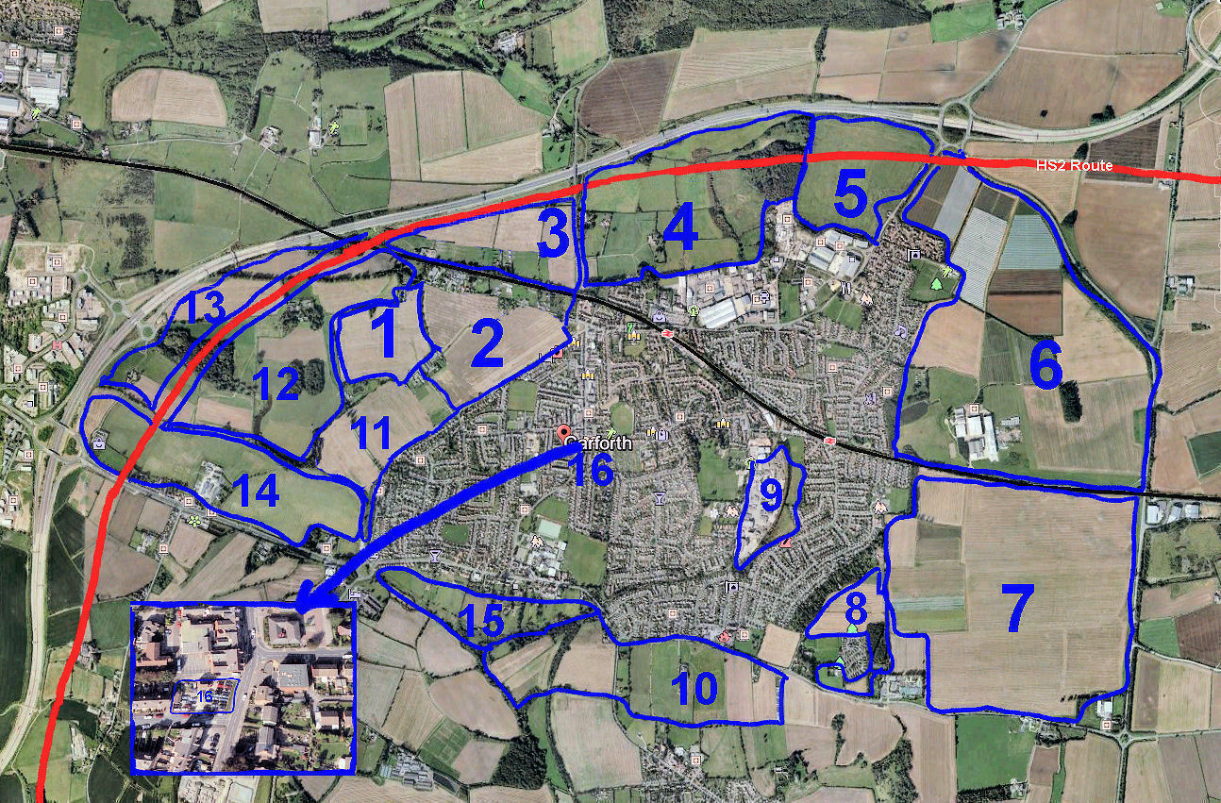
The red line denotes the proposed route of HS2
The grey line is the route of the M1
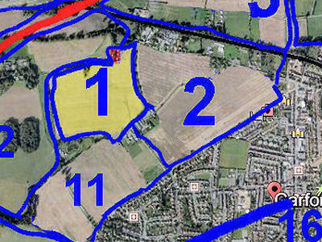
Area 1a (in Yellow)
This is a large field close to Barrowby Hall (in Area 12b) and south of the approach road to the Hall. The western boundary is the closed footpath from Pike's Water Lilies of Garforth. The northern boundary is the track from Barrowby Lane to Barrowby Hall. The eastern boundary is the hedge with area 2c and the most southerly border is the back of Clear View Farm, Fairview Farm and Pike's Water Lilies. Barrowby Hall is run and farmed by J C Barrowman and Sons and the hall is situated close to the north-eastern corner of this Area.
The land quality varies from good to very good and the field is devoted to arable crop farming. It was sown to oil-seed rape in Autumn 2017 and the piece of land extending from the fence at the top of the field for ca 50 metres to Barrowby Lane produced a good crop of fodder maize in 2017. The crop is generally uniform but patchy with drainage problems in the lower level.
The field, of ca.12.5-15 ha., rises gently (<4%) uniformly from Clear View and Fairview Farms to Barrowby Lane and from the highest points gives good views over Garforth.
There is a small triangular spinney, about 500 m² in size, on the northern edge of the field.
There is no public access and the owner discourages visitors. The access road from Barrowby Lane to Barrowby Hall has a "Private" notice and the track which used to run from Pike's Water-lilies up to Barrowby Hall has a locked gate at the bottom and has become overgrown and impassable.
The approach road to Barrowby Hall goes all the way to the Hall though marked "Private please keep out" after it passes the derelict cottage in Area 1b.
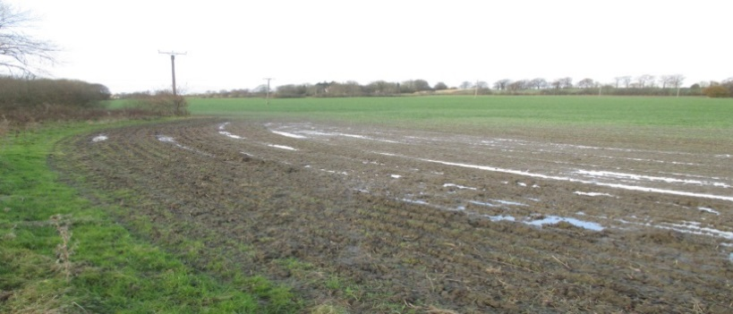
The official extension of Barrowby Lane is a public right of way, part of the Leeds Country Way, but is closed to vehicular traffic.
Poor Drainage
General View
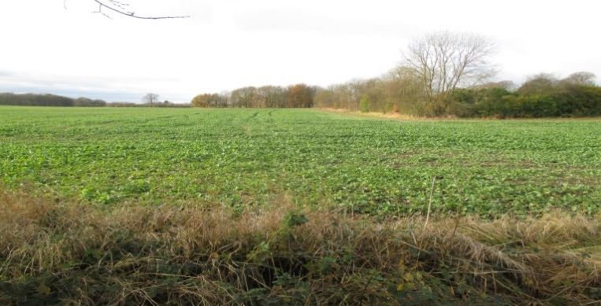
Area 1b (in Red) Map on Page 1. Note! On the map, this area is a small dot at the top right of Area 1.
At the north-eastern corner of 1a this is an area of about 0.4 ha which includes a derelict and uninhabitable cottage and a garden that is now wildly overgrown wasteland.
The soil is good and, with attention, the area could be made useful. However, having been neglected for at least 15 years, it has become an interesting wild-life habitat.
There is a gentle slope to the site which offers views over Garforth.
The access point is part way up the un-metalled track which leads from Barrowby Lane to Barrowby Hall.
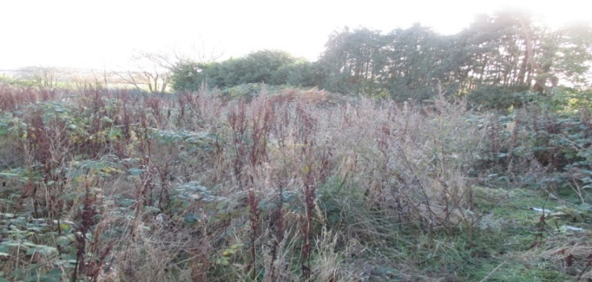

Garden of Derelict House

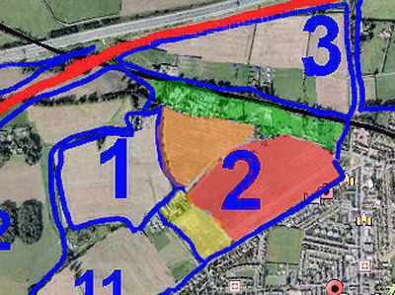
Area 2a (in yellow)
This small field of 1.56 ha belongs to the Knowles family of Clear View Farm and is bordered by A642 (Wakefield Rd) from Barley Hill Rd and up to house No.79, along the road up to Clearview Farm, then by Areas 1a and 2b.
There is a slight slope of only 1-2% and the land quality is reasonable but there are drainage problems during wet periods.
The main use is for arable farming, usually the growing of oil-seed rape or cereals but there are at least 2 paddocks for horses and ponies. A strip of land parallel with Wakefield Road ca. 10 -15 metres wide is not used, probably because of poor drainage.
At the higher end of the field are the detached farm-house and several farm buildings which were previously used for commercial egg production.
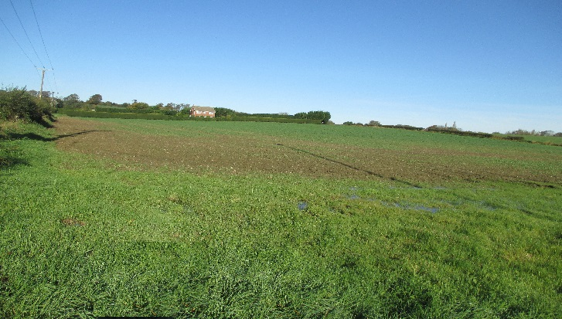
The standard of management is good.
Apart from the buildings and paddocks, the field is all farm land with no trees; on two sides it is hedged with thorn bushes (mainly hawthorn) and a large tall Leylandii hedge separating the farm-house from the land to the north-west of the field. A metalled road runs along one side of the field from Wakefield Road and into a public footpath running at the back of the farm and then along Area 2B.
Area 2b (in Red) Map on Page 2
General View with Farmhouse

This field, of about 13ha, is bordered on the south-east by Wakefield Road and on the north by Barrowby Lane. It is separated from 2c by a ditch and from 2a by a hawthorn hedge. There is also a hawthorn hedge, with gaps, along Wakefield Road.
The land is of reasonable quality, well-managed and is used for fully-mechanised arable farming. A V-shaped section of about 0.4 ha on the northern edge is used for a dog and cat kennels (Paddipaws Hotel) and a detached house. Apart from this area and a small copse approx..0.2 ha, mainly of willows, the use is totally agricultural.
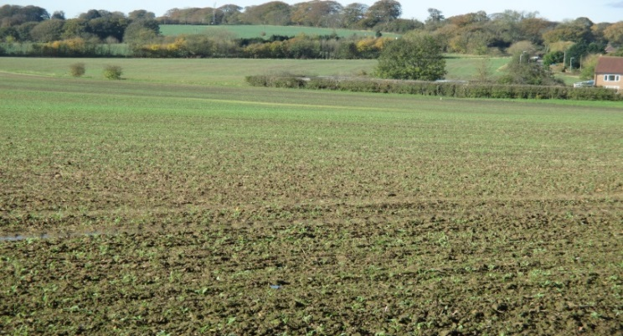
Tracks from Wakefield Road and Barrowby Lane provide access for farm machinery. There is a gentle gradient of about 2%, the northern edge of the field being slightly elevated and providing reasonable views of Garforth.
General View
Planted Crop and Willow Plantation
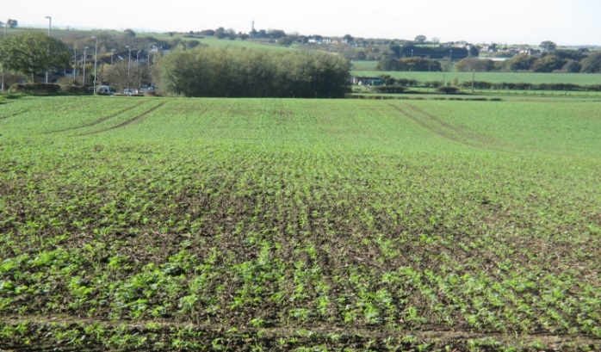
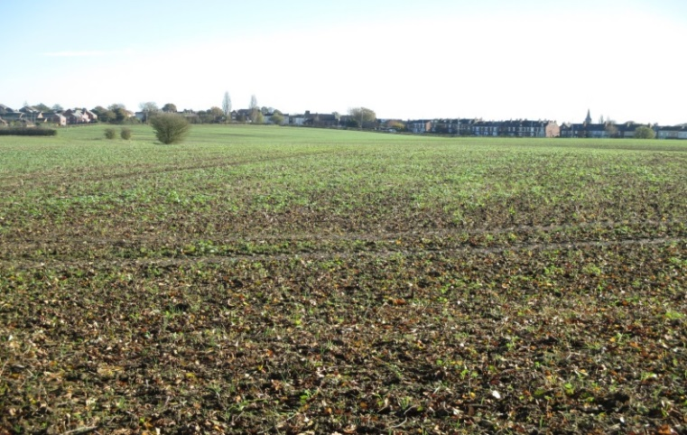
Area 2c (in Orange) Map on Page 2
This area, about 6 ha, is roughly triangular in shape and is bordered by Barrowby Lane on the north and a public right of way on the west. It is separated from 2b by an open ditch. It has a slope of about 2% in a northerly direction from Clear View Farm up to Barrowby Lane.
The land is reasonable to good arable quality and is used to produce agricultural crops of good quality and quantity. It is totally devoted to farming and is at present sowed with early oil-seed rape. The level of management is good.
There are several lone trees (sycamore and hawthorn) along the separating ditch, 3 or 4 rows of mixed species trees planted between the public footpath and the arable land (birch and silver birch, beech ash and ornamental Viburnum and wild rose).
Looking towards Wakefield Road
On the northern edge, Barrowby Lane (surfaced and with lamp-posts) provides access for farm implements. There is a public footpath along the western edge and good public access along the eastern boundary. From the northern corner, the highest point, a pleasant view of Garforth can be seen.

Area 2d (in Green) Map on Page 2
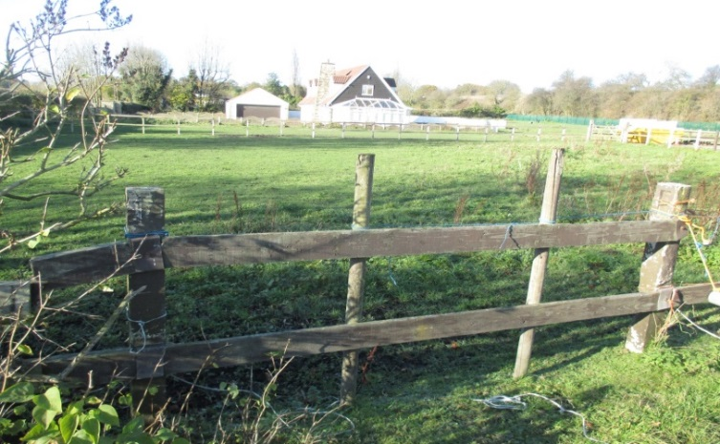
This area, between the Leeds/York railway line and Barrowby Lane, is mainly residential but there are 4 paddocks, each of about 0.5 ha., and all used broadly for agricultural production. The land quality is good, possibly No.2 i.e. the best in the district and provides separate pasture for horses, sheep and goats. The pasture is either grazed or cut and conserved. One field has a good stand of maize probably used for animal fodder.
All the fields are flat with negligible slope and are managed presumably as a hobby but to a good to satisfactory standard. All the plots have adjacent houses and gardens and are surrounded by trees.
View facing West
Most of the houses are two-storey and all the plots are accessible from Barrowby Lane which has lamp-posts every 40 metres or so and is fully surfaced.

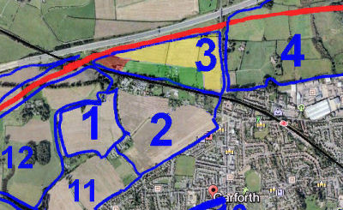
Area 3a (in Yellow)
This Area is bordered on the north by the M1 motorway, on the east by Barwick Rd and on the south by Areas 3b and 3c. HS2 is scheduled to pass along the complete northern edge. The Area, about 15 ha, roughly triangular in shape, is made up of several fields and has a gentle slope of ca. 2% from the south-western corner to the north -eastern corner.
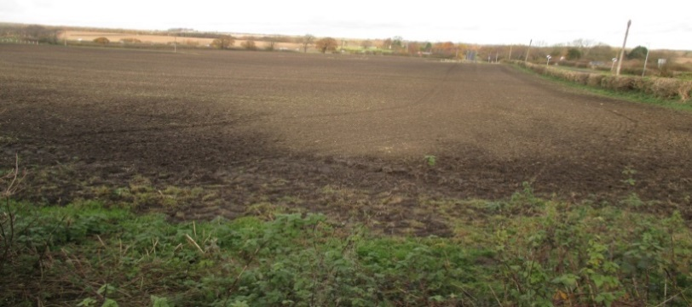
It is good quality farmland and is devoted to arable farming, cereals (probably wheat) being grown in 2017.
The presence of functioning water troughs in the fields is evidence of live-stock farming at some time. The crop farming is totally mechanised and the management is good.
Eastern edge from Nanny Goat Lane
There is no public access to these fields.
Area 3b (in Red)
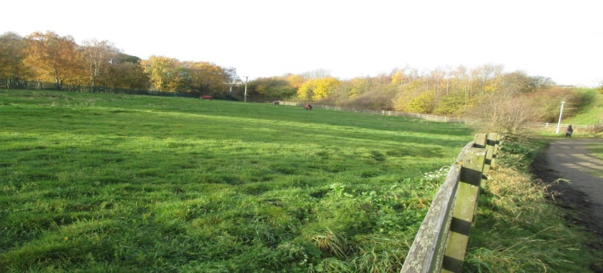
This Area is White House Farm, on Nanny Goat Lane. It is bordered on the south by the Leeds/York railway and on the north by Area 3a. It extends eastwards from the M1 underpass for approximately 400 metres along Nanny Goat Lane. towards Garforth.
The land, approx. 8 ha. In area, is mostly flat but with a medium slope at the western end and is devoted to pasture, overgrazed in places.
Well-maintained field – White House Farm
The farm is a commercial enterprise with a farmhouse, farm yard, several stables for housing and training horses. About 20 horses are kept at livery, for training and as an equestrian centre. Apart from the farmland itself, with its hedges and trees, there is a narrow strip of woodland.
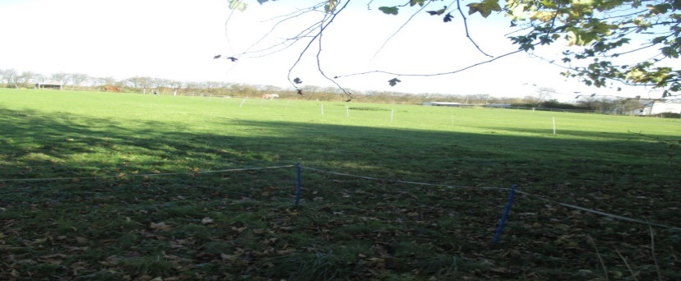
Area 3c (in Green) Map on Page 4
This Area is made up of ca 0.5-1.0 ha of small pieces of green space (hobby-farming) attached to houses along Nanny Goat Lane between 3a and 3b. There are 2 or 3 fields adjacent to the residences but not part of the gardens.
The land is flat and of good quality, not cultivated but used as pasture. The fields, which probably belong to the owners of the near-by houses, are well managed and some are used for horses and ponies.
Typical ‘Hobby’ Field
All the houses and pieces of land are set back and are not clearly visible from the road (Nanny Goat Lane), which is metalled but has no street lighting. There is good public access along the eastern boundary.

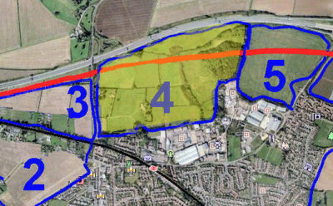
Area 4 (in Yellow)
This Area, of approx..60 ha, consists of about 14 separate fields. The northern boundary is the M1 and the western boundary is Barwick Road. On the south it is bordered by the public footpath from Barwick Road to the Fly Line which forms the eastern boundary. The proposed HS2 route crosses the area from east to west.
The quality of land is reasonable to poor and there is a gentle to flat gradient, although the stream has steep banks.
The land is mainly agricultural apart from several small copses and hedges with thorn and other trees of various species.
A few fields on the western side are cultivated with either cereal or oil seed rape each year; others are meadows and yield an annual crop of hay. The rest of the ground is rough grazing, with
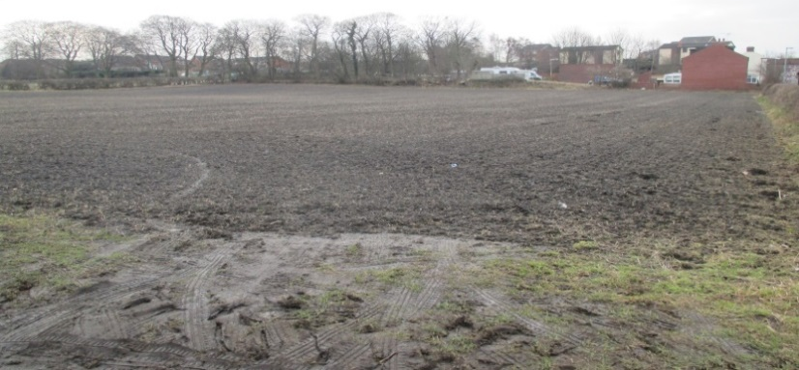
interesting trees, flowers and grasses, or wooded. In the north-eastern corner, Hawks Nest Wood, which abuts the Fly Line contains some useful trees but management is poor with little weeding or thinning of surplus trees.
Farming, where practiced, is managed satisfactorily but the forestry shows few signs of recent management. About half the area is given over to arable or livestock farming with the rest covered by trees and scrub. Many of the trees have been planted as part of a plan with others being self-set.
View from the South at the field entrance
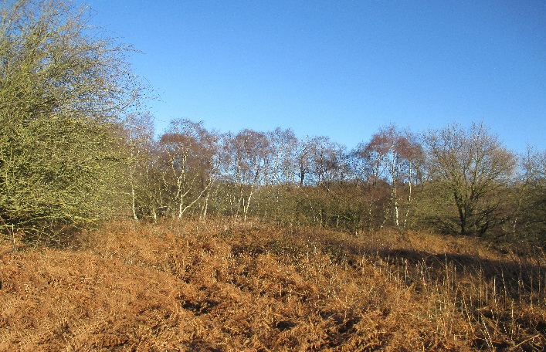
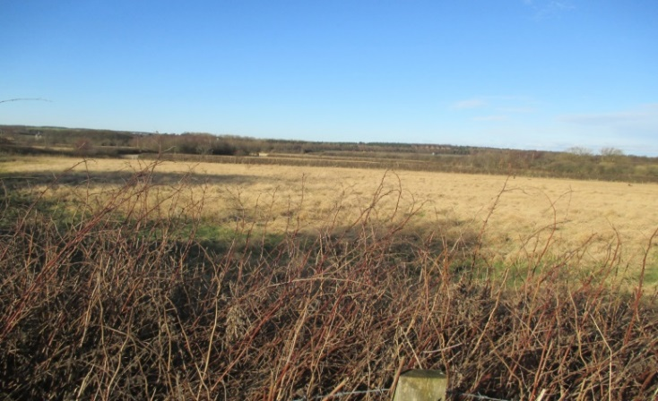
There are no farm buildings, but four houses are on the western part, two having a frontage onto Barwick Road. Lowside Cottage and the Elms are built in their own grounds.
Hawk’s Nest Woods

Rough Grazing
The area is very popular with walkers even in winter but at least some of the land has been worked for mining and some areas are considered dangerous. A restricted-access sign warns of the dangers of mine-workings and deep water and asks visitors to keep out. The M1 is visible across the area but the only accessible road is Barwick Road on the western boundary.

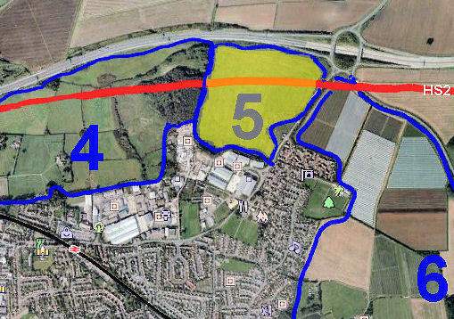
Area 5 (in Yellow)
This Area is a large field bordered on the east by the A642 from the Garforth industrial area to the M1. The northern border is parallel to and close to the M1 from the roundabout to the disused Garforth to Aberford rail track (the Fly Line). The western border follows this Fly Line to the industrial area at the bottom of Ash Lane. The southern border passes behind several industrial units which front on to Isabella Road and follows a largely disused footpath. The HS2 railway is scheduled to run across the field in an east to west direction.
The field, approx. 21 ha.in size, has a fairly uniform slope of about 3% from east to west with some steep falls and old quarry workings on the eastern side.
As a result of mining and quarrying the land is of poor quality and is used as animal pasture. When surveyed (Feb. 2018), it hosted 60-70 ewes but occasionally is used for cattle.
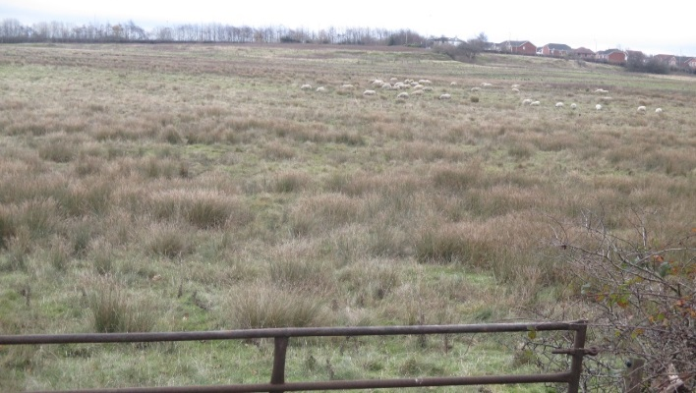
Apart from grasses, other vegetation is mainly reeds and weeds associated with poor drainage and water-logging. A small stream runs from east to west along the northern boundary.
Although the pasture is inherently poor, the sheep looked in good condition.
On the eastern border, about 120m from the south-eastern corner and fronting the A642, stands the Weigh House. This is a very old, high quality, residential dwelling occupying land which, presumably, was excised from the large field at some stage.
Swampy Pasture ( Sheep in background)
The field can be accessed from the A642 and there are views from the high point along the A642 and down towards the M1 and Hawks Nest Wood.

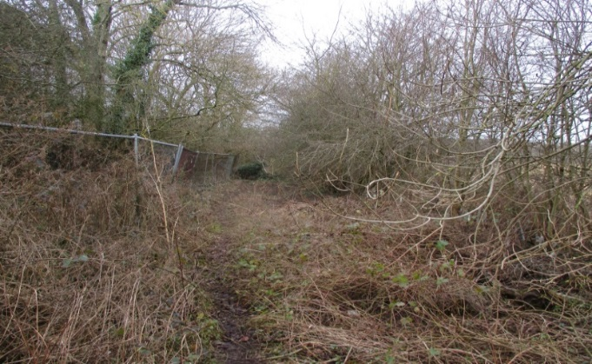
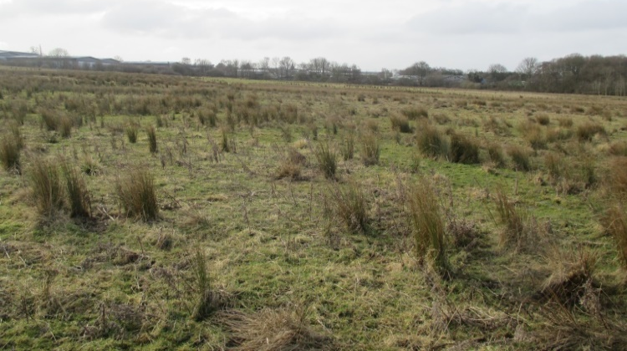

Abandoned Footpath on South Boundary
Boggy Rough Grazing

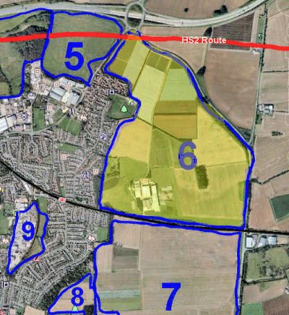
Area 6 (in Yellow)
The most northerly of the two fields owned by Makin Enterprises, this field is one of the most easterly in the Garforth area. It is roughly triangular in shape with its eastern boundary running along the A656 from the M1 junction 47 southwards to the Leeds/York railway line. The southern boundary is parallel to and close to the railway up to the Garforth urban area. The western boundary follows the Garforth urban area until it meets the A642 which it then follows to M1 junction 47. This area together with the field immediately to the south (Area 7) comprise Sturton Grange Farm. The proposed HS2 rail line will cross a small area at the most northerly point of the field.
The top and bottom parts are mostly flat with a gentle rolling area in the middle. With its very good quality fertile soil, Natural England places it as the best quality land in the Garforth area.
Large areas (>50%) are covered with poly tunnels producing strawberries. Cereal production is carried out on a small part of the
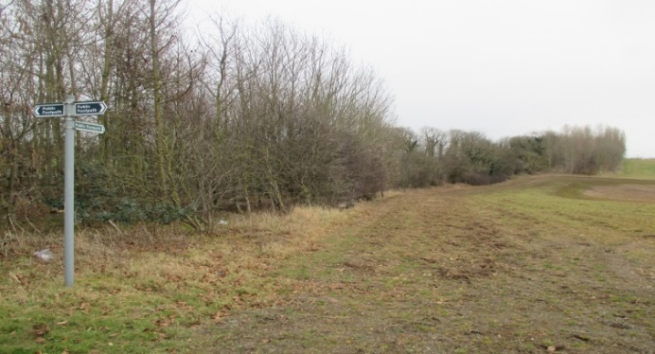
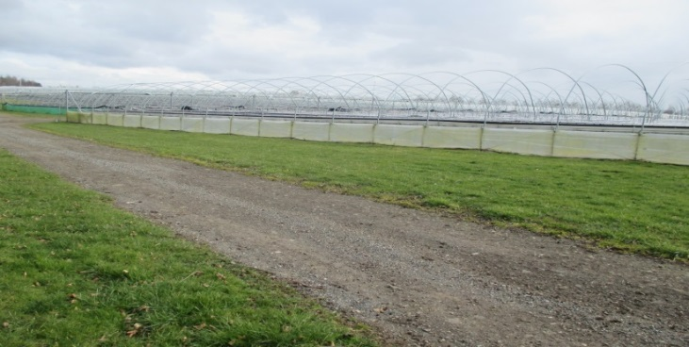
remaining area.
Wooded Eastern Boundary
Poly-tunnels under construction
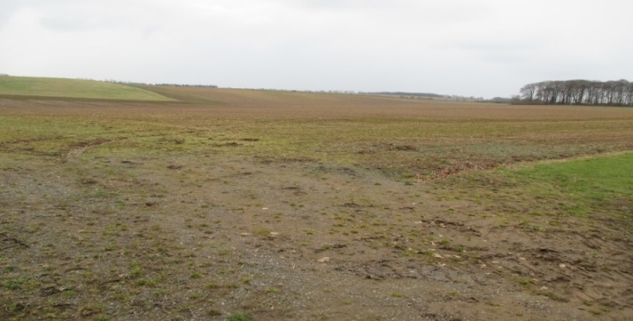

A large complex of farm buildings is used as offices and for the business of importing and grading of potatoes. The farm also advertises space for storage and the building area has prefabricated housing as accommodation for the seasonal labour which is hired to operate the farm. The main farm residence (Sturton Grange) is next to the office and working farm buildings complex.
Prepared for sowing cereal – 3-acre Wood on right
Since this appears to be a successful commercial enterprise the management is, presumably, top class
Along its western and eastern borders particularly, the area is surrounded by a 20 m strip of trees which is well managed and attractive. A small, 3 acres (1.2ha.), plantation is in the most southerly quarter and an ash plantation runs along the eastern border of the farm. There is also an area of about 1 ha. of lawn as well as a small lake and woodland in front of Sturton Grange House. This provides grazing for visiting Canada geese.
A grass runway, for use by private light aircraft, and a tarmac road run along the southern part of the field.

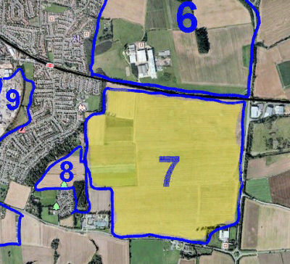
Area 7 (in Yellow)
Area 7 is the more southerly of the two fields owned by the Makin family. Roughly square in shape, its eastern boundary runs along the A656 (Ridge Way) from the Leeds/ York railway line to the roundabout on the A63 at Peckfield. The southern boundary runs from Peckfield farm shop, along the A63 to the Garden Centre and the western boundary follows Green Lane from the Winfield Outdoors store to the Leeds/ York railway. This area and Area 6 to the north comprise Sturton Grange Farm and are the most easterly parts of Garforth. Peckfield farm shop on the south east corner and the Garden Centre and Outdoor supplies shops at the south west corner border the farm field.
If the land occupied by the farm shop, garden centre and outdoor supplies shops is excluded, the field is 132 ha. In size.
The field is gently rolling and almost flat, although there is an overall slope of <2% rising from the south west to the north east corners.
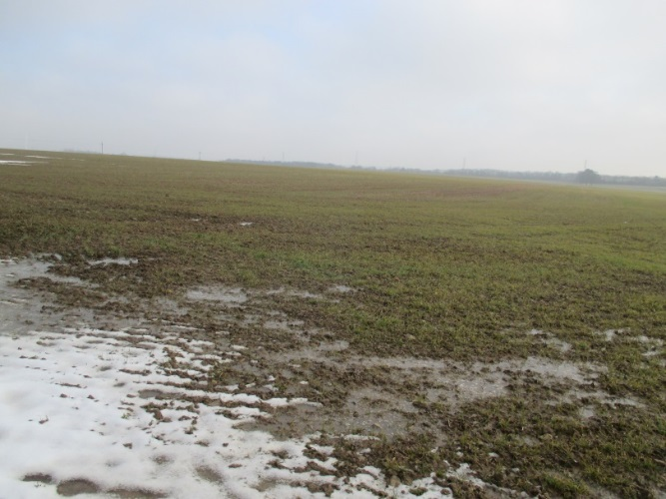
It is very good quality fertile land and the most southerly area shows numerous sandstone chips, indicating an underlying sandstone geology.
Almost the whole area is devoted to farming, usually cereals and the standard of management appears to be first class. The southern 40% or so was already (March 2018) sown with a winter cereal (wheat or barley).
In the north-east corner is Stub Wood, approx. 0.4 ha. This is a piece of rough woodland, largely unmanaged, and currently not open to the public although it is reported to be beautiful in Spring with many wild flowers.
View from
south-west corner

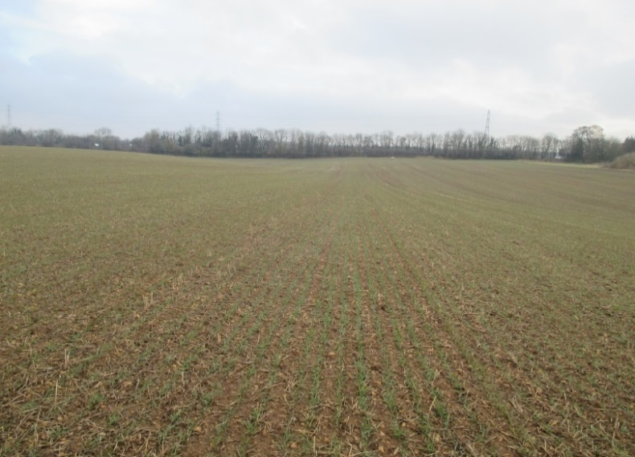
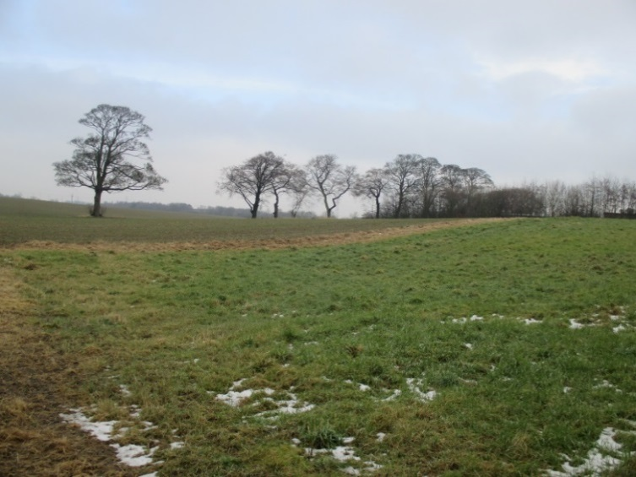
Winter Cereal, growing
Southern part of field

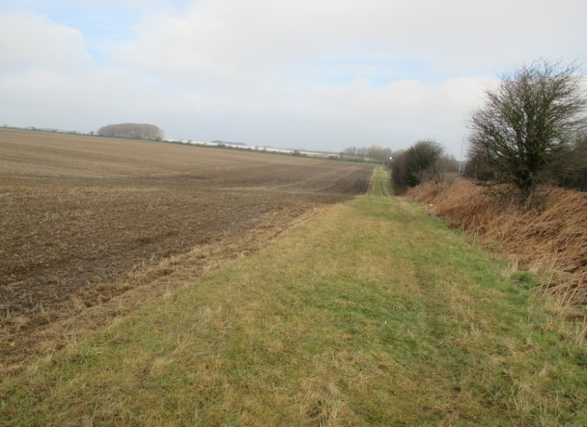
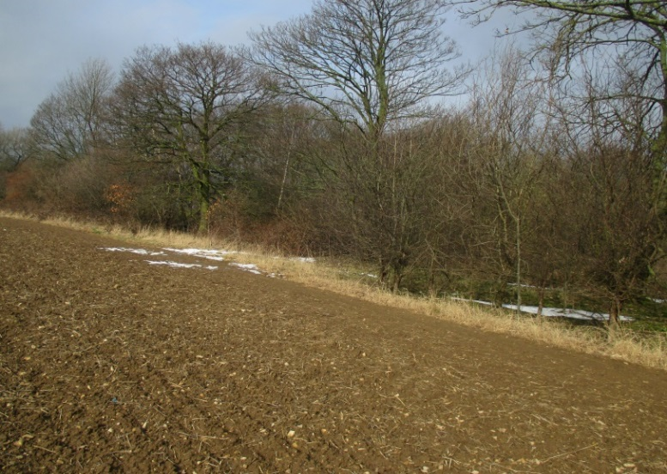
Eastern edge, along-side Ridge Road
South end of Stub Wood

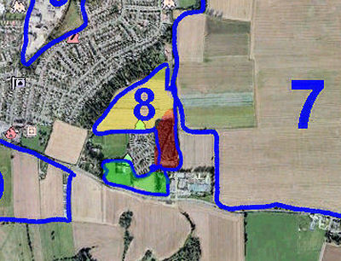
Area 8a (in Yellow)
This Area is basically triangular in shape with an eastern edge next to Green Lane opposite side Area 7. The western boundary is the steep land of Garforth Cliff and the southern boundary is Area 8b plus Cliff Top residential area and the reservoir park associated with the local water infrastructure
The Area is approx.30 ha. In size, effectively flat, and of very good agricultural quality suitable for producing crops and husbanding livestock.
There are three fields. The most southerly field produced a cereal crop in 2017 and the 2018 crop has yet to appear. The middle field has recently been re-seeded with grass either for silage or for pasture (grazing). The most northerly field has permanent pasture for grazing sheep and or horses.
The standard of management is good. There are farm buildings, a house and a caravan on the site

Southern-most part
Pasture, on left, with Cereal Crop, on right
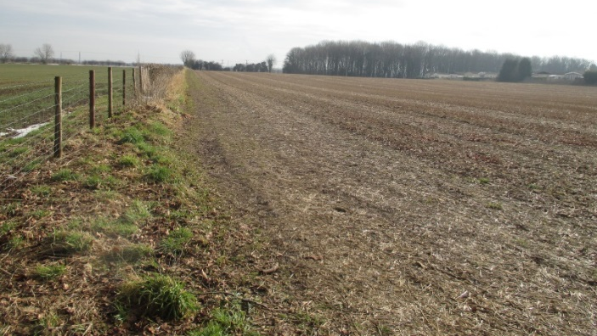
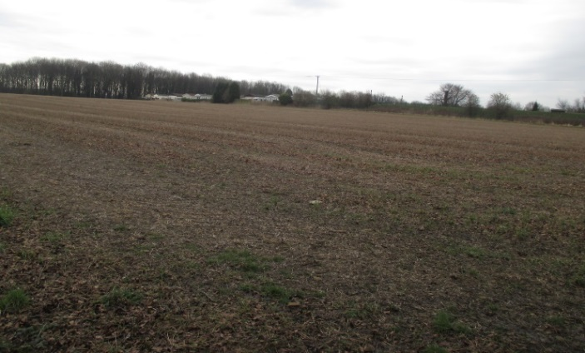

The western edge overlooking Garforth cliff is very pleasantly wooded and is a landmark but the view over Garforth and beyond is obscured by the line of tall trees.
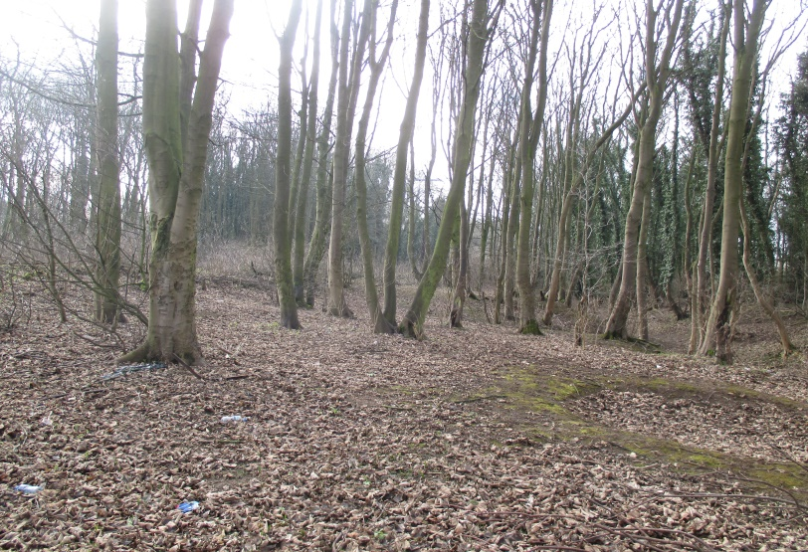
Area 8b (in Red)
Area 8b is immediately to the south of 8a and is basically a disused quarry. It has no obvious agricultural or housing potential but could have potential for recreational use. It is simply a hole in the ground which is currently well wooded. It is accessible from Green Lane immediately north of the Winfield Sports Shop. The western border is a steep cliff rising from the quarried area.
There are man-made cliffs on the western and northern sides, a gentler slope from the eastern edge and small hills along the floor of the quarry. The Area is about 1.3 ha in size and mostly covered with many large attractive mature and semi-mature deciduous trees, apparently unmanaged!
General View
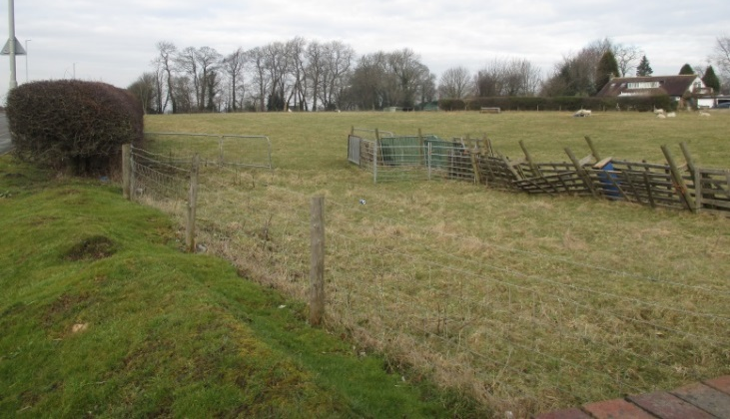
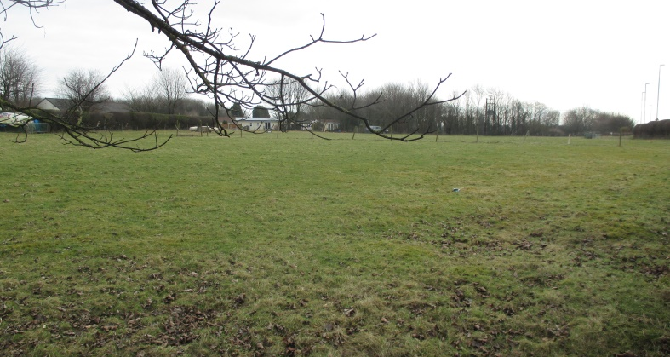
Area 8c (in Green) Map on Page 9
Another field between Cliff Top and A63
Field between Cliff Top and A63

This Area 8c consists of the three green fields between Cliff Top Park on the north, the A63 Selby road on the south and the Garden Centre Park on the east. The fields, about 1.5 ha. In total, are flat park-land and pasture. At least one of the fields was being used to graze sheep when visited. The Area has good amenity value, particularly for the residents of the Cliff Top housing estate.

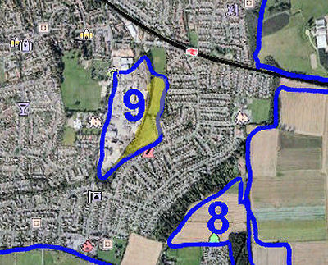
Area 9 (in Yellow)
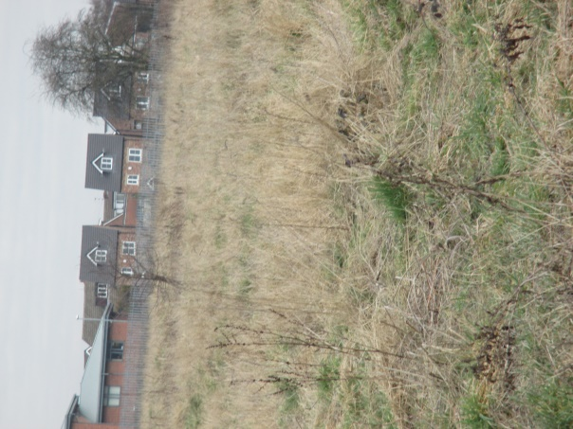
This Area, known as Kennet Meadow, is bordered on its west by the route of the dis-used railway line adjacent to the erstwhile Stocks Blocks site (now under housing development). The eastern and southern borders are the rear of the houses along Fairburn Drive or the associated cul-de-sacs and the northern border is the sports and leisure facility and cricket field on Green Lane.
Kennet Lane protrudes into the field and almost divides it into two halves.
The field is no longer accessible to the public.
It is about 3.2 ha in area, sloping slightly from north to south and with a steeper west to east additional slope in the southern half of the field.
View from end of Kennet Lane
The area used to be pasture but, since it has not been managed or put to use for many years, it has become wild scrub-land.
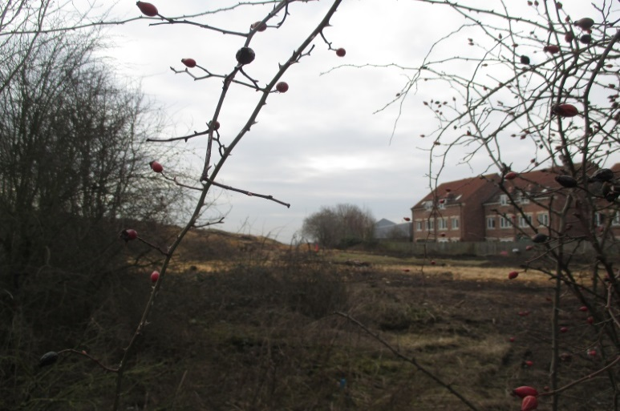
A botanical survey, commissioned by Leeds City Council, gives a comprehensive list of grasses, flowers and miscellaneous weeds such a nettles and thorns throughout the area i.e. a mainly scrubland environment. A list of common bird and insect life was also included.
View from Green Lane
Another view from end of Kennet Lane
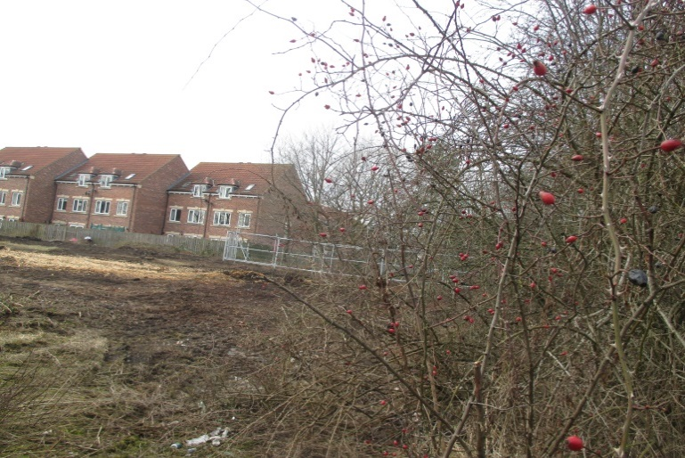

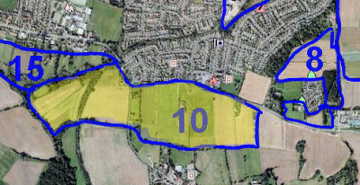
Area 10 (in Yellow)
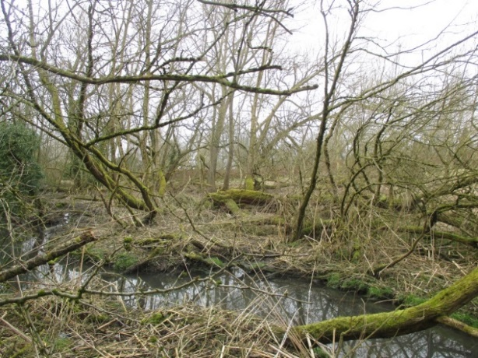
Area 10 is an expanse of land south of the A63 road in Garforth from Garforth Growers to Kippax Beck. The northern border runs west along the A63 for about 1000 m, crossing the B6167 Kippax road and up to the road bridge over the Lines Way/ Leeds Country way route. The boundary heads in a south westerly direction following the border of Area 15 and then runs for a short distance south-east, returning eastwards along the southern edges of the fields and finally running, northwards, alongside the Garforth Growers’ poly tunnels back up to the A63. The southern boundary runs almost directly west for about 1.2 km.
Woodland, west of The Lines Way
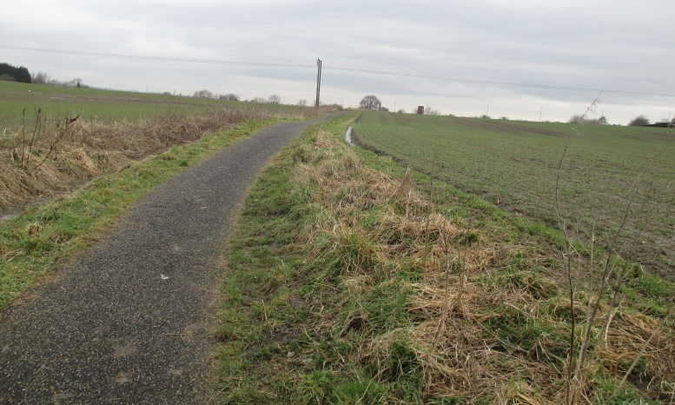
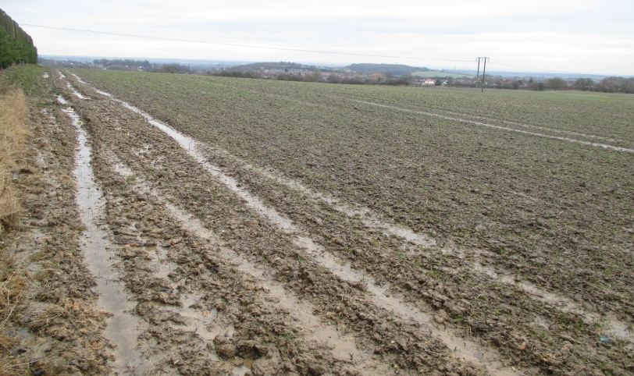
The Area is comparatively large, very irregular in shape and difficult to measure. A rough estimate could be as much as 30 - 35 ha. The topography is very variable. The eastern third of the area is Garforth cliff with a field gradient of ca 5% falling from the north east to the south west. The gradient reduces as the area levels out to ca 1% towards the west. The Lines Way has deep falls on either side and the most westerly piece of land has a gradient of over 5%. Heavy rain causes flooding.
View from north-eastern corner
Garforth to Kippax Footpath, looking north

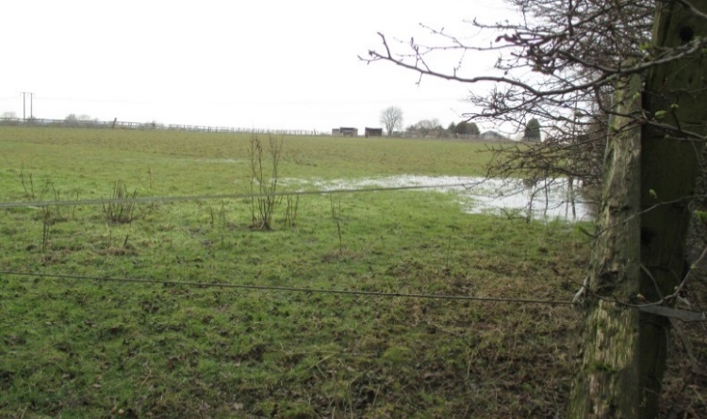
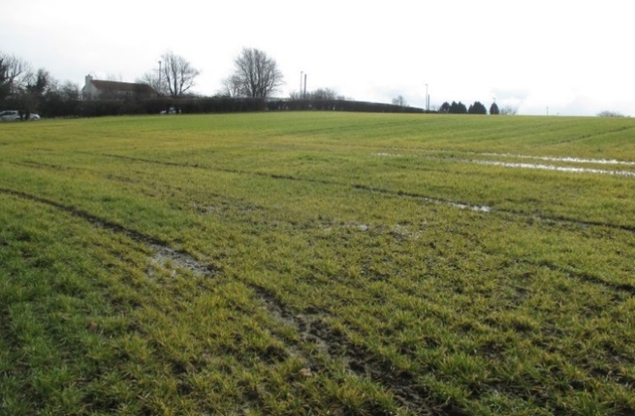
Cereal field, east of The Lines Way
Pasture-land, from southern border
The land is good agricultural quality for crop and livestock production and well-managed in places. The eastern fields are presently sown with winter cereals, probably wheat. Further to the west, the land is devoted to pasture land.
On the eastern boundary is the Garforth Growers business complex which includes 17 polytunnels producing garden seedlings for wholesale, a semi-detached house, offices and other buildings. There are two farms with houses and farm buildings and other houses along the northern edge of the farmed area.
Several routes and pathways cross the area. The most easterly is a major footpath from Garforth to Kippax, then the B6137 main route to Kippax and, finally, the Lines Way. This last is a popular country walk, made out of the disused railway line, and forming part of the Leeds Country Way.
Some particularly wet areas of the fields are given over to reeds, rushes and bird life.

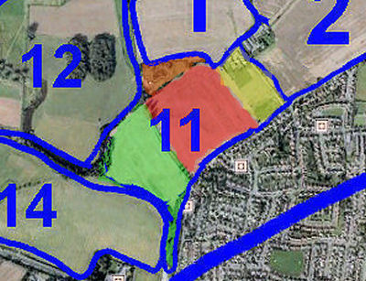
Area 11a (in Yellow)
Bordered on the west by trees and a hedge separating it from Area 11b,
by Wakefield Rd on the south-east, the road to Clear View Farm on the east and Area 1a on the north-east, this Area is used by the occupants of the two bungalows situated near the north-western border.
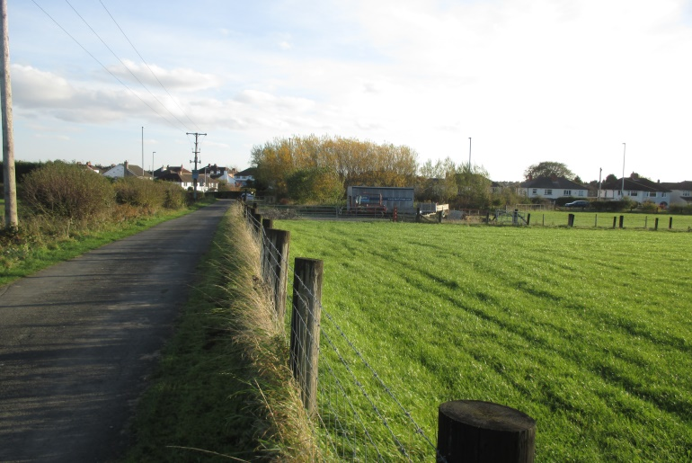
The Area occupies about 2.5 ha in total and is in three main sections i.e. next to Wakefield Road about 0.6 ha is used as pasture for sheep and incudes a small wood with willows, a pond and basic farm buildings. Adjacent to this is a meadow of 1.2 ha, presently used to produce silage, which will be pasture for sheep later in the year. Beyond this meadow, to the north-west, is an area of 0.6 ha which is part fruit orchard and part pasture.
A fourth section is the two bungalows, polytunnel/greenhouse and farm buildings at the north eastern boundary of the field.
The fields are good quality farmland, with no measurable slope (less than 1%), managed by the occupants of Fairview Farm and are an example of good quality hobby farming involving sheep production and orchard management.
The small willow wood and the pond are good for keeping excess water under control.
South-eastern section and Pasture
Wakefield Road runs along the bottom of the field in a north easterly direction and a metalled road leads off at right angles to this to run along the side of the field a public footpath at the back of the farm and then along the edge of Area 2b.

Area 11b (in Red)
This Area is bounded on the west by a track leading to Pike’s Water-lilies business which forms the northern boundary. The south-eastern boundary is Wakefield Road and it is separated from Area 11a on the north-east by a hawthorn hedge and trees.
The field is about 9.0 ha in area and slopes gently (< 2%) from the south-west to the north-east.
It is good quality land, although with drainage issues in places, and is used for arable farming typically cereals or oil seed rape.
The field was covered with a recently-sown crop of oil seed rape (November 2017) and appeared to be well-managed.
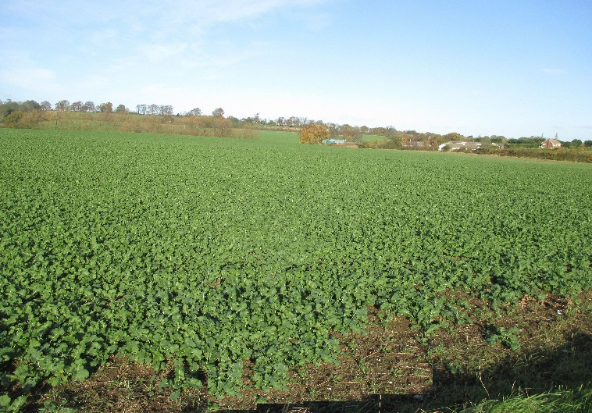
There is a pleasant wooded water-course along the northern boundary.
Field, from Pike’s Water-lilies access road

Field, facing North

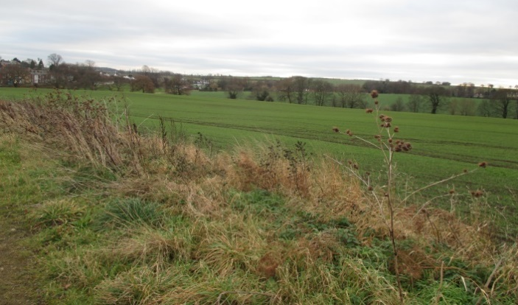
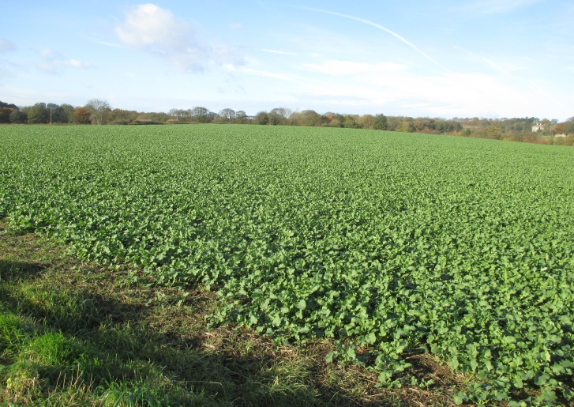
Area 11c (in Green) Map on Page 12
This Area consists of two separate fields. The larger field is bordered on the north-west by a wooded valley, by the road to Pike's Water-lilies on the north-east, a line of trees along the south-western edge and a beck with trees along the south-eastern boundary. It is 5.5 ha in area and is good quality farmland with a relatively steep slope from the north west down to the south-east close to the beck. There are drainage issues at the north-western edge.
General View
The field is well-managed, entirely devoted to arable farming, and currently has been sown with winter wheat.
There is a public footpath leading to Pike’s Water-lilies along the north-western edge.
The second field is sausage-shaped and runs between the beck and Wakefield Road. It extends beyond the larger field and along the eastern border of Area 14, separated from the Miller & Carter car park by a treed hedge. It is about 1.5 ha in area, quite flat and lies about 2 metres below the level of Wakefield Road. It is good pasture-land and currently is being used for cows. Access to the field is from Area 14 by means of a gated bridge over the beck.
Area 11d (in Orange) Map on Page 12
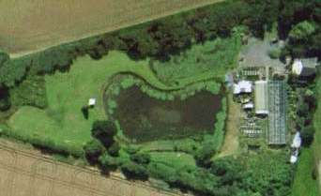
This is a small area north-west of Area 11b and comprises Pike’s Water-lilies of Garforth, a farm specialising in the cultivation and supply of water-lilies, pond and water garden plants plus a range of fresh-water fish.
The area occupies 1.2 ha, is flat and level, and with a detached farm house/office, surrounding buildings and glass-houses.
There are ponds and, abutting Area 11b, an amount of woodland consisting of various deciduous species.
The area is a good commercial business dealing in ornamental fish and aquatic plant production together with management of
View from above
View from above
woodland for solid wood fuel production logs, wood chip etc.
Access is by means of an un-metalled track which used to lead from Wakefield Road to Barrowby Hall but is now closed and
sealed after it reaches Pike’s Water-lilies farm.
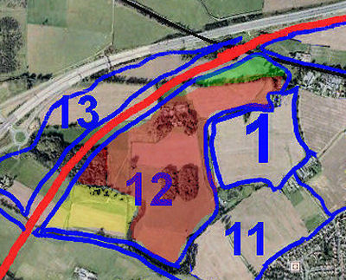
Area 12
This is a large area, bordered on the north western side by the proposed HS2 rail route from Area 14 through to the present Leeds to York railway. The border turns south to meet the north eastern corner of Area 1, then follows that border, first west, then south, to Pike's Water-lilies. It then runs south west along the northern edge of Area 11 to meet and follow the boundary of Area 14.
Because of the very irregular shape and the difficulty of locating the alignment of HS2 at this stage, the total area is only roughly estimated to be 85 - 95 ha. The Area contains a variety of land types and kinds of woodland together with a multiplicity of land uses as will be seen in the following descriptions of each section.
Area 12a (in Yellow)
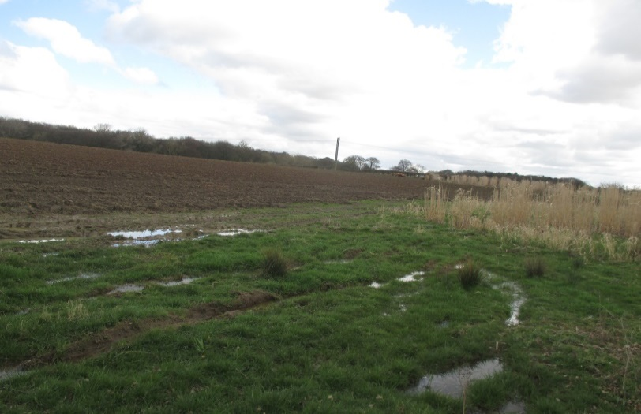
This section is the north-western corner of Area 12, about 9 ha in size, and currently comprises the arable land of Bradbury Grange Farm.
The land, which is reasonable quality, slopes (less than 5%) from the north-east to the south-west down from Bradbury Grange Farmhouse.
The farm has three fields, all prepared for an arable crop. In April 2018, the land had been rough-ploughed for spring planting but, because of the clay soil and the very wet winter and spring, there had been no chance of seed bed preparation up to then.
Ploughed field
with wild-life conservation area in the foreground
In addition, two small areas have been set aside at the bottom of each field for wildlife feeding and conservation.
Area 12b (in Red)
This Area is the Barrowby Hall land and forms the bulk of Area 12. The green space completely surrounds the Barrowby Hall mansion house and the Leeds Country Way public footpath forms the northern border of the land. Access is limited and there are few points from which the area can be viewed closely without trespassing.
The Area is very irregular in shape and about 60-70 ha in size. The most northerly 250 metres has a relatively steep slope of ca 6%. The remainder has a fairly uniform gradient of less than 2%.
Pasture in the centre of the Estate
Barrowby Hall, from the Park-land
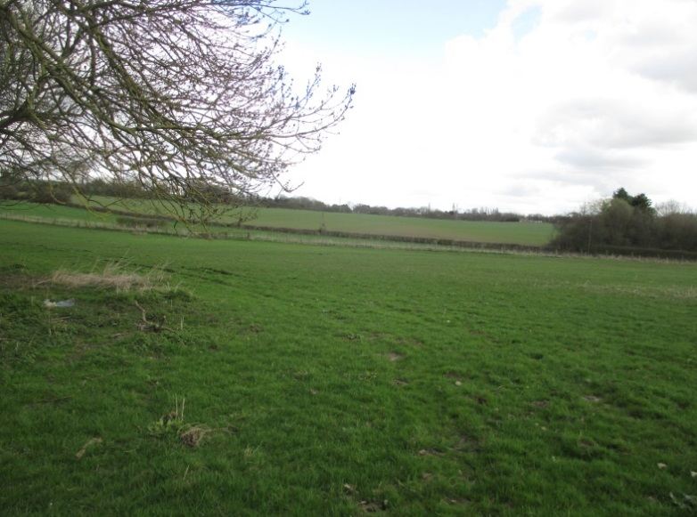
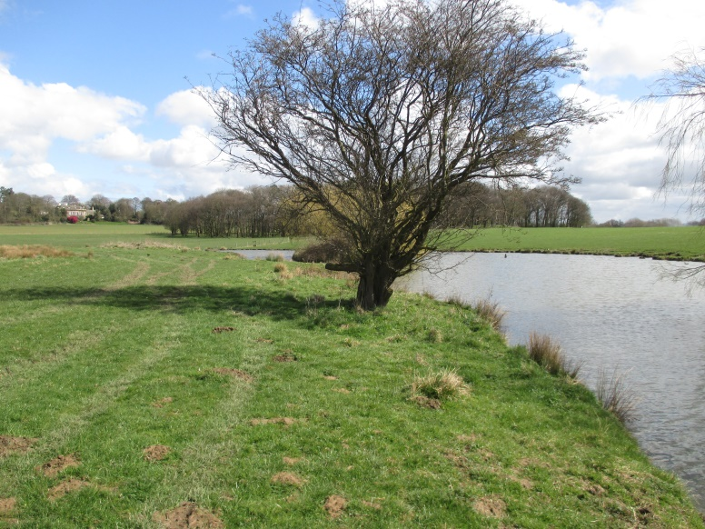
The land is good quality, tidy, and well-managed. It is a mixture of arable land (cereal, including maize, and oil seed rape), pasture and parkland, forestry and lakes. Most of the arable land was autumn planted but at least one ploughed part was awaiting seed bed preparation and sowing. The central part of this Area is almost classical English parkland with two areas of woodland and attractive lakes. It is even labelled as "Barrowby Park” on some maps.
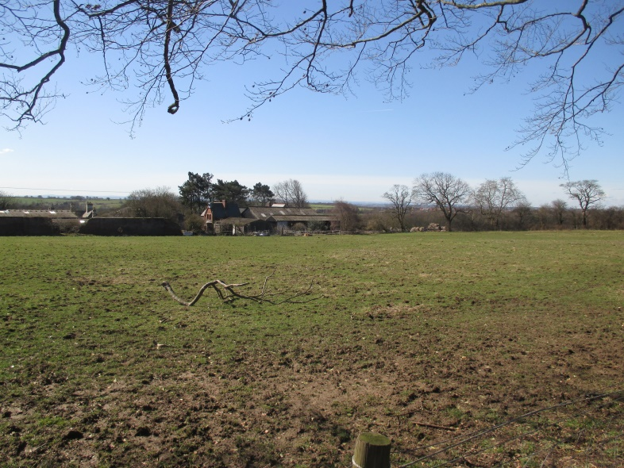
The attractive woodland areas contain a good range of deciduous trees and, like the parkland, can be viewed from a distance from the Leeds Country Way bridleway that borders the northern edge of the land (Barrowby Lane on the OS map). Within the Area itself, the highest points give good attractive views over Garforth although the land does not have public access.
Wildlife can be seen in and around the woods and Canada Geese are to be found near the lakes and in the parkland.
The mansion house - Barrowby Hall - with a wide range of farm buildings and a walled garden stands in the Area.
The surfaced road from Barrowby Hall goes all the way to Barrowby Lane but is signed "Private please keep out" before it passes the derelict cottage in Area 1b.
Barrowby Hall Estate, from the farm buildings
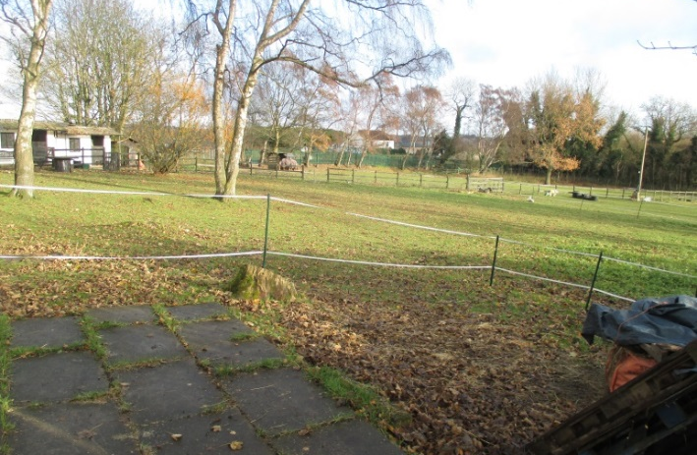
Area 12c (in Green) Map on Page 14
This is a triangular area, north of Area 12b and contains three pieces of land not obviously associated with the Barrowby Hall
estate.
It is about 6 ha of good quality land, mainly used for sheep pasture. There is about 1.5 ha of stables and horse pasture and some rough ground with a vegetable allotment in the middle.
The buildings include indoor space for storage, for stabling and managing the horses.
Buildings and Pasture at the north-eastern end
The management is separate from Barrowby Hall.

Area 13 (in Yellow)
Area 13 is really part of Austhorpe.
It is the shape of an elongated triangular wedge of land bordered on the north-west by the M1 and on the south-east by the proposed HS2 rail route. The base of the triangle is a line of a hedge and trees south-west of Bradbury Grange Farm. The point of the triangle is at the eastern end where the new HS2 line will cross the existing Leeds to York rail route.
Its size is possibly 30 ha but because of its irregular shape this Area is difficult to estimate accurately.
The western part, Bradbury Grange farm and the wooded area has a medium slope (ca 5%) in a south-easterly direction. The arable part, to the centre, slopes about 4% directly south and the sheep pasture is gently rolling but essentially level.

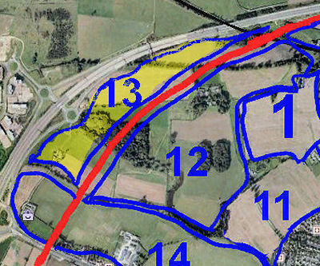
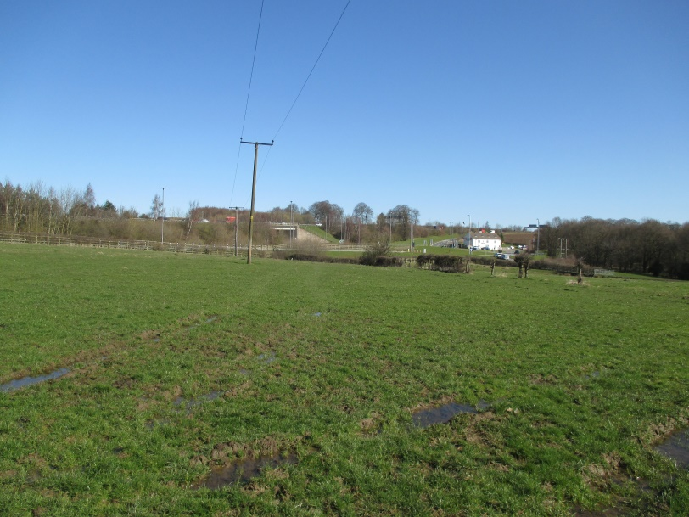
The land use is varied and includes rough pasture, woodland and arable farming and the land quality is classed as good. The pasture land is used for grazing sheep and lambs. In April 2018, the arable land had been ploughed and was awaiting seeding. The waste material from a small area of maize planted in 2017 was still awaiting removal.
View from the pasture to the east
About 8 ha on the western side comprises Bradbury Grange Farm with its pasture land, arable land, a farm-house, farm buildings and 12 caravans presumably for letting or storage. A wooded area occupies just over 1.0 ha. and the remaining portion from the woodland to the northern-most point is about 20 ha.
The woodland area is fairly attractive although not particularly well managed. This may well be the habitat of important species of wildlife.
The Area contains land belonging to 3 farms i.e. Bradbury Grange to the west, Barrowby Hall in the central part and Shippon House Farm sheep pasture in the extreme north-east.
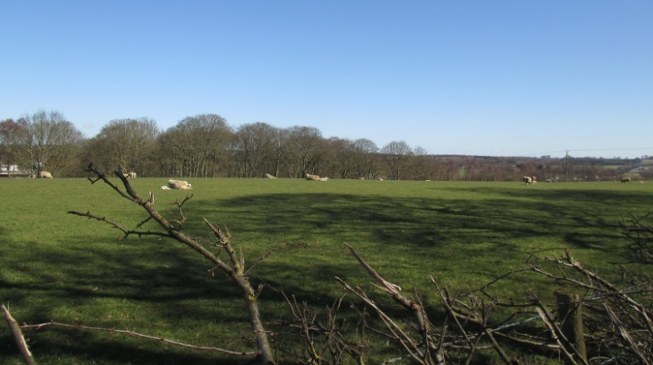
There is a public track to Bradbury Grange from the ring road (A63).
Sheep with lambs, north of the bridle-way
Bradbury Grange Farm-house and Buildings
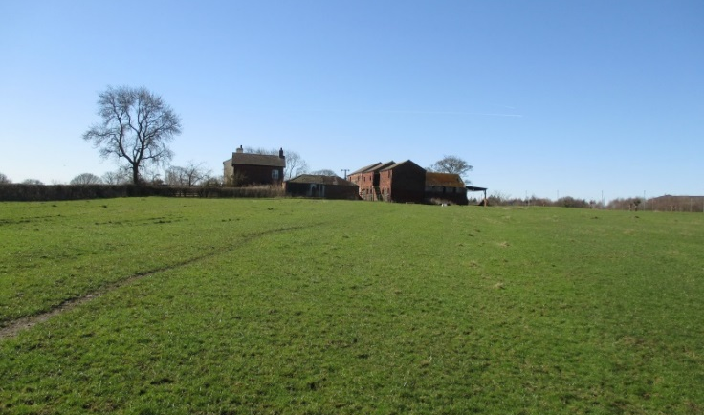
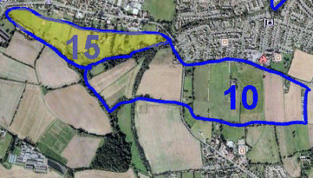
Area 15 (in Yellow)
This Area is categorised as PAS land i.e. Protected Area of Search land. This is reserve land for consideration after the end of the plan period of the current development plan. It is currently under consideration as suitable for a short road to relieve traffic congestion.
The Area is an inverted triangle of greenspace with its base running east of the Miller and Carter public house and south of the Selby Road A63 to the disused rail line, the Lines Way. The greenspace is the land south of the single row of houses and businesses, (some with substantial garden areas), and stretching down to the Beck. The apex is at the most southerly point where the Beck meets a stream coming from the ponds on the south eastern side.
The greenspace area is between 6 and 7 ha. and the land quality is classified as average.
There is a fairly steep slope in a north-to-south direction of 7.5%, rising up to 10% in places.
It would appear that there are several owners of the greenspace and its management is considered to be satisfactory. Google Earth shows 11 distinct fields but farming is confined to the four western fields, the remaining land being as gardens or for recreational purposes for the nearby houses.
Rough grazing land towards the eastern end
Eastern end of farmed PAS land, from the South
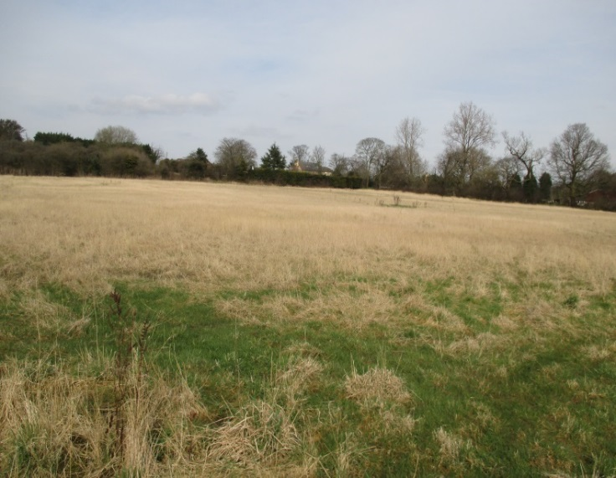
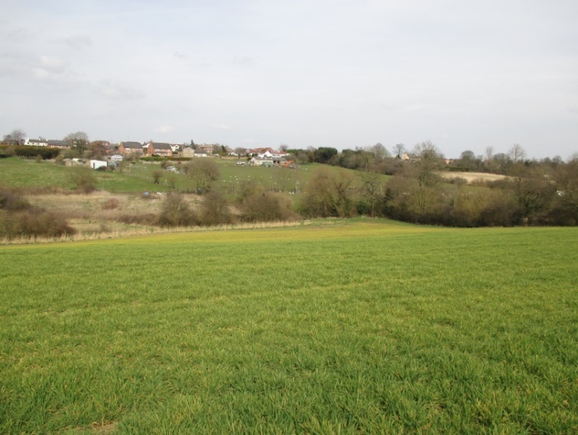
The land is grassland with grazing being the predominant pursuit. One field with farm buildings had 30 ewes with young lambs when visited in early April 2018. There was no evidence of conservation for winter fodder
On the south-eastern side, there is an attractive lake-land feature and woodland which are largely shielded from public view. The southern boundary with the Beck is wooded and has deciduous trees and bushes.
At the end of a public pathway from the roundabout is a building associated with the Water Treatment Plant as well as some water treatment infrastructure. On the pasture-land there are also some buildings needed for the husbanding of the livestock.
The area has several public footpaths and the western fields are accessible from the A63 and the path to the Water Treatment plant.

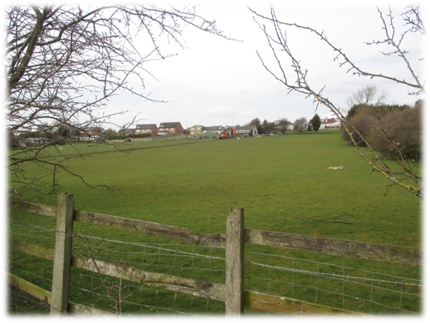

Grazing Pasture and Farm Buildings

Acknowledgments
Physical Survey - Chris Lomas
The survey was carried out between November 2017 and April 2018, mostly during a harsh cold winter.
Photographs - Chris Lomas
Maps - Chris Coyle and Maurice Norman
Text and Presentation - Maurice Norman

