

***Character Assessment Area 5: Lotherton Industrial Estate***

Parkinson Approach, Higham Way, Hanbury Gardens, Spring Close, Newhold Terrace, Ash Terrace,Lotherton Way, Fusion Court, Aberford Road, Ash Lane, Fusion Point, Newhold, Isabella Road

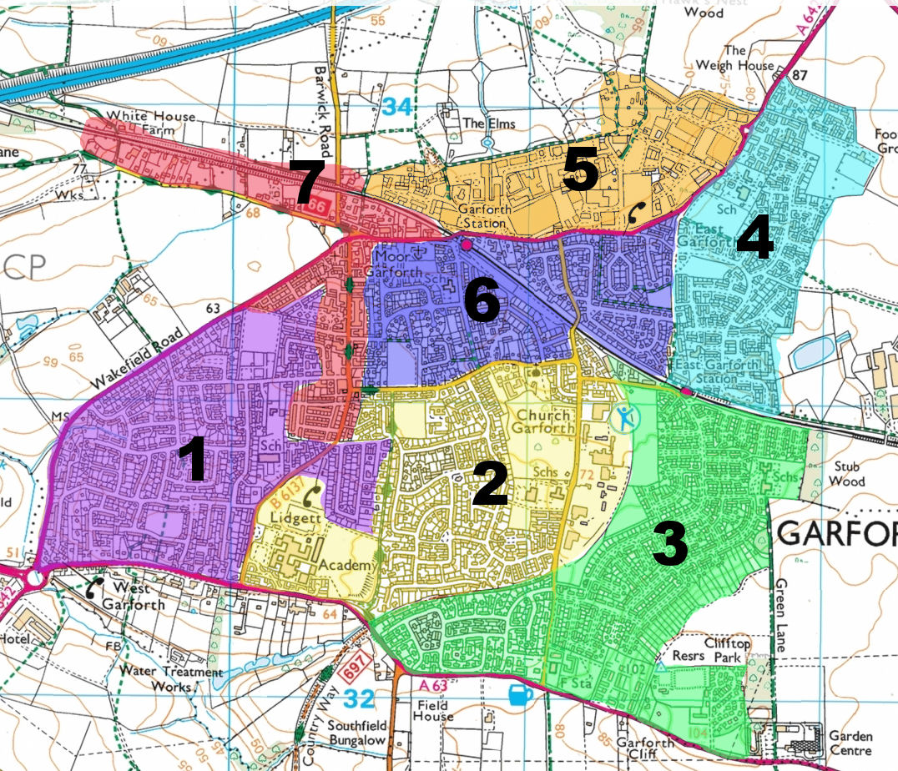**Area 5**

This area is bounded on the south by Aberford Road A642 and the Leeds to Selby/York railway line, to the north by the Aberford parish boundary and a footpath, beyond which are open fields. The western boundary is a footpath leading from a pedestrian crossing over the railway.

It is Garforth’s main employment area and contains Industrial Units, Commercial Buildings and some residential dwellings. Large companies and small enterprises exist side by side. The range of businesses is extremely diverse from car-making through pharmaceuticals and foodstuff to joinery, transport, catering and many, many more.

**Aberford Road**

All entrances and exits to and from the Business Area are via Aberford Road A642 which gives easy access to the A1, M1, M62 and Leeds Ring Road. From the Aberford boundary to the railway bridge hedges and fences separate it from the Business Area, whose buildings can be seen on the northern side. The only building on the northern side of the road itself is the Toll Bar Garage, on the site of the 1794 Toll Bar. Aberford road was a Turnpike Road and Bar Lane, opposite, also has Toll Bar associations.

**Parkinson Approach**

This is the most westerly of the entrances to the estate and shortly after its entry turns sharply to the west to have Tesco Car Park on the left and the Filling Station on the right. The store itself is further in on the left and on the right is a car wash enterprise. Further on still there is a branch to the right. This is **Hanbury Gardens**, a modern development of large detached houses of red brick with grey tiles. They have bay windows on the ground floor, covered porches and integral garages. Much of the area is paved and the road is tarmac with a pavement each side and bollards to protect the footpath. Mature trees have been planted throughout and a large grassed area with trees and shrubs is situated to the right of the entrance.

Parkinson Approach continues a little further and then becomes **Higham Way.** This is a much more extensive development of similar character but with more variety in the type of dwellings provided. The houses are all large but some are semi-detached with detached garages whereas the rest are detached with integral garages. The style is red brick with grey tiles to the main roof and to the garage roof and the porch and window coverings. All have bay windows to the ground floor but of great variety. The gabling of the upstairs windows is also varied in style. There are many grassed areas and the development is well-provided with shrubs and mature trees. Most of the semi-detached houses have long wide driveways. The road is tarmac and has a footpath either side.

At the estate entrance, on the right-hand-side on Parkinson Approach, is a new project under development. It will include a supermarket, pub/restaurant and other retail and leisure facilities.

**Lotherton Way**

Lotherton Way is the main road on the estate and is reached from Parkinson Approach by continuing straight on after the estate entrance instead of turning left towards Tesco. It is not a wide road considering the size of the vehicles which use it continually. For much of its length it has fences or walls surrounding large industrial buildings with forecourts or parking areas but in between are open stretches allowing access to rows of smaller units. Some of the buildings are of red brick and some of these are styled architecturally. About halfway along the road, on the right, is the entrance to **Lotherton Court**, a complex of small business units, (Elmfield Business Park), arranged in a square surrounding a parking area. Just before the end of the road, on the left, and screened off by a fence and hedge is a very large residential property surrounded by a large grassed area. The building is white with grey roof pitched at the sides and ends and has multiple chimneys. The lower front has been extended and has a tiled pitched cover. There is also a side extension similarly covered. The driveway to the house is long but not made up. At the very end of the road is Phoenix Court, a new development which at the moment consists of a large red brick commercial building with offices and a block of 4 red brick, flat-roofed units, each 4500 squ. ft. in area.

**Fusion Court**

Further to the east along Aberford Road is the entrance to Fusion Court. This is a complex of 4 blocks of 2-storey buildings in red brick with grey pitched roofs and gables. The buildings are offered as office accommodation by building, floor or unit. In front of each building is car park space and centrally there is a spacious car park. At the entrance and within the area are a few mature trees.

**Ash Lane**

Ash Lane, off Aberford Road opposite the fish shop, is not very wide and not well made-up. There are no footpaths. On the right-hand side is a large playing field, separated from the road by a high hedge. The left-hand side is mostly fenced and is occupied by various businesses, the first being a materials-handling firm. After this, comes the entrance to Fusion Point, a complex of 3 large industrial buildings housing a computer firm, a transport firm and printer-repair company. Beyond this complex is the new supermarket development. The next stretch begins with a micro-brewery, then a firm supplying building materials and near the end of the road, on both sides, is a large complex of storage yards, buildings and manufacturing plant operated by a company supplying fencing, gates, cast stone and concrete products. Beyond this is a large building and lorry park used by a tanker transport firm and a haulier. Ash Lane finishes here as a road but continues as a footpath through Hawks Nest Woods, under the M1 to Parlington.

**Newhold**

The entrance to this road is off Aberford Road almost opposite East Garforth Primary School. For the first 100 M the road is fenced on both sides, with a wide grass verge and footpath on the left and a narrow grass verge on the right. On the left is a single-storey industrial building and a yard followed by the entrance to **Spring Close,** which leads between various large and small industrial units with a great deal of undeveloped open space and then forms two branches. One branch continues to run straight on towards the playing field off Ash Lane whilst the other branch circles round, past more buildings, some large, to re-join Newhold. It also passes **Ash Terrace**, a group of 7 Victorian Terraced houses. These 2-storey houses have double chimneys and decorative brick-work brackets under the eaves and most are now painted white.

From the Spring Close entrance Newhold continues straight on but now has high un-managed hedges on both sides. At the end it runs into **Newhold Terrace**, another group of 7 Victorian 2-storey houses, similar to those of Ash Terrace, now all painted white. There are some detached garages and Newhold runs round the end of the group to link the two terraces.

**Isabella Road**

This road is the newest on the estate and is entered from the roundabout on Aberford Road. It is a short wide road and on each side has a low open fence, a wide footpath and landscaped verges with grass, shrubs and trees. There are 3 large buildings on the left and 3 smaller but substantial buildings on the right. The buildings are all of a similar style, being of red brick, with white cladding sides and grey low-pitched wide roofs. They all provide manufacturing or processing space and office accommodation, together with off-road space for cars and lorries.

Isabella was the name of one of the Gascoigne sisters and also the name of the pit which was sited nearby.

**Topography and Appearance**

All the roads entering from Aberford Road slope downwards onto the estate. There is a general slope from north-east to south-west but the estate is level with no undulations. There are undulations on the playing field off Ash Lane but this is probably due to erstwhile mine workings.

It is impossible to make an industrial estate look picturesque but Isabella Road presents a pleasing appearance and shows what can be done. The rest of the estate is evidence of piece-meal expansion with little architectural coordination. Although some individual buildings have style and some blocks like Fusion Court have a pleasing presentation, the majority are little more than utilitarian, as is their lay-out.

**A narrow road

Description generated with very high confidenceAmenities**

Supermarket with Parking and Service Station



***Newhold Terrace***