Wakefield Road A642, Selby Road A63, Farfield Court, Lidgett Lane & Court, Barleyhill Road, Barleyhill Cres, Poplar Ave, Knightsway, Kingsway & Garth, Kings Croft, Summerhill Rd, Queens Way, Alandale Cres, Road, Drive & Grove, Poplar Ave, Knightsway, Kings Croft, Ringway, Springbank, Springbank Cres, Westbourne Cres, Road, Terr, Ave & Drive, Lowther Grove, Avenue, Road & Drive, Goosefield Rise, Abbots Way.
Character Assessment Area 1: West Garforth
This area is largely residential but includes a few businesses in Barleyhill Road, Barleyhill Road Recreation Park, Strawberry Fields School and an Open Space off Goosefield Rise. Appearances vary from 1930 & 1950 to 1970 style. The dwellings are predominately red-brick detached and semi-detached houses and bungalows with walled or hedged front gardens.
Fairfield Court
A 1970 development in the form of a cul-de-sac with large detached and semi-detached houses on each side leading to a T-shaped turning area. The front gardens are either open or with low walls. Integral garages are at the front and level with the building line. The houses are of red brick, some being partly-rendered white. Gardens are well-kept and the general appearance of the cul-de-sac is pleasing.
Wakefield Road
Nursing Home
Wakefield Road – typical 1937-50 style
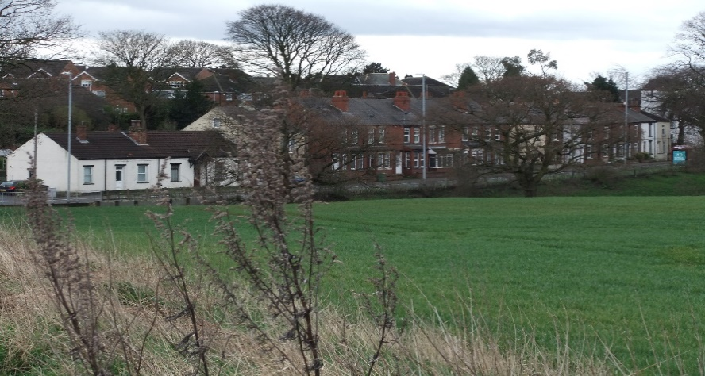
Over a mile in length, Wakefield Road contains a variety of styles since its houses were built in small groups at various periods with intermittent infill rather than as an ordered development. Downhill from Fairfield Court are detached and semi-detached houses with hipped gable roofs, red or brown concrete pantiles of 1970 style together with 1940 style semi-detached dwellings. Continuing towards Allendale Crescent are circa 1930/1950 semi-detached houses of red brick with hipped gable roofs and clay tiles (some original slate still visible). Casement windows are fitted, with bay windows to the fronts. Near the Alandale Crescent junction is an infill development of 3 detached dwellings circa 2005. The site is sloping with hawthorn hedging and has a shared drive with on-site parking. Further on is the Turnpike Milestone and beyond, where the Cock Beck passes under the road is a Nursing Home, set back from the road. After this comes a row of terraced houses, Da Villas, circa 1890. Before the Ringway junction is The Beeches, a Victorian cottage shown on the 1890 map of Garforth. Just before the Garforth Bridge roundabout is a car wash and a car spares fitting station. Two other automobile businesses, with wide open forecourts, are situated about halfway down the road from Town End. At the roundabout stands a pub/restaurant, now called the Miller & Carter. This was previously known as ‘The Old George Inn’ and was mentioned in 1822. It probably existed as a coaching inn considerably earlier, hence the name.
Da Villas
Topography and Appearance
Wakefield Road sweeps down steeply from Town End to Garforth Bridge in a series of undulations and wide curves. It is a major bus route and has 4 bus stops, some with shelters. The road is wide with wide pavements both sides. On the eastern side, paved parking areas are provided along some sections. There are no houses on the western side which is bordered by a low hedge with some mature trees. Nearly all the houses have an unrestricted view westwards over open arable fields. At the bottom end, where there are no houses, the road is bordered with high hedges and mature trees on both sides.
Barleyhill Road
At its entrance from Wakefield Road, Barleyhill Road has high hedges, both sides. The first property on the right is a large modern detached house surrounded by extensive garden space set well back from the road. On the left is another, but smaller, modern detached house with an open-plan front garden. Further in, round the curve and along the road, the houses are detached and semi-detached of 1950/80 style, some with bay windows and most with walled front gardens. On the southern side is the Working Men’s Club and to the north is the Recreation Ground and Playing Field. Also on the left are a motor accessories shop and a take-away. Terraces of houses, some 1930 style with no front garden, others later with walled or fenced front garden run the rest of the road to the Public Car Park. At the end of the road, before it reaches Main Street, on both sides are several businesses, including a hairdresser’s, an Italian restaurant and a dance school. The roads leading off from Barleyhill Road show a variety of developments of different eras, from 1930 to the present day. Examples are :-
Poplar Avenue Beginning with Terraced Houses, circa 1930, with no front gardens, the buildings are red-brick with distinctive under-eaves brickwork decoration. Leading into Kingsway are semi-detached houses and bungalows, 1950/60 style, with low-walled front gardens, well-cared-for and with some mature trees.
Barleyhill Crescent A 1960 style development of semi-detached houses and bungalows with large walled front gardens.
St Joseph’s Court A modern terraced development of red brick and grey tiles. 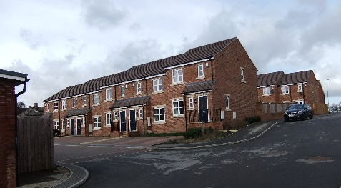 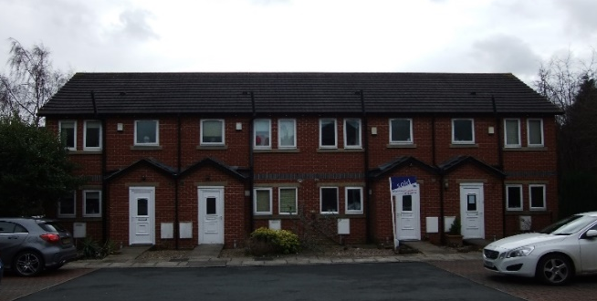
Barleyhill Fields and Close
St Joseph’s Court
Barleyhill Fields and Close Red-brick terraced 2-storey houses built in 2014/5
Ringway
Ringway connects Lidgett Lane with Wakefield Road and acts as a feeder for the several streets to its north and south. From its eastern end to where it meets Westbourne Drive it is lined on both sides with 1950/60 style semi-detached bungalows with tiled roofs and good-sized front gardens with low walls. The road continues with semi-detached 2-storey houses of a similar style but with bay windows up and down. The front gardens now have hedges and fences. From here on, the dwellings are a mixture of semi-detached houses and bungalows with medium walls, high fencing and hedges. Towards the western end, the houses are newer and include larger detached houses standing well back from the road.
Topography and Appearance
Ringway sweeps down from Lidgett Lane in a series of undulations and curves, the final link with Wakefield Road being a sharp bend with a steep slope. The road is 2-cars wide and has pavements on both sides. Over most of its length, where there are bungalows, it presents a well-ordered appearance of well-kept gardens with shrubs. However, in the case of the houses the view is less regular since there is a mixture of walls, fencing and hedges which in most cases obscure the front gardens completely. The Wakefield Road exit has a long high fence on one side and a high hedge on the other, both obscuring the properties.
Lidgett Lane
From Ringway to Lowther Road Lidgett Lane sweeps downhill in a curve and on its right are the playing fields of Garforth Academy followed by the complex which used to be the Police Station and Medical Clinic. On the left, it starts with 3 Victorian dwellings, one detached with an added porch, 2 semi-detached with bay windows and a combined widow and door covering supported by iron columns and another detached house that has been modified and has an integral garage added. Further down the road is the entrance to Strawberry Fields Primary School. The school buildings stand back from the road and are shielded from view by large trees. This is followed by the entrance to Lidgett Court, a modern, circa 2000, development of some 20 dwellings, mixed detached houses and bungalows and semi-detached bungalows. The designs are varied but most have the garage built onto the side of the dwelling. Where this is not the case the garage is provided remote from the house. Apart from the entrance the development is paved throughout with no footpath. Gardens are mostly open plan and shrubs and small trees are plentiful. Next, on Lidgett Lane, there is a modern bungalow with an attractive low-walled garden laid out with grass and shrubs. This is followed by an interesting stone house and garage complex, built circa 2000, and then another modern bungalow with a stone frontage. The next building is The Coach House which has been modernised and extended to the rear to become a care home for up to 21 residents. Lidgett House which stands next to it has also been modernised and is now a business enterprise. To finish this stretch are two Victorian dwellings which have been rendered and greatly modified to form 2 detached 2-storey houses.
Lowther Road, Lowther Grove, Lowther Drive and Lowther Avenue
Coming off on the eastern side of Lidgett Lane, Lowther Road is so called since it led to Lowther House, the home of the Hon. Henry Cecil Lowther, a prominent Garforth land-owner in the 18th. Century. Today it leads to three side-roads servicing a housing estate of some 107 dwellings. The general style in Lowther Grove and Lowther Drive is that of 1960-1970 with most of the dwellings being semi-detached 2-storey houses, of red brick, red or grey tiles and with bay windows up and down. Some have a canopy over the door and some have the door set back to form a porch. The type of bay window varies. Mixed in with these houses are semi-detached bungalows and detached houses. Some of the detached houses are of an unusual design with a large gabled front not seen elsewhere in Garforth. There are also some semi-detached houses which do not have bay windows but have half of the front extended forwards to give extra room. On the eastern side of Lowther Drive the properties are of high quality. They are large 4-bedroomed houses or large bungalows with dormer windows, all standing in spacious grounds with landscaped gardens which screen the buildings from the road. Many of the properties have very long drives which make the dwellings very secluded. Lowther Avenue is of a different character from the rest of the estate since it contains much older property. The first of these is Springfield House which is large 2-storey Victorian house with bay lwindows. The combined door and widow canopy is supported by pillars with decorative brackets. There is an attic skylight and large brick brackets under the eaves. This house forms part of Springfield Care Home, which is a new building complex offering residential care for up to 69 persons and extends a considerable distance along the eastern side of the road. Also on that side are a chalet-type modern house, a large modern detached house with a detached double garage and a large (? 7-bedroom) 3-storey Victorian house. This last property has very large bay windows, a roof with decorative ridge tiles and a finial at each end, and stands in its own grounds. On the other side are 3 detached 2-storey houses of 1950 style. All are of different designs. At the end of the road, behind iron gates, is a single-storey dwelling called Eden Villa. The road is only made up for part of its length and has no footpaths.
Selby Road
From Garforth Bridge to Lidgett Lane, Selby Road shows a great variety in the type and style of dwellings. Since the developments were small, often individual plots, and executed at various times over many years, most of the dwellings have their own character with little repetition. Although much altered, the Gaping Goose Inn dates back to before 1733. Opposite are houses that were built since 2000. In the mix are detached, semi-detached houses and bungalows of 1930, 1950/60, 1980 and 2000 styles. Red brick predominates but is in no way universal. Almost opposite the entrance to Lidgett Lane stands Garforth House, dated 1850 but extensively modernised. On the same side is a service station with a wide frontage. Interesting side-roads are :-
Springfield Place This cul-de-sac includes a Victorian terrace of red-brick slate-roofed houses, a modern chalet-type house with dormer windows and 2 large modern detached houses standing in their own grounds and surrounded with mature trees.
Rockley Grange Gardens A very modern development of semi-detached houses standing in a fully-paved area.

Topography and Appearance
From Lidgett Lane, Selby Road slopes down to the west, becoming steep from the Gaping Goose onwards. At this point the land to the north is considerably higher than the road as witnessed by the high red-brick retaining wall. The road is wide, with pavements both sides, and was re-aligned in the 1960’s. The old course of the road can be seen in front of the inn. Here and opposite are wide grass verges decorated with floral displays by ‘Garforth in Bloom’. Because the dwellings were largely individual developments, their frontages show no regular pattern and include walls, fences and hedges. In many cases the hedges are high and screen the property from the road. The roundabout at Garforth Bridge sports a very large weeping willow, watered by the Cock Beck. Traffic lights control the Lidgett Lane junction.

Amenities
Recreation Ground – Barleyhill Road
Strawberry Fields Primary School
Working Men’s Club – Barleyhill Road
Gaping Goose Inn
Miller and Carter (Old George) Inn

